  - NHS Equality Delivery System

EDS Report for Nottingham and Nottinghamshire ICB
  - Report 1 for Domain 1: (Commissioned or Provider Services) – Lung Cancer Screening Programme

Classification: Official
Publication approval reference: PAR1262

Contents
Equality Delivery System for the NHS 2
Introduction 4
Stakeholder Engagement 4
Summary Table: Key Evidence and Score by Outcome 5
Further Evidence and Narrative from Stakeholders 7
Closing Reflection 9
Appendix 1a: Table 1 LCS Programme 10
Appendix 1b: Table 2 EDS Action Plan 23

Equality Delivery System for the NHS
The EDS Reporting Template

Implementation of the Equality Delivery System (EDS) is a requirement on both NHS commissioners and NHS providers. Organisations are encouraged to follow the implementation of EDS in accordance EDS guidance documents. The documents can be found at: www.england.nhs.uk/about/equality/equality-hub/patient-equalities-programme/equality-frameworks-and-information-standards/eds/
The EDS is an improvement tool for patients, staff and leaders of the NHS. It supports NHS organisations in England - in active conversations with patients, public, staff, staff networks, community groups and trade unions - to review and develop their approach in addressing health inequalities through three domains: Services, Workforce and Leadership. It is driven by data, evidence, engagement and insight.
The EDS Report is a template which is designed to give an overview of the organisation’s most recent EDS implementation and grade. Once completed, the report should be submitted via england.eandhi@nhs.net and published on the organisation’s website.

Name of Organisation |  | Nottingham and Nottinghamshire ICB (NNICB) | Organisation Board Sponsor/Lead
 |  | Nottingham and Nottinghamshire ICB (NNICB) | Gemma Whysall; Director of Commissioning – Nottingham and Nottinghamshire
Name of Integrated Care System |  | Nottingham and Nottinghamshire ICS
NHS Equality Delivery System (EDS)
EDS Lead | Claire Haynes; Senior Public Equality and Diversity Manager |  | At what level has this been completed? Domain 1
 |  |  |  | *List organisations
EDS engagement date(s) | April 2025-March 2026 |  | Individual organisation | Nottingham ICB
 |  |  | Partnership* (two or more organisations) | - Primary Care Patient Participation Group (PPG)  - Core 20+5 Ambassador for Nottingham and Nottinghamshire  - Your Health Nottinghamshire  - Maggie’s Cancer Charity
 |  |  | Integrated Care System-wide* | Shared practices with other Integrated Care Boards (ICBs), the East Midlands Cancer Alliance and the Screening Community of Practice Forum.

Date completed | 16th March 2026 | Month and year published | TBC 2026
Date authorised | TBC 2026 | Revision date | TBC 2027

Introduction
This report outlines Nottingham and Nottinghamshire Integrated Care Board’s (NNICB) work in relation to Domain 1 of the NHS England Equality Delivery System (EDS), which focuses on ensuring that health services are accessible, safe and responsive to the diverse needs and experiences of all patients.
For the 2025 EDS reporting cycle, NNICB has selected the Lung Cancer Screening (LCS) Programme as a key area of focus, recognising its significant role in supporting earlier diagnosis and reducing health inequalities. The programme offers lung health checks and low-dose CT screening to individuals aged 55–74 with a history of smoking, with the aim of detecting lung cancer at an earlier, more treatable stage.
The programme is delivered through a community-based model, utilising mobile CT scanners and targeted engagement and communication strategies. It places particular emphasis on addressing health inequalities by prioritising communities with higher smoking prevalence, greater levels of deprivation and increased lung cancer mortality.

Stakeholder Engagement
To assess performance across the four outcome domains, engagement was conducted with a range of stakeholders, including a Primary Care Patient Participation Group (PPG), a Core20PLUS5 Ambassador for Nottingham and Nottinghamshire, a community care provider (Your Health Nottinghamshire) and a voluntary sector organisation (Maggie’s Cancer Charity). This approach ensured a broad spectrum of perspectives, encompassing patient insight, voluntary and community sector input and expertise in equality and inclusion.

When going through this report, please refer to table 1 in Appendix 1a for the outcomes and evidence collated for this service, and table 2 in Appendix 1b for the Domain 1 EDS Action plan 2026-28.

Summary Table: Key Evidence and Score by Outcome
Domain | Key Evidence |  | Patient Participation Group (PPG) | Core 20 + 5 Ambassador | Your Health Nottinghamshire | Maggie’s Cancer Charity
1A Patients (service users) have required levels of access to the service | - Community-based CT scanners with 7-day, extended hours.  - Tailored, multi-language materials.  - Uptake actively monitored by patient demographics.  - Patient case study highlights real-world impact. |  | 3/3 | 3/3 | 3/3 | 3/3
1B Individual patients (service users) health needs are met | - Press release and presentation showcasing delivery of the SMD initiative.  - Patient-led video and dedicated programme website with translation function.  - Targeted engagement with higher-risk communities, including LGBTQI promotion at Pride events.  - Multichannel, culturally inclusive communications and engagement strategy.  - Guidance poster on developing tailored pathways for the prison population. |  | 3/3 | 3/3 | 3/3 | 3/3
1C When patients (service users) use the service, they are free from harm | - Screening delivered in line with national LCS guidance.  - Low-dose CT scans to minimise radiation exposure.  - Specialist thoracic radiologist reporting, supported by AI tools.  - Multidisciplinary clinical pathway with rapid referral to respiratory and oncology services as needed.  - Robust programme governance monitoring safety, quality and performance indicators.  - Safe operation of mobile CT units with trained staff and appropriate clinical equipment. |  | 2/3 | 2/3 | 2/3 | 3/3
1D Patients (service users) report positive experiences of the service | - Review of patient satisfaction survey and summary of improvements made.  - Uptake rate by primary care network (PCN)  - Evidence that the most deprived quintile have seen the greatest improvement in early-stage lung cancer detection. |  | 3/3 | 3/3 | 3/3 | 3/3
 | Total |  | 11/12 | 11/12 | 11/12 | 12/12
 |  |  |  |  | Total Score | 45/48

Further Evidence and Narrative from Stakeholders
Additional Evidence and Insights from Patient Leaders, Including the PPG Member from Eastwood Primary Care Centre, Actively Engaged in Lung Cancer Screening Stakeholder Meetings

1A The team have all the evidence to prove that access is a whole community approach. With coordinated access times, great efforts go into placing the scanner in the right place to help patients access and with excellent communications tailor strategies in each individual community addressing the culture and particular community centred there. I have seen in each meeting the team active monitoring identifying problem areas and a great example is Bev’s story produced to help improve the identified low uptake of younger women. The team work so hard at each meeting to prepare as they go into each different communities to ensure that the different cultures with diversity faiths etc have the necessary approach using an excellent communication strategy to target local people to help them understand the importance of scanning therefore improving up take. I have been involved in helping review booklets and patient information and liaising with local supermarkets to help with siting of the scanner in the most accessible place for patients.

1B A definite top score here there has been a whole team approach to reaching people experiencing severe multiple disadvantage (SMD) including a real stand out programme working with an SMD working group they tailored a programme for a one stop shop. Positioning a scanner in the city centre and offering more than just scanning working with a street help nurse providing immediate clinical care, mental health support ,smoking sensation, signposting to housing help and even giving follow up care. A real stand out exemplary project one worthy of award, well done team.

The team have collected lots of evidence to demonstrate they have engaged and communicated with all areas and worked with the VCSE including working with learning disabilities and LGBT. The communications team present at every meeting discussing different approaches and feedback the different ways they have tried to reach the whole community and produce a wide range of literature in different languages and approaches. Excellent communications team.

1C Through excellent leadership of the project we are reassured that screening is delivered safely with a robust programme governance discussed in our multidisciplinary meetings that I attend. I am reassured that the quality and safety of the operation for all patients and staff.

1D The team have overwhelming evidence of the positive support for the programme from all patients including learning disabilities SMD and the minority communities. With scores often four or five and the uptake above the national average lessons have been learned and addressed and implemented to provide a seamless service for patients. The team have listened to people, the VCSE and have worked with the different community teams to improve accessibility and all most of the preventable reasons for not attending. An excellent multidisciplinary team that is well lead, coordinated and work well together to provide a safe excellent service that is making a difference.
Additional Evidence and Narrative from a CORE 20+5 ICB Ambassador for Nottingham and Nottinghamshire
1A Good evidence of targeted activity responsive to specific user needs. Some data showing the participation rates for working age invitees would enhance this.
1B Good evidence of working with VCSEs to develop accessible materials, and literally ‘meeting patients where they are’ for SMD and prison populations.

1C A more detailed example of an escalation pathway might enhance this response. Evidence around providing alternative venues for the screening might also improve the response, thinking particularly about SMD patients. However, patient safety is not my area of expertise.

1D Evidence of good patient engagement demonstrated throughout the pack. Answer might be enhanced by a full breakdown of patient satisfaction responses.

Additional Evidence and Narrative provided by Maggie’s Cancer Charity

To Note: Some stakeholders found it difficult to award an “Exceeding” rating for domain 1C due to the challenge of objectively measuring “freedom from harm” in a screening service, where harm is largely prevented through processes rather than immediately visible outcomes. Despite this, scorers noted that the service demonstrates multiple layers of safety and reassurance.

Closing Reflection
The Nottingham and Nottinghamshire LCS Programme demonstrates strong alignment with EDS Domain 1 outcomes. It achieves high levels of accessibility, delivers responsive care, maintains safe screening pathways and supports positive patient experiences. Continuous evaluation, stakeholder engagement, and targeted initiatives ensure that equity remains central, particularly for underserved populations. Future work will focus on extending reach, reducing inequalities and exploring innovative service delivery models.

The scores collated through stakeholder engagement suggest that the programme is excelling in EDS Domain 1 related activity.

Appendix 1a: Table 1 LCS Programme
Outcome |  | Rating | Owner (Dept/Lead)
1A: Patients (service users) have required levels of access to the service | Narrative  The LCS Programme uses population health intelligence to prioritise PCNs with the highest smoking prevalence and lung cancer mortality rates, reducing inequities in access and outcomes.  A community-based delivery model ensures accessibility, with mobile CT scanners located in supermarket car parks and local community hubs. Clinics operate extended hours (typically 8am–8pm, seven days per week) to accommodate work and caring responsibilities.  Evidence  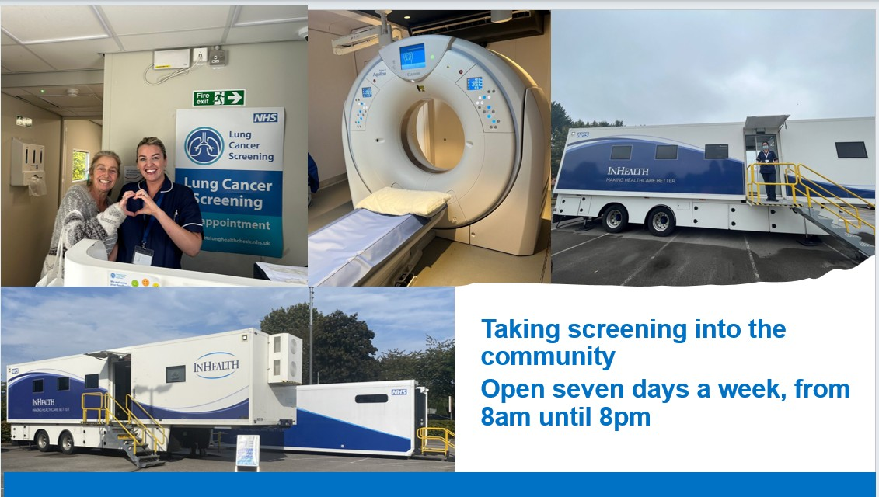  An opt-out invitation model simplifies booking and normalises participation. A range of contact strategies are used, including direct telephone calls, letters, and text messages.  Communications are tailored to local populations, with multi-language materials, community champions, GP practice engagement and partnerships with voluntary and faith organisations to reach underserved groups.  Evidence  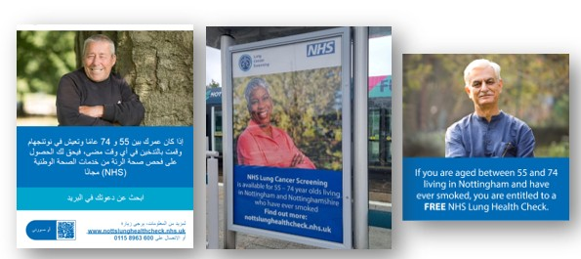  Active monitoring of uptake, combined with a comprehensive demographic analysis of patient attendance, identified lower participation among women and younger age groups.  Evidence  To address this, the programme:  - Highlighted female patient case studies to improve engagement (e.g., Bev’s story). Evidence https://notts.icb.nhs.uk/2025/07/30/bevs-journey-from-feeling-healthy-to-navigating-the-unexpected-diagnosis-of-lung-cancer/  - Partnered with large local employers, such as Boots, Warburtons, and Raleigh, to raise awareness.  - Engaged community organisations, including the Miners Welfare, to reach targeted populations. | 12/12 | LCS Programme Lead
1B: Individual patients (service users) health needs are met | Narrative  Individual risk is assessed via the Lung Health Check, evaluating smoking history, respiratory symptoms, family history, and other risk factors to determine eligibility for low-dose CT screening.  The programme integrates preventative health interventions using the “Making Every Contact Count” approach, offering immediate referral to local stop-smoking services, behavioural advice and pharmacotherapy.  A core focus of the programme is reaching people experiencing severe multiple disadvantage (SMD) including homelessness, substance misuse and significant mental health challenges, recognising that this population often faces substantial barriers to healthcare and poorer health outcomes.  In Nottingham, which has the eighth highest prevalence of SMD nationally, this approach aligns closely with the Core20PLUS5 initiative, targeting those most at risk and benefiting from tailored interventions.  To ensure the health needs of SMD patients are met, the programme has implemented several adaptations:  - Pathway redesign informed by lived experience: Working with the Nottingham SMD Working Group the programme identified barriers such as lack of transport, fear from previous negative healthcare experiences, complex pathways and language challenges.  - Mobile CT scanners in city centres allowed for drop-in appointments, same-day lung health checks and scans and broader health support removing the need for multiple visits.  - Key workers supported with attendance and the communication of results for patients who have no fixed address.  - The programme also provided additional support, including blood tests and general health checks, mental health signposting, housing advice and immediate clinical care delivered by a street health nurse.  Evidence  https://notts.icb.nhs.uk/2024/07/02/life-saving-lung-health-checks-successfully-delivered-to-some-of-the-most-vulnerable-people-in-nottingham/  A presentation showcasing the delivery of the SMD initiative has been shared with the screening community as an example of best practice, as well as with the East Midlands Cancer Alliance. This was also presented at a national forum, the HSJ Modernising Diagnostics and Cancer Forum, showcasing the innovative approach taken.  Further bespoke pathways include collaboration with learning disability nurses to develop accessible information and a patient-led video to reassure attendees.  Evidence  https://www.youtube.com/watch?v=dANObpFgScE  Promotional materials are translated into the most spoken languages in Nottingham and Nottinghamshire and accessible for those with sensory impairments.  A dedicated programme website provides patient-led resources, videos and full website translation options.  Evidence  https://nottslungcancerscreening.nhs.uk/  Collaboration with social prescribers, voluntary organisations and primary care ensures patients are not only assessed but also supported to navigate follow-up care.  Attendance at events such as Nottingham Pride provides an opportunity to engage with LGBTQI communities, who experience higher rates of smoking, the primary risk factor for lung cancer. UK government data from the UK Government Equality Impact Assessment for LCS shows that 22.3% of gay or lesbian adults smoke compared to 15.5% of heterosexual adults (Gov.Uk, 2025).  Evidence  Gov.UK (2025) Equality Impact Assessment: screening for lung cancer. Available at: https://www.gov.uk/government/publications/lung-cancer-screening-equality-impact-assessment/equality-impact-assessment-screening-for-lung-cancer?utm_source=chatgpt.com  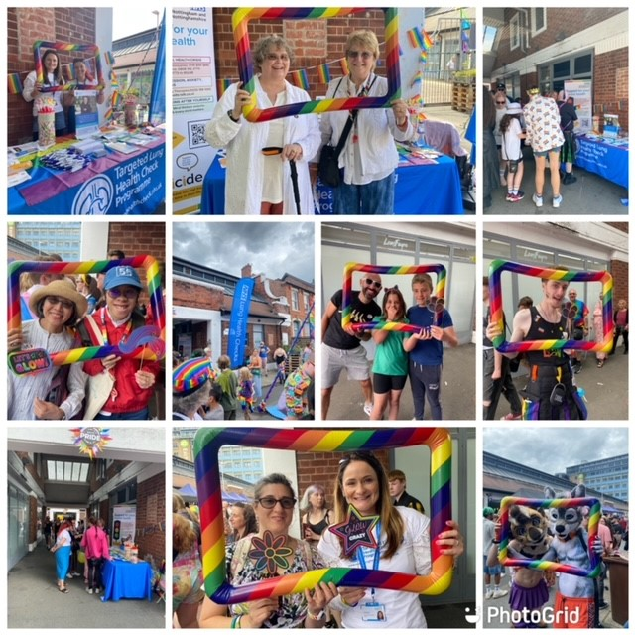  A multi-channel approach has been implemented to maximise reach and engagement across diverse population groups. Activities include:  - Public transport advertising (bus and tram networks) to reach a broad cross-section of the community.  - Billboard and digital screen advertising in high-footfall areas to increase visibility and awareness.  - Targeted social media campaigns, using postcode-level data to reach higher-risk and underserved populations.  - Local radio advertising in both English and Urdu to engage audiences who may not access digital platforms.  - Patient case studies to provide relatable narratives.  - Community engagement events, including outreach at local festivals and targeted events such as football matches.  - Press releases to amplify messaging through local media outlets.  - Direct communications to primary care, including TeamNet messages to GP practices to support case finding and referrals.  - Distribution of promotional materials across community settings, including cafés, pharmacies, community groups, faith centres and libraries.  Evidence  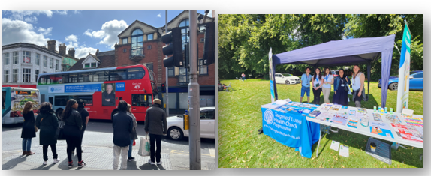  Collaboration with health and justice commissioners has been undertaken to support the development of a tailored lung cancer screening pathway for the prison population. This work recognises that individuals in secure and detained settings often have significantly higher smoking prevalence and poorer health outcomes, placing them at increased risk of lung cancer.  Evidence  Improving access to LCS for prison populations in Nottingham and Nottinghamshire. | 12/12 | LCS Programme Lead and Communications and Engagement Lead
1C: When patients (service users) use the service, they are free from harm | Narrative  The LCS programme delivers screening in line with national clinical standards for targeted LCS. Low-dose CT scanning is used to minimise radiation exposure while maintaining diagnostic accuracy.  All scans are reported by specialist thoracic radiologists and supported by artificial intelligence technology to assist with detection and prioritisation. The programme operates within a multidisciplinary clinical pathway, ensuring that patients with abnormal findings are referred promptly into specialist respiratory and oncology services for further investigation and treatment.  Robust governance and quality assurance processes support the safe delivery of the service. Clinical protocols and pathways are aligned with national screening guidance and programme performance indicators are routinely monitored to ensure safe and consistent delivery.  The service is delivered by a trained multidisciplinary workforce including Specialist Nurses, Radiographers, Clinicians and Radiologists. Staff receive training specific to LCS pathways to ensure assessments are delivered safely and that patients receive appropriate advice.  Although the service operates within community locations using mobile CT units, safety remains a key priority. All units meet required clinical and safety standards and are staffed by appropriately trained professionals with clear escalation pathways for patients requiring further investigation.  Evidence  • Screening delivered in line with national LCS guidance.  • Use of low-dose CT scanning to minimise radiation exposure.  • Specialist thoracic radiologist reporting supported by artificial intelligence tools.  • Multidisciplinary clinical pathway with referral into respiratory and oncology services where required.  • Programme governance structures monitoring safety, quality and performance indicators.  • Safe operation of mobile CT units with trained staff and appropriate clinical equipment. | 9/12 | LCS Programme Lead, Clinical Director,  Responsible Assessor, Responsible Radiologist, Responsible Clinician.
1D: Patients (service users) report positive experiences of the service | Narrative  The community-based LCS programme is designed to provide a familiar, non-clinical environment, reducing patient anxiety and encouraging engagement. This is supported by extended clinic hours, accessible information resources and patient-led videos that improve understanding of the screening process.  Robust feedback mechanisms include:  - Patient experience surveys  - Follow-up on lower-rated responses  - Direct contact for complaints or concerns  Survey results show consistently high satisfaction, with most responses rated 4 or 5. Negative feedback is actively addressed and used to drive improvements.  The programme is also successfully reaching individuals with additional needs: 127 of 432 survey respondents reported having an impairment, health condition, or learning difference that significantly impacts daily activities.  Evidence  Review of patient experience survey findings and summary of resulting improvements.  Over 100,000 invitations have been issued, achieving an average uptake of 66.4%, with some areas reaching 75%, well above the 51% national average. This highlights the effectiveness of the opt-out, community-based model and the programme’s comprehensive communication strategy.  Evidence  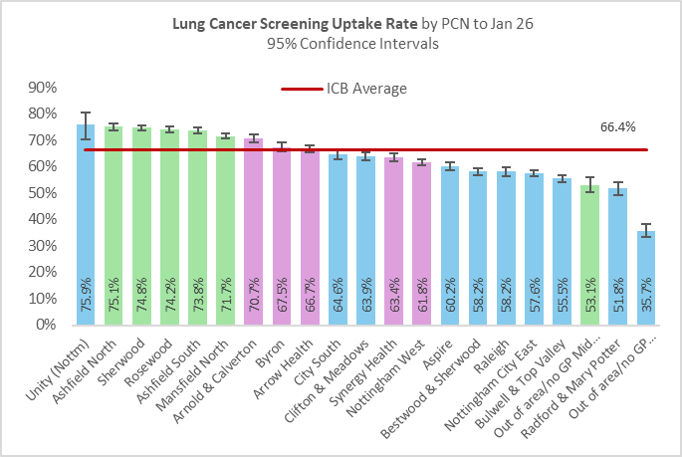  More than 55,000 assessments have been conducted, resulting in 40,000 CT scans and the detection of 500 cancers. Notably, 70% of the lung cancers diagnosed were at an early stage, compared with just 25% before the programme, demonstrating a significant improvement in early-stage detection. People from the most deprived areas (deprivation quintile 1) have experienced the greatest benefit.  Evidence  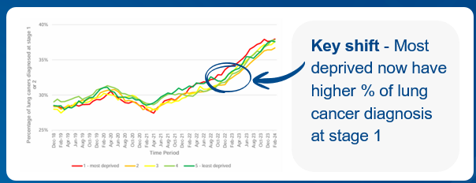  GP practices have reported positive engagement with the programme, supported by regular communication. This is essential to ensure consistent messaging is delivered to patients from this trusted source  Evidence  A quarterly GP newsletter is distributed to maintain awareness and share updates on uptake, rollout progress and key clinical information.  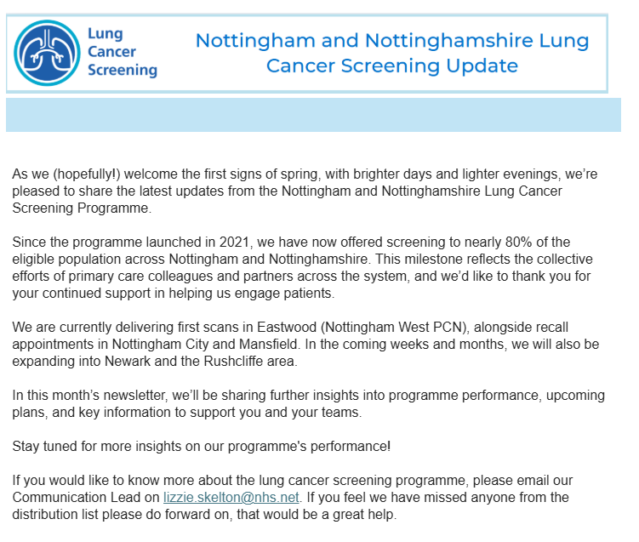 | 12/12 | LCS Programme Lead and Communications and Engagement Lead

Domain 1 score = 45

This score reflects only Domain 1 outcomes. The overall score and EDS Organisation Rating will be available after Domains 2 and 3 are assessed and reported.

EDS Rating and Score Card
Please refer to the Rating and Score Card supporting guidance document before you start to score. The Rating and Score Card supporting guidance document has a full explanation of the new rating procedure, and can assist you and those you are engaging with to ensure rating is done correctly

Score each outcome. Add the scores of all outcomes together. This will provide you with your overall score, or your EDS Organisation Rating. Ratings in accordance to scores are below
Undeveloped activity – organisations score out of 0 for each outcome | Those who score under 8, adding all outcome scores in all domains, are rated Undeveloped
Developing activity – organisations score out of 1 for each outcome | Those who score between 8 and 21, adding all outcome scores in all domains, are rated Developing
Achieving activity – organisations score out of 2 for each outcome | Those who score between 22 and 32, adding all outcome scores in all domains, are rated Achieving
Excelling activity – organisations score out of 3 for each outcome | Those who score 33, adding all outcome scores in all domains, are rated Excelling

Appendix 1b: Table 2 EDS Action Plan
EDS Lead | Year(s) active
Claire Haynes; Senior Public Equality and Diversity Manager | April 2021-On-going screening programme
EDS Sponsor | Authorisation date
Gemma Whysall; Director of Commissioning – Nottingham and Nottinghamshire | TBC March 2026

Domain | Outcome | Objective | Action | Completion date
Domain 1: Commissioned or provided services | 1A: Patients (service users) have required levels of access to the service | Ensure all eligible patients can access lung screening services regardless of location, socioeconomic status or personal barriers. | - Continue progress with system-wide rollout, with the aim of achieving 100% coverage by September 2028, thereby ensuring no variation in provision across Nottingham and Nottinghamshire.  - Continue focused engagement in areas with the lowest screening uptake to reduce inequalities and improve participation.  - Pilot to study impact of transport assistance to reduce practical barriers to attendance.  - Expand delivery through additional accessible community venues, including the Community Diagnostic Centre, to bring services closer to local populations.  - Regularly review patient feedback on barriers to access and use this insight to adapt and refine service delivery. | March 27
Domain 1: Commissioned or provided services | 1B: Individual patients (service users) health needs are met | Meet individual health needs and reduce engagement barriers for underserved groups. | - Continue collaboration with learning disability nurses to adapt screening pathways and improve accessibility for individuals with learning disabilities.  - Explore the development of a pilot LCS programme for the prison population, ensuring equitable access to screening regardless of prison category.  - Undertake ongoing monitoring of screening uptake across protected characteristics to identify and address inequalities in access and outcomes.  - Deliver tailored engagement and outreach for underserved communities, including Gypsy, Roma and Traveller populations.  - Further develop and refine personalised screening pathways for individuals with severe mental illness (SMI).  - Continue to share learning and best practice with the wider screening community to support continuous improvement.  - Strengthen the integration of the Making Every Contact Count (MECC) approach to support behaviour change and improve overall health outcomes. | March 27
Domain 1: Commissioned or provided services | 1C: When patients (service users) use the service, they are free from harm | Ensure safe screening with robust clinical governance and clear escalation pathways. | - Ongoing monitoring of safety indicators to promptly identify and address potential risks.  - Continued staff training and competency assessments to maintain high clinical and procedural standards.  - Participation in external quality assurance and audit programmes, with regular review of outcomes and implementation of recommendations.  - Regular review and updating of protocols in line with emerging evidence and national best practice guidelines.  - Sharing safety lessons and best practice across other screening programmes and partner organisations to support continuous improvement. | March 27
Domain 1: Commissioned or provided services | 1D: Patients (service users) report positive experiences of the service | Provide a patient-centred service with high satisfaction and responsive feedback mechanisms. | - Patient feedback and experience monitoring: Systematic collection and review of patient feedback (e.g. surveys and qualitative insights) to inform service improvements.  - Continued efforts to reduce inequalities and improve uptake in low-participation areas, ensuring a more inclusive and accessible patient experience.  - Funding and offering transport options (e.g. taxi or tram travel support) to reduce stress and improve attendance.  - Exploring a pilot LCS programme for the prison population to ensure equitable and dignified access to care.  - Ensuring staff are trained in communication skills, cultural competence and supporting individuals with additional needs (e.g. SMI, LD).  - Providing screening in community-based, familiar and accessible settings to enhance patient comfort and engagement.  - Sharing patient experience insights and best practice across the East Midlands and nationally to continuously improve service delivery. | March 27

Patient Equality Team
NHS England and NHS Improvement
england.eandhi@nhs.net

