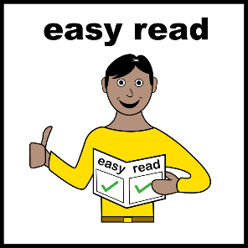

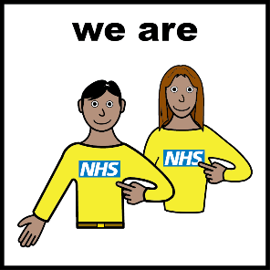

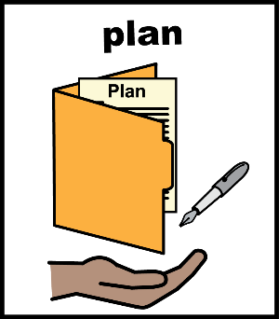

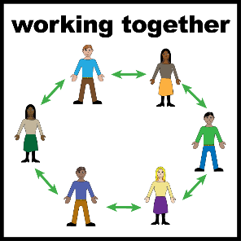

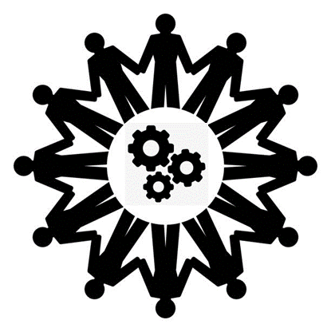

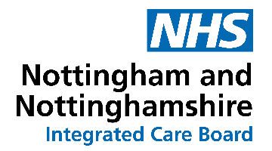

Easy Read: Volunteer Sign-up Form

NHS Nottingham and Nottinghamshire Integrated Care Board

We plan how to improve people’s health, provide quality care and get better value for money.

We are looking for volunteers to work with us to make health and care services better.

This is called co-production.

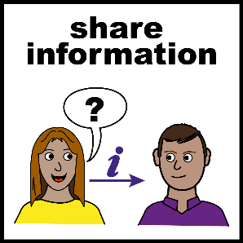

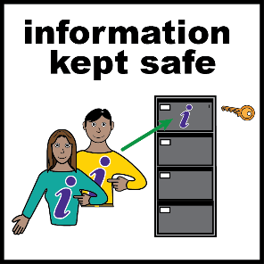

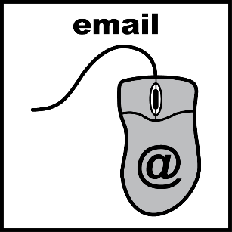

When you fill in this form, we will tell you about how you can volunteer with us.

We will keep your information safe.

Email the Co-production Team if you:
- Have any questions
- Want this form in another language or format.
- Need help filling in the form.
- Want to STOP hearing from them.

Email address: nnicb-nn.icbcoproductionteam@nhs.net.

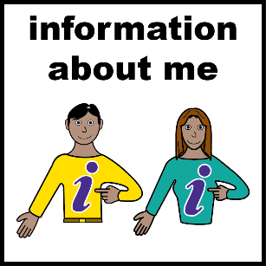

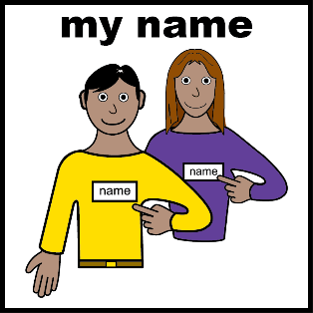

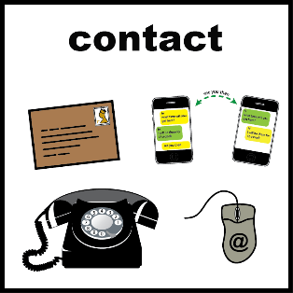

Section 1: Information About Me

My name is:

I like to be contacted by:
☐ Email. My email address is:
My email address is:

☐ Phone.
My phone number is:

☐ Post.
My address is:

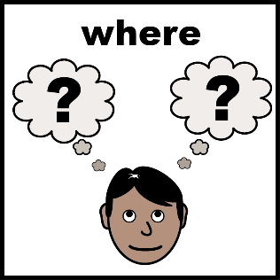

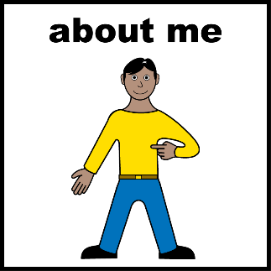

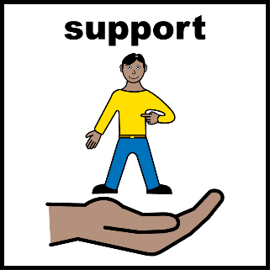

Where in Nottinghamshire do you live?
☐ Ashfield ☐ Bassetlaw
☐ Broxtowe ☐ Gedling
☐ Mansfield ☐ Newark & Sherwood
☐ Nottingham City ☐ Rushcliffe

Tick one or two boxes:
☐ I use or have used health services. Or,
☐ I am an unpaid carer, friend or family member of someone who uses or has used health or care services.

In the box, tell us what support you need to volunteer with us. For example, clear information or meetings in person.

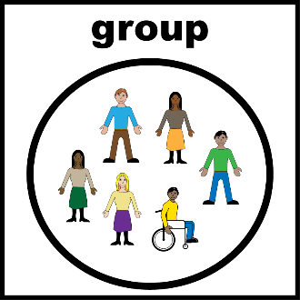

If you know which project or co-production group you are signing up for, please tell us in the box:

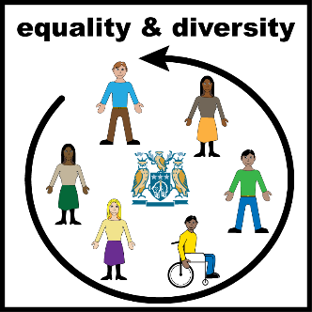
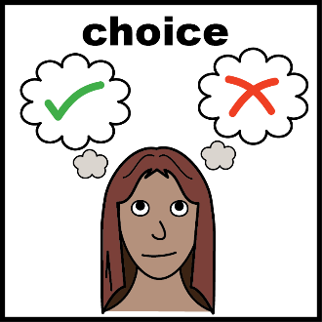
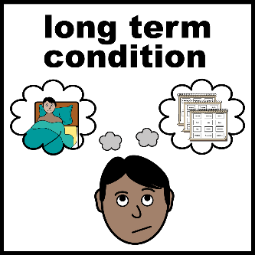
Section 2: Equality & Diversity Information

This section is optional, which means you only fill it in if you want to.

Do you have a physical or mental health condition, lasting or expected to last 12 months or more?
☐ Yes
☐ No
☐ I don’t want to say

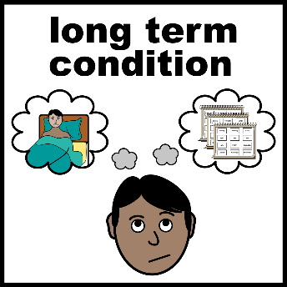

Do any of your conditions or illnesses stop you doing everyday activities?
☐ Yes, a lot
☐ Yes, a little
☐ No
☐ Prefer not to say
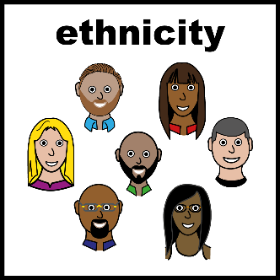
What is your ethnic group?
This is the group of people you share a culture with, for example, African, English, or Caribbean.
Please tell us in the box:

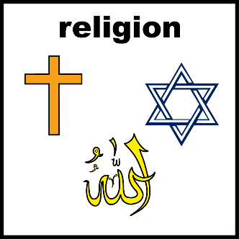
What is your religion?
For example, you might be Sikh, Muslim or have no religion.
Please tell us in the box:

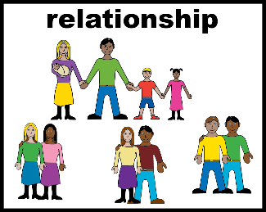

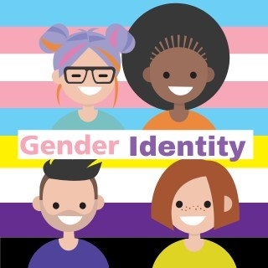

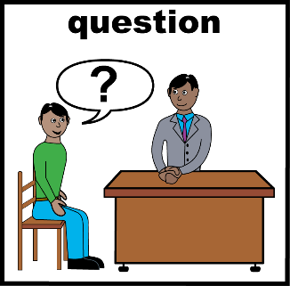

What is your relationship status?
For example, you might be married, or single. Please tell us in the box:

What is your gender?
☐ Woman ☐ Man
☐ Non-binary ☐ Intersex
☐ Prefer not to say

Is your gender now the same as it was when you were born?
☐ Yes ☐ No
☐ Prefer not to say

What is your sexual orientation?
For example, you might be straight, gay or don’t know. Please tell us in the box:

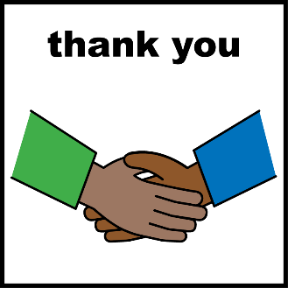
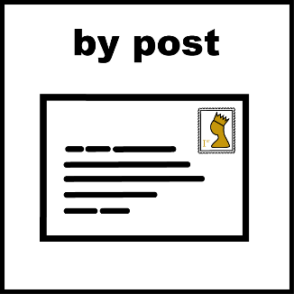
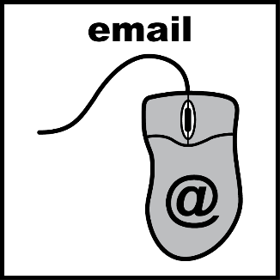
Section 3: Next steps

Thank you for filling in this form. Please choose one option below.

Post your form to the Co-production Team at:
NHS Nottingham and Nottinghamshire Integrated Care Board
Sir John Robinson House
Sir John Robinson Way
Arnold
NG5 6DA

Email your form to nnicb-nn.icbcoproductionteam@nhs.net

We will read your form and contact you.

End of the form.

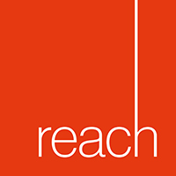

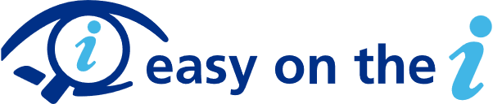

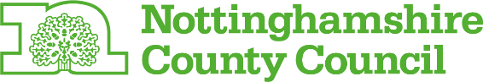

Other Information

Thank you to the Voice and Participation Group at Reach Learning Disability for their ideas on how to make this document better.

Pictures in this document courtesy of:

- Leeds and York Partnership NHS Foundation Learning Disability Service Easy on the i – Image Bank

- Nottinghamshire County Council Adult Social Care and Health.

