Nottingham and Nottinghamshire Response: NHS England Statement on information on health inequalities (duty under section 13SA of the National Health Service Act 2006)

Table of Contents
Introduction 3
Nottingham and Nottinghamshire Population Profile 4
Impacting on Health Inequalities 7
How do we Measure Deprivation? 8
Summary of 2024/25 Position: Position as of 1st April 2025 8
Elective Care 11
Size and shape of the waiting list; those waiting longer than 18 weeks, 52 weeks and 65 weeks – by deprivation and ethnicity. 11
Age-standardised rates of elective admissions 14
Age-standardised rates of outpatient appointments 15
Age-standardised rates of virtual outpatient appointments 15
Elective activity vs pre-pandemic levels for under 18s and over 18s 16
Urgent and Emergency Care 18
Age standardised activity rates with 95% confidence intervals for emergency admissions 18
Emergency Admissions for Under 18s 20
Respiratory 21
Uptake of covid and flu vaccinations by age and demographic 21
Mental Health 24
Overall number of severe mental illness (SMI) physical health checks 24
Rates of total Mental Health Act detentions 25
Rates of restrictive interventions 27
NHS Talking Therapies recovery rate 28
Children and Young People’s (CYP) Mental Health Access 29
Cancer 29
Percentage of cancers diagnosed at stage 1 and 2, case mix adjusted for cancer site, age at diagnosis, sex 30
Cardiovascular Disease (CVD) 31
Stroke - rate of non-elective admissions (per 100,000 age, sex standardised) 32
Myocardial infarction – rate of non-elective admissions (per 100,000 age-sex standardised) 33
Percentage of patients aged 18 or over with GP recorded hypertension, in whom the last blood pressure reading in the preceding 12 months is below age-appropriate treatment thresholds (indicator of optimal condition management) 33
Percentage of patients aged 18 and over with no GP recorded CVD and a GP recorded QRISK score of 20% or more, on lipid lowering therapy 34
Percentage of patients aged 18 or over with GP recoded atrial fibrillation and a record of CHA2DS2-VASc Score of 2 or more who are currently treated with anti-coagulation drug therapy 35
Diabetes 35
Variation between percentage of people with Type 1 and Type 2 Diabetes receiving all 8 care processes. 36
Variation between percentage of referrals to the National Diabetes Prevention Programme from the most deprived quintile and percentage of Type 2 Diabetes from the most deprived quintile 37
Smoking Cessation 38
Proportion of adult acute inpatient settings offering smoking cessation services 38
Proportion of maternity inpatient settings offering smoking cessation services 39
Oral Health 40
Tooth extractions due to decay for children admitted to hospital aged 10 and under (number of admissions) 40
People with Learning Disabilities and Autistic People 42
Learning disability annual health checks 42
Adult mental health inpatient rates for people with a learning disability and autistic people 42
Maternity and Neonatal 43
Pre-term births under 37 weeks 43
Data Quality 44

Introduction
Health inequalities are unfair and avoidable differences in health across the population, and between different groups within society. Deprivation and ethnicity are two key drivers of inequality and often affect a person’s ability to access healthcare, their outcomes when receiving a diagnosis or treatment for a condition and their experiences of settings when receiving care.
Evidence shows these elements are more likely to be negative when compared to people accessing care living in the least deprived areas. There are also other population groups who may have additional complexities which also increase their risk of health inequalities such as learning disabilities or those with severe and multiple disadvantage.
To drive forward the NHS focus on health inequalities, NHS England published a Statement on Information on Health Inequalities in November 2023. The Statement set out a description of the powers available to relevant NHS bodies to collect, analyse and publish information. NHS England has a statutory duty to conduct an annual assessment of Integrated Care Boards (ICBs) including the extent to which they have fulfilled their statutory obligations regarding health inequalities, adhering to this Statement supports this annual statement.
Nottingham and Nottinghamshire Integrated Care Board (ICB) and Integrated Care System (ICS) recognise that good quality, robust data enables the NHS and wider system partners to understand more about the populations we service. The ICB and ICS are supported by a Strategic Analytics Intelligence Unit (SAIU) that has the skills and expertise to allow for effective reporting and analysis to identify groups that are at risk of poor access to healthcare, have poor experiences or outcomes from care and as a result take targeted action to reduce health inequalities.
NHSE have provided a list of key metrics for monitoring that are the focus of the Statement. The metrics align with the national five strategic health inequality priorities alongside the clinical areas in the Core20+5. Actions are supported by the Nottingham and Nottinghamshire Joint Forward Plan.
The data and information provided in this Statement will be used by the ICS to shape and monitor improvement activity to further reduce healthcare inequalities, fulfilling the Statement’s aim to help drive improvement in the provision of good quality services.

Nottingham and Nottinghamshire Population Profile
Nottingham and Nottinghamshire Integrated Care System (ICS) is a partnership between organisations across the NHS and Social Care. The ICS supports health and wellbeing, active communities and ensures high quality joined up care, when needed, for local people. The ICS is home to 1,170,475 people across the City and the County, 20% of which are children and young people (Census Data 2021).
18% of the population are aged 65 and over. The majority of this age group live in the county areas. Over the last 18 years there has been an increase in total population numbers across the ICS. However there has been a larger increase in older age groups and a decrease in the number of births.
Based on the 2021 Census, 80% of the Nottingham and Nottinghamshire population are from a White British ethnicity. People from an Asian heritage are the second largest ethnicity group in Nottingham and Nottinghamshire, making up around 6% of the overall population. 6% of the ICS population are from a White Other group, 4% are from Black African/Caribbean heritage, 3% are from a mixed heritage and 1% are from other ethnic groups.
The ethnic makeup of each district varies across the system. Nottingham City is privileged to be rich in its ethnic diversity, with around 46% of the City population being from ethnic groups other than White British. 15% of the City population are from an Asian heritage, 10% are from Black African/Caribbean heritage, 8% are from White other groups, 6% are from a mixed heritage and 3% are from other ethnic groups.
Despite the many positives of living in Nottingham and Nottinghamshire, there are also challenges which may unfairly affect certain population groups within society, leading to poorer health outcomes often described as health inequalities.
Nottingham City, Mansfield and Ashfield fall into the 20% most deprived districts in England. 55% of Nottingham City and 15% of the county population live in the 20% most deprived areas in England. People from ethnic minority groups are also overrepresented in areas of higher deprivation. Ethnicity can also increase the risk of developing certain conditions too such as Type 2 Diabetes and high blood pressure. We know deprivation can contribute to the risk of poorer outcomes however, additional barriers and risks may face some minority ethnic groups which can worsen inequalities.
People in the most deprived areas of Nottingham and Nottinghamshire are more likely to develop long term conditions at a younger age and live in poor health for longer. The life expectancy difference is around 8 years less for those in the most deprived areas of the ICS compared the least deprived areas. The average life expectancy of the ICS is also lower than the England average by up to 3 years for males and 2 years for females, life expectancy is consistently worse across the ICS for males. Nottingham City ranks in the lowest 25% of districts in England for life expectancy for both men and women.
The disparities between men and women continue when looking at years spent in good health, also known as healthy life expectancy. Although women may live longer, they are living in poorer health for longer and at a younger age than men across the ICS. On average, women in Nottingham City will spend 70% of their life in good health compared to 75% for men, both figures are lower than the England averages of 77% for women and 80% for men. Rates in the county are similar to the England averages but still reflect the disparities between men and women.
Poor healthy life expectancy not only decreases quality of life but also has wider reaching economic consequences for the local system. If people become ill at a younger age it can increase the risk of economic inactivity, creating losses for the local economy in addition to increased costs incurred by the NHS.
Data for this section has been taken from the Nottingham and Nottinghamshire Joint Strategic Needs Assessment Dashboard which can be accessed here: JSNA Dashboard
  - Condition Prevalence Across the ICS
Table 1 provides an overview of the stark differences between Primary Care Networks (PCNs) across the system and provides context to our interpretation of the data. The PCNs are listed in order of deprivation, PCNs with the highest levels of deprivation to the lowest. The table shows that where deprivation is high, long term condition prevalence and risk factors are higher. We also can see that emergency hospital admissions and avoidable deaths are higher and median age of death is lower. The colour red indicates higher prevalence or worse outcomes.

Table 1

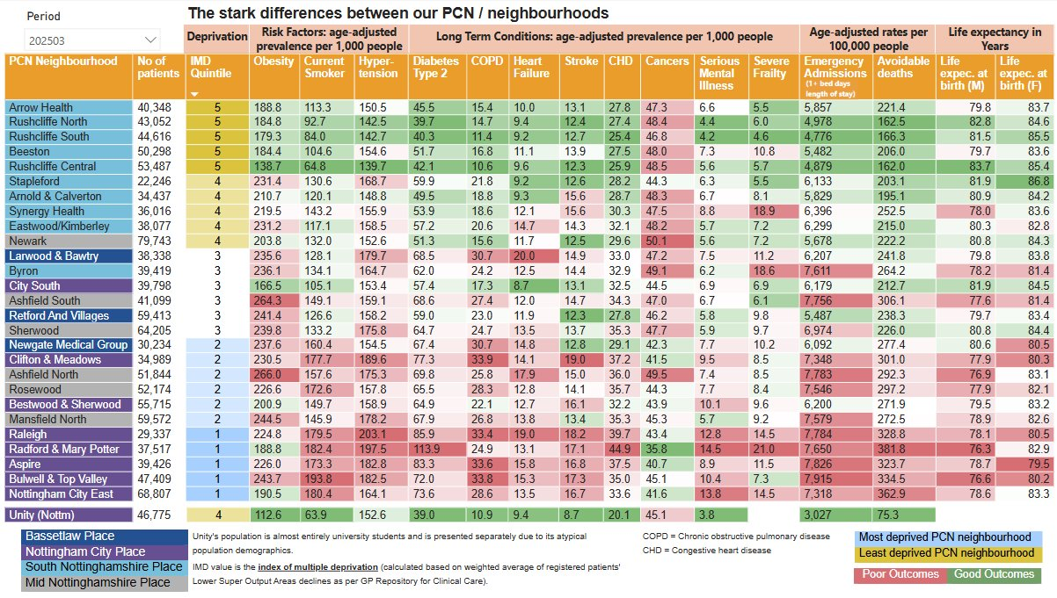

Impacting on Health Inequalities
Health inequalities are differences in the status of people’s health, but the term can also be used to refer to differences in the care that people receive and the opportunities they have to lead healthy lives. Both can contribute to health status and can be impacted by wider societal influences and barriers.
When assessing differences in health care, we need look at three areas; access, experience and outcomes and reducing barriers and disparities that can contribute to, or reduce health inequalities.
- Access to healthcare: Access to healthcare refers to the availability of services that are timely, appropriate, easy to get to and use, and sensitive to user choice and need. Barriers such as location of services, affordability of transport, work commitments, caring responsibilities, health literacy or language barriers, may affect ability to access healthcare. Some factors may be more likely to negatively impact those in the most deprived areas and people from minority ethnic groups. Access to services can be measured by monitoring uptake of services and referrals.

- Experience of using healthcare services: Previous experiences when accessing healthcare or interacting with medical professionals can affect engagement with treatments and future use of services. Poor experience when using just one element of the healthcare system may prevent a person seeking help at the right place and right time in the future. Different social groups may have systematically different experiences within the services that they use, including in terms of the quality of care they receive and whether they are treated with dignity and respect. Monitoring patient feedback and listening to those with lived experience are key in helping healthcare systems drive forward positive, patient-centred change which in turn will help reduce health inequalities. Embedding personalised care approaches is a key ambition of the ICS, enabling people to become more involved with their care and decision making.

- Patient Outcomes: Worse health outcomes occur when people have limited access to health care, experience poorer-quality care and practise more risky health-related behaviours. People from the most deprived areas are more likely to have the poorest outcomes, with a life expectancy up to eight years lower than those in the least deprived areas. People from minority ethnic groups may also experience poorer outcomes when accessing services. Enabling preventative healthcare, equitable access to health services and coproducing services with people with lived experienced are some ways in which overall outcomes could be improved.

Utilising data from the indicators included in this statement can help the system to identify disparities in access to services and patient’s outcomes, highlighting where change is needed. Equitable approaches focussed on improving outcomes will allow a focus on those population groups where need and risk is higher, ensuring resources are distributed in the most effective way.

How do we Measure Deprivation?
We measure deprivation by using Index of Multiple Deprivation quintiles. The Index of Multiple Deprivation (IMD) quantifies the deprivation of an area by using multiple indicators across seven domains, including income, crime rates, employment levels, educational attainment and living environment to establish an overall deprivation score for all the LSOAs (lower super output areas) in England. The overall scores are then ranked and then divided into 5 quintiles. Quintile 1 includes the 20% most deprived areas nationally, whereas quintile 5 includes the 20% least deprived areas in England. We have used this breakdown of quintiles when assessing data by deprivation to understand if there are differences in outcomes between the most and least deprived areas.

Summary of 2024/25 Position: Position as of 1st April 2025
The tables below are taken from the summary page of the Nottingham and Nottinghamshire Health Inequalities Dashboard. This dashboard was developed to monitor the statement indicators, with some additional metrics added based on local priorities.
The health inequalities summary compares indicators for each demographic group to the Nottingham and Nottinghamshire ICB population overall. Values are coloured based on whether they are statistically significantly different to the ICB overall.
For some indicators, data quality is not robust enough to present accurate statistical comparisons. This is a particular issue for comparisons by ethnic group for indicators which use a primary care-based denominator and a secondary care-based numerator such as age-standardised rates of admissions. For these, values are still presented for information but should be interpreted cautiously. ‘Other’ ethnic group values have been omitted because they are particularly affected by this issue. Ethnicity-specific values for patients with 'Unknown' ethnicity are not presented here but are included in the total values. In some instances, this may lead to the overall value being higher than any given ethnicity-specific values.

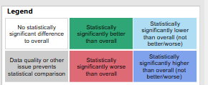
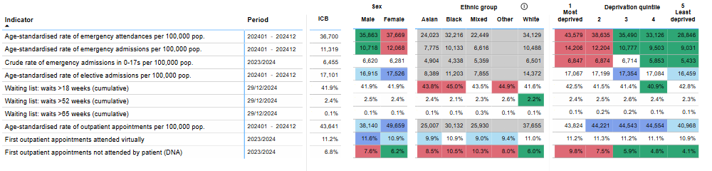
Elective Care
Cardiovascular Disease (CVD)
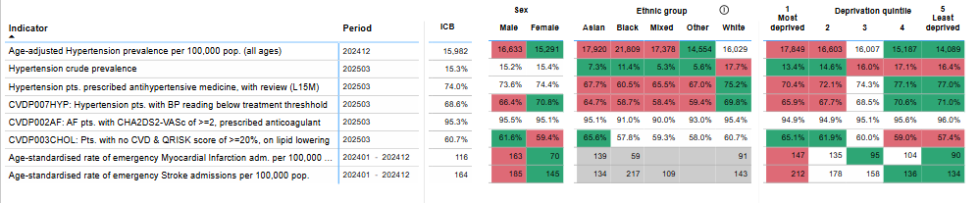
Cancer
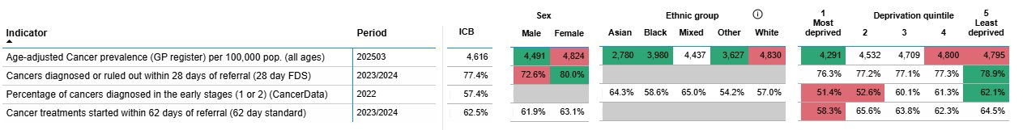
Maternity and Child Health
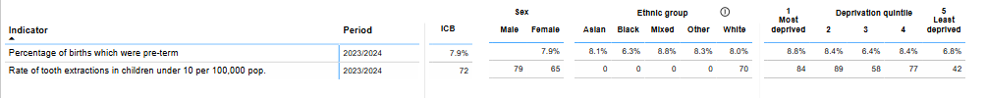
Diabetes
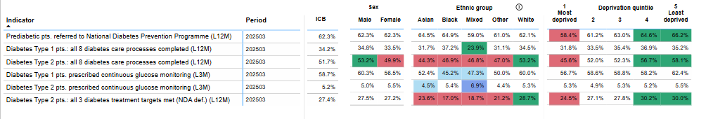
Learning Disabilities and Autism
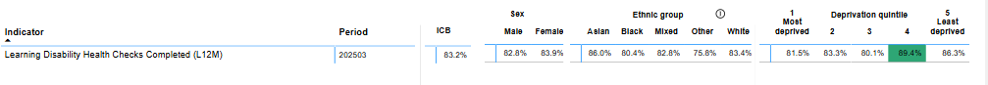
Mental Health
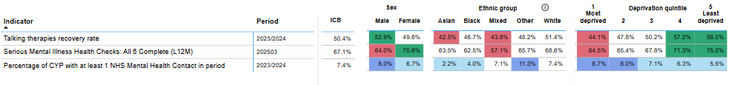
Respiratory
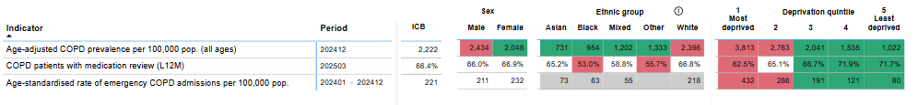
Vaccinations and Immunisations
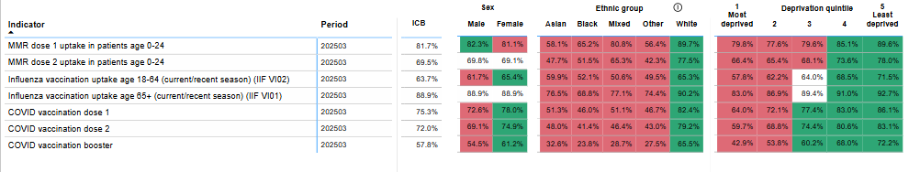

Elective Care
Elective care covers a broad range of non-urgent services usually delivered in a hospital setting such as diagnostic tests and scans, outpatient care, surgery and cancer treatment. The COVID-19 pandemic has had a significant impact on the delivery of elective care, meaning more patients are now waiting longer for treatment than they were before the pandemic began. Elective restoration is one of the five strategic NHS Health Inequality Priorities.
The impact of waiting longer for treatment on individuals, their families and carers is wide ranging and can increase the risk of poorer outcomes following intervention.

Size and shape of the waiting list; those waiting longer than 18 weeks, 52 weeks and 65 weeks – by deprivation and ethnicity.
Changes in the overall size of the waiting list over time can be viewed in figure 1 which shows the reduction in size over 2024. It should be noted that there was a step change in April 2024 because of Sherwood Forest Hospitals (SFH) changing how they reported patients who are overdue for a review, reducing their overall waiting list numbers by around 12,000. The change brought SFH in line with national guidance. Even without this change, the ICB’s overall number of waits lasting more than 18 weeks would have fallen in the last year.
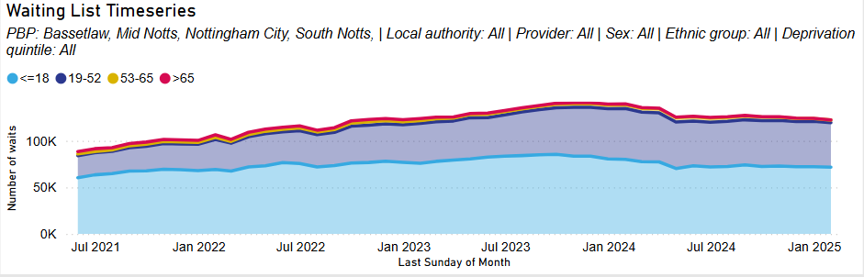
Figure 1: Waiting list time series as of January 2025

Locally there are no statistically significant differences in the proportion of waits which are more than 52 weeks by deprivation quintile for the overall waiting list. Nor are there statistically significant differences in the proportion of waits which are more than 52 weeks by ethnic group. The tables below detail the breakdown of the waiting list by deprivation and ethnicity.
Figure 2: Waiting list by deprivation as of January 2025
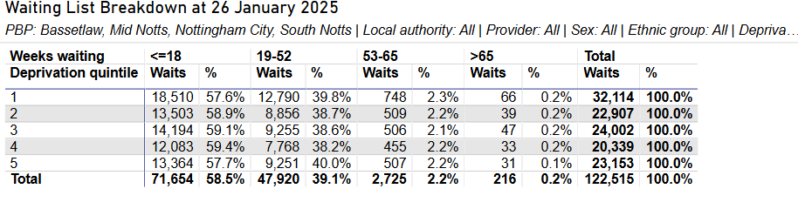

Figure 3: Waiting list by ethnicity as of January 2025
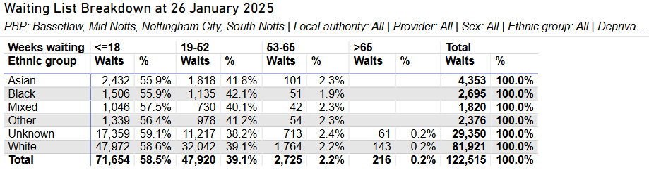
For those living in the most deprived quintile, the proportion of waits which are more than 18, 52, or 65 weeks has decreased since the last statement period. The gap between the most deprived and the least deprived quintiles has also decreased for all long waits except those lasting more than 65 weeks. However, those waiting > 65 weeks accounts for a very small number of waits, and the difference is not statistically significant.
Figure 4: Changes to the waiting list for the most deprived quintile, January 2024 - January2025
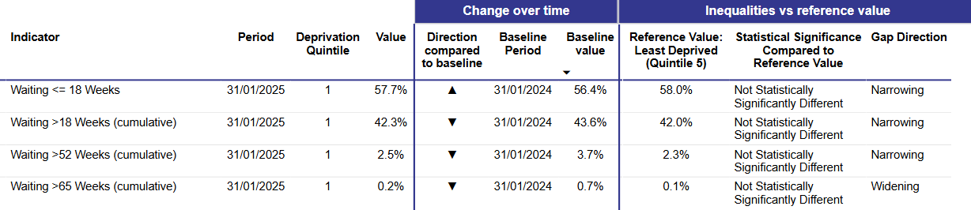

Inequalities by Specialty
An analysis was undertaken in February 2025 to understand whether there were waiting list inequalities by deprivation for each specialty. While there were some percentage point gaps for those waiting more than 18 weeks between the most and least deprived for specialties, these reflected only small absolute numbers, and the gaps were not statistically significant. The table below summarises the largest percentage point gaps by specialty, and the charts further below provide an example of the waiting list analysis available through the SAIU Health Inequalities dashboard. The paediatric surgery example shows the gap in the percentage waiting more than 18 weeks between the most deprived and least is not statistically significant.
Table 1: Specialties with the largest percentage point difference in the percentage of patients waiting more than 18 weeks in the most and least deprived quintiles at 26 January 2025. Only specialties with over 100 total waits over 18 weeks are included.
 | Specialty/  Treatment Function | Total Waiting List | Total Waiting List >18 weeks | Percentage of patients living in deprivation quintile 1 waiting for >18 weeks | Percentage of patients living in deprivation quintile 5 waiting for >18 weeks | Gap between percentage of waits more than 18 weeks between the most and least deprived
Specialities with a pp gap in favour of least deprived | Paediatric Surgery | 547 | 196 | 41.2% | 26.3% | 14.9pp
Specialities with a pp gap in favour of least deprived | Orthodontics | 414 | 247 | 62.9% | 50.0% | 12.9pp
Specialities with a pp gap in favour of least deprived | Paediatric Trauma & Orthopaedics | 597 | 196 | 36.5% | 24.1% | 12.3pp
Specialities with a pp gap in favour of least deprived | Endocrine Surgery | 376 | 161 | 48.4% | 36.4% | 12.0pp
Specialities with a pp gap in favour of least deprived | Dermatology | 7472 | 3049 | 45.3% | 39.8% | 5.5pp
Specialities with a pp gap in favour of most deprived | Oral and Maxillofacial Surgery | 2461 | 1604 | 62.0% | 66.8% | 4.8pp
Specialities with a pp gap in favour of most deprived | Audiology | 824 | 281 | 33.1% | 41.1% | 8.0pp
Specialities with a pp gap in favour of most deprived | Spinal Surgery Service | 1540 | 564 | 32.6% | 41.1% | 8.5pp
Specialities with a pp gap in favour of most deprived | Geriatric Medicine | 784 | 324 | 35.4% | 45.0% | 9.6pp
Specialities with a pp gap in favour of most deprived | Pain Management Service | 400 | 182 | 38.8% | 52.4% | 13.5pp

Figure 5: Waits for paediatric surgery lasting more than 18 weeks by deprivation quintile, January 2025
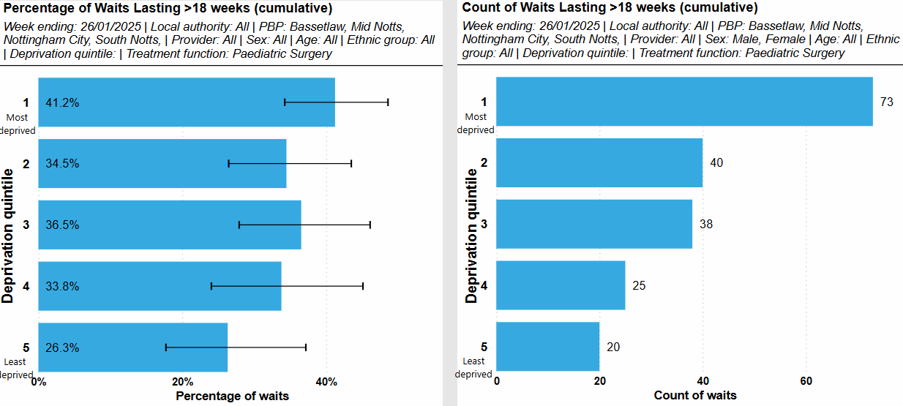

Age-standardised rates of elective admissions
Data for 2024 shows there has been an increase in the number of age standardised elective care admissions for those in the most deprived areas. These figures now show the elective admission rate for those in IMD Quintile 1 are now in line with the ICB overall, suggesting an improvement in equity of access to elective care. Elective admission rates remain below the ICB overall for those in IMD Quintile 5. Elective rates of admission by deprivation and ethnicity are shown in figure 4. Emergency rates of admission and emergency attendance are provided within the Urgent Care Section.
Figure 6: Age standardised rates of Elective Admissions by deprivation and ethnicity Jan 2024 – Dec 2024.
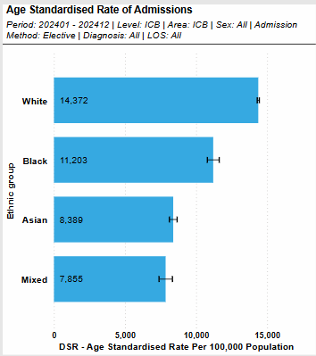
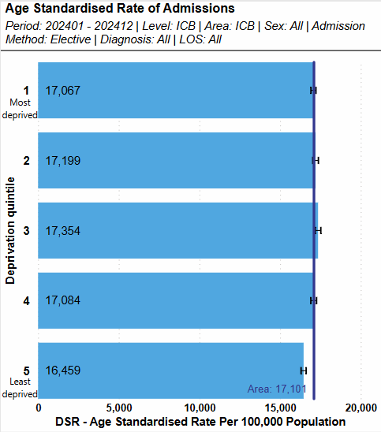

Age-standardised rates of outpatient appointments
The charts below show the age-standardised rate of first outpatient appointments completed in the most deprived populations is in line with the ICB overall. Figures in 2023 showed this was slightly higher than the ICB overall. Numbers of first appointments have increased across all population groups over 2024.
Outpatient appointment rates, where ethnicity is known, are significantly higher in the White population than other ethnic groups. Rates in the White population were around 1.3 times higher than for the Black population and 1.6 times higher than for the Asian population. However, it should be noted that the same issues with ethnicity coding which affect the calculation of rates for admissions also affect outpatient appointments.
Figure 7: Age standardised rates of First Outpatient Appointments by deprivation and ethnicity January 2024 to December 2024.
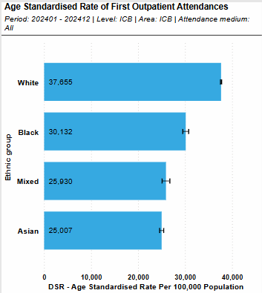
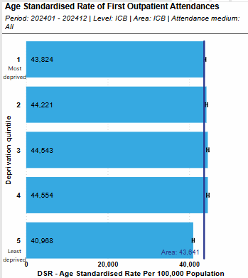

Age-standardised rates of virtual outpatient appointments
In 2024 a total of 56,331 first outpatient appointments were attended virtually by the Nottingham and Nottinghamshire ICB population. This equates to an age standardised rate of 4,516 appointments per 100,000 population. This is an increase of around 3,000 appointments in total and 200 per 100,00 population in comparison to 2023.
The charts below detail rates of virtual outpatient attendances by deprivation and ethnicity in 2023/24. Rates are similar across all IMD quintiles except quintile five, which is lower. Although virtual appointments have helped to increase access to healthcare for some, care must be taken for those at risk of digital exclusion which is one of the five NHS five strategic health inequality priorities. Risk factors for digital exclusion include age, ethnicity and deprivation.

Figure 6: Age standardised rates of Virtual Outpatient Appointments by deprivation and ethnicity 2023/24.
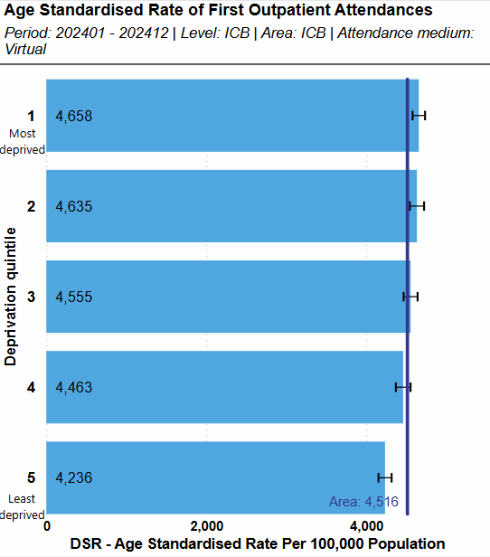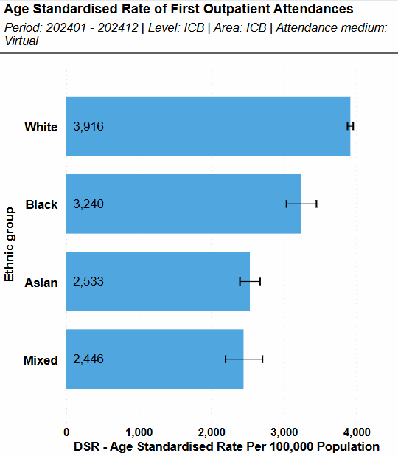

Elective activity vs pre-pandemic levels for under 18s and over 18s
Across both age groups, the number of elective admissions increased from April-December 2019 to April-December 2024. For under 18s, the overall increase was 9.5%, and for adults the increase was 14.7%. For both age groups, this also represents a year-on-year increase against the period covered by the previous statement, April-December 2023.
By deprivation quintile, the percentage increases against baseline were broadly similar for adults. The largest percentage increases were for those living in the least deprived areas (18.3% for quintile 5, 16.4% for quintile 4), and those living in the most deprived quintile (14.7%).
Figure 7 Adult (18+) Elective admissions time series by deprivation Apr 2019 – May 2024
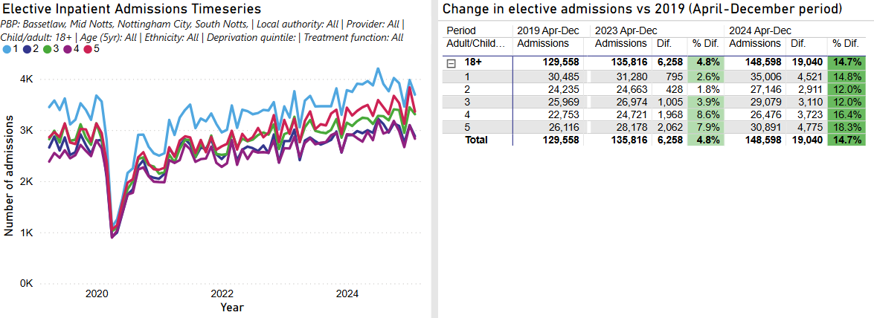
For children, the overall number of elective admissions is much smaller, and there is more variation in the percentage changes by deprivation quintile. Deprivation quintile three saw an almost 20% increase in elective activity for under 18s. Elective activity increased by 11% for deprivation quintile 1. There were slightly fewer elective admissions for children in quintile 4 compared to the baseline.
Figure 8 0-17 Elective admissions time series by deprivation quintile April 2019 – May 2024
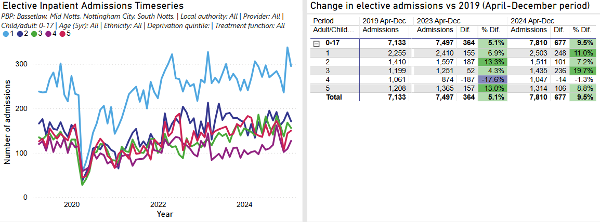
By ethnic group, elective admissions increased for all ethnicities across both age groups except for children with an ‘Unknown’ ethnicity. Elective admissions increased by a smaller percentage for both White children and adults compared to other, smaller, ethnic groups. The largest percentage increases were for Asian and Black children (76.7% and 74.4%), and adults of Mixed ethnicity (68.8%). It is likely that changes in the ethnic profile of Nottingham and Nottinghamshire partially explain the large relative increases in elective admissions for ethnic minority groups. Improvements in ethnicity recording may also have contributed to higher recorded activity for these groups.
Figure 9 Adult (18+) Elective admissions time series by ethnicity April 2019 – May 2024
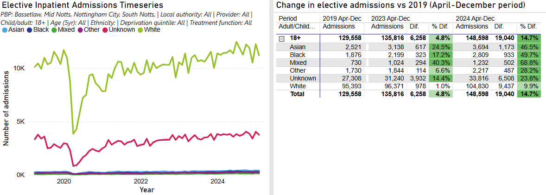

Figure 10 0-17 Elective admissions time series by ethnicity April 2019 – May 2024
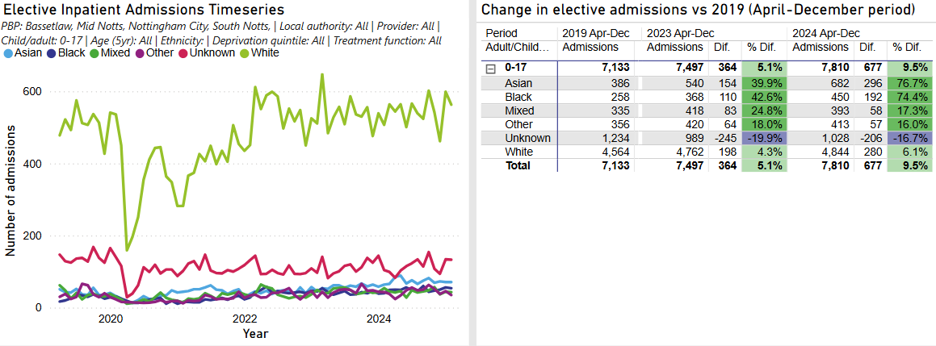

Urgent and Emergency Care
Urgent and emergency care services provide a critical role in healthcare, often treating people with serious or life threatening injuries or illnesses which cannot be treated in Primary Care or in the community. National data shows that people living in the most deprived areas are 1.7 times more likely to attend A&E than those in the least deprived areas. Evidence shows that people who are socially excluded underuse some services, such as primary and preventative care, and often rely on emergency services such as A&E when their health needs become acute. This results in missed opportunities for preventive interventions, serious illness and inefficiencies, and further exacerbates existing health inequalities.
This section of the Statement includes metrics on emergency attendances and emergency admissions into hospital, previously mentioned in the elective care section.

Age standardised activity rates with 95% confidence intervals for emergency admissions
The rate of emergency admissions is significantly higher for those in IMD quintile 1 than the ICB overall and those in IMD quintile 5. In comparison to 2023, age standardised rates of emergency admissions for the ICB overall have increased by 10%. Rates in IMD quintile 1 have increased by 9%, and rates in IMD quintile 5 increased by 11%.
Rates of emergency admissions are statistically significantly higher in the White and Black populations than other ethnic groups. Rates for these populations were around 1.3 times higher than for the Asian population. Compared to 2023, age-standardised rates for minority ethnic groups have increased faster than for the White population. This may indicate an improvement in ethnicity coding as the number of emergency admissions with an Unknown ethnicity increased at a slower rate than emergency admissions overall.
Figure 11: Age standardised rates of Emergency Admissions by Deprivation and ethnicity, 2024
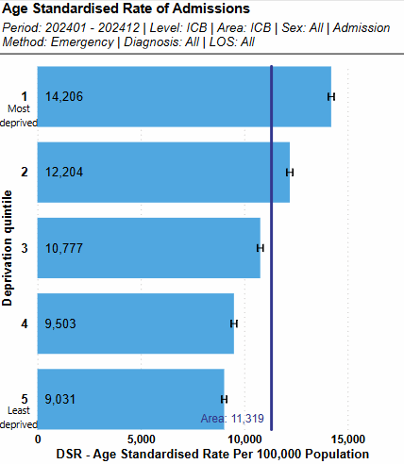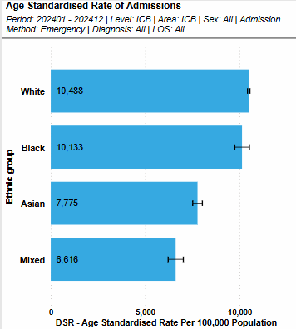

Emergency Admissions for Under 18s
The chart below shows the crude rate of emergency admissions for under 18s over financial year 2023/24. This is an update to the data included in the previous statement which provided data over the 2022/23 period. Emergency admissions for under 18s remain higher in the two most deprived IMD quintiles, and there has been in increase in the rate of emergency admissions for quintile 3.
Figure 12 also presents emergency admissions by ethnicity. Rates are highest in those from other and unknown ethnic groups, with a 7 percentage point increase in figures when compared to the previous year. In comparison, the ICB overall over the year increased by 0.9%. This potentially highlights continued issues in ethnicity recording and data quality. The Data Quality section of this Statement refers to the accuracy and completeness of patient demographics recorded in Secondary Care.
Figure 12: Crude rate of Emergency Admissions by deprivation and ethnicity in 0-17s, 2023-2024
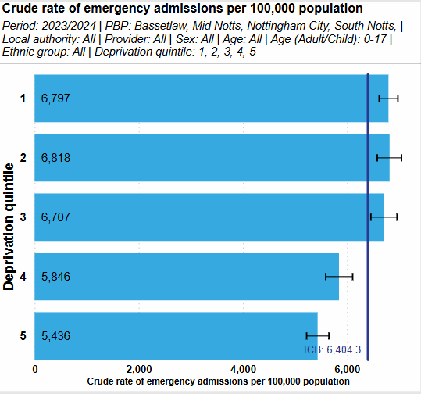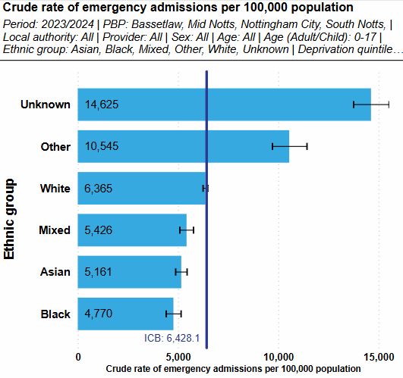

Age standardised rate of emergency attendances at emergency departments
For the calendar year 2024, the ICB overall for attendances at emergency departments increased by around 5% over 2023. Increases to the most and least deprived populations were in line with this rise. The rate of attendances at emergency departments is significantly higher in the most deprived quintile compared to all other quintiles. Rates of emergency attendances are 1.5 times higher in the most deprived quintile compared to the least deprived quintile.
By ethnic group, rates of emergency attendances are highest in the White population. Rates are lowest in the Mixed and Asian population. Like other secondary care indicators, rates for emergency attendances may be distorted by higher numbers of attendances with an 'Unknown' ethnicity.

Figure 13: Age standardised rate of emergency attendances by deprivation and ethnicity, January to December 2024
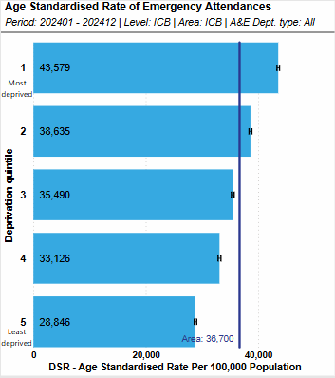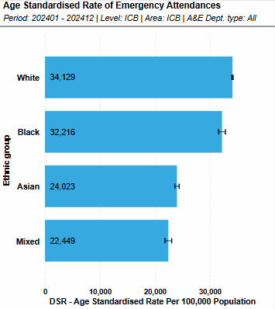

Respiratory
Immunisation is one of the most cost-effective public health interventions, ensuring coverage is not only high overall, but also within underserved communities is essential for disease control and elimination strategies. Immunisation against respiratory illnesses such as flu and covid, particularly in groups who have additional risk factors for illness, can prevent the worsening of existing health conditions and prevent hospital admissions. Respiratory illnesses are currently the second highest reason for emergency admissions for people living in the most deprived populations.

Uptake of covid and flu vaccinations by age and demographic
Vaccination rates for both covid and flu are lowest across younger age ranges, Black, Mixed, Asian and Other ethnic groups and for those in the most deprived IMD quintiles. Rates increase for all ethnic groups in the least deprived quintiles, although coverage remains lower than for the White ethnic group. This data is shown below in figures 14, 15, 16 and 17. These trends have remained the same throughout the 2023/24 and 2024/25 vaccination seasons.

Figure 14 The proportion of all eligible patients with a flu vaccination by age, as of March 2025
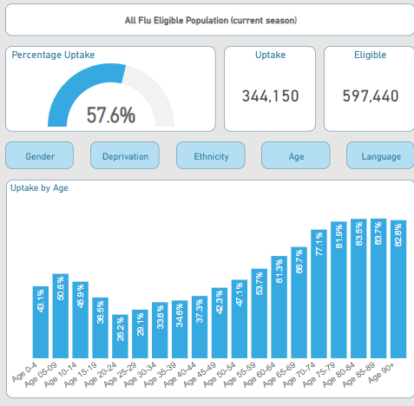

Figure 15 The proportion of all eligible patients with a flu vaccination by deprivation decile, March 2025
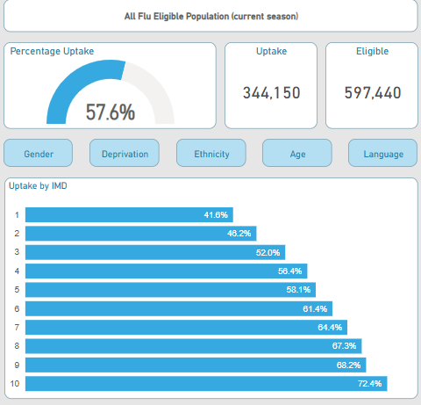

Figure 16 The proportion of patients aged 18+ with a flu vaccination by ethnicity, March 2025
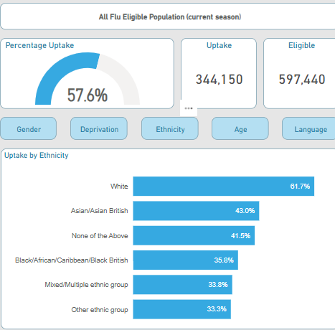

Figure 17 The proportion of patients aged 12+ with a Covid vaccination by deprivation and ethnicity, March 2024
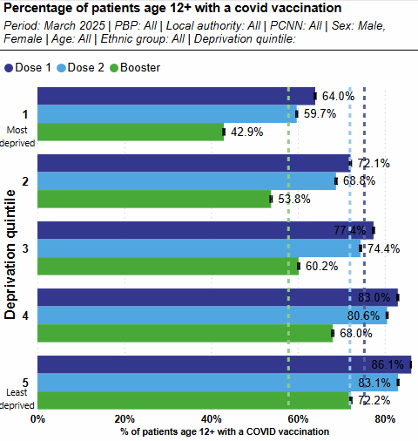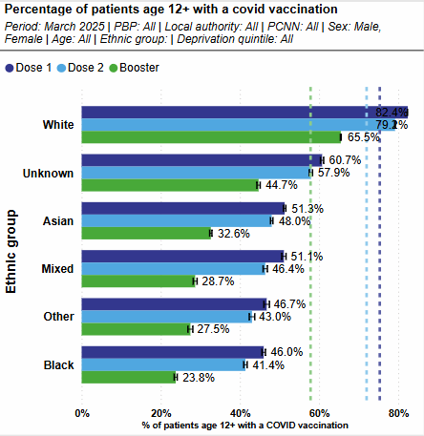

Mental Health
Mental health problems can affect anyone and have a significant effect on the lives of individuals, their families, communities and wider society. Research in 2018 found that over the course of a week, 1 in 6 adults had experienced a common mental health disorder, such as anxiety.
People with severe and enduring mental illness are at greater risk of poor physical health and reduced life expectancy compared to the general population. Patients with severe mental illness (SMI) on average have a life expectancy 15-20 years shorter than the general population. Smoking rates within this population are over 40% nationally, which is much higher than the national smoking rate of 12.9% in the general population.
People experiencing poor mental health are less likely to be in employment, more likely to experience social isolation, and more likely live in poor quality housing or in a less safe area. Children who experience poor mental health may have poorer educational attainment and school attendance and may be at an increased risk of worsening mental and physical health into adulthood. These factors increase the risk of health inequalities an individual may face.

Overall number of severe mental illness (SMI) physical health checks
It is estimated that for people with SMI, 2 in 3 deaths are from physical illnesses that could be prevented. Major causes of death in people with SMI include chronic physical medical conditions such as cardiovascular disease, respiratory disease, diabetes and hypertension. Physical health checks provide opportunity to spot the signs of these conditions early as well as valuable contact with a health professional. Monitoring of SMI Physical Health Checks also forms part of the Core20 Plus 5 national approach to reducing health inequalities and places a focus on improving uptake across ethnic minority groups.
In March 2025, 67% of people with SMI received a health check, exceeding the target figure of 60%. Figure 18 shows the breakdown of completed SMI checks by deprivation and by ethnicity. A lower proportion of checks were completed in people from IMD quintile 1, with a 10 percentage point gap in uptake of checks between the most and least deprived populations. By ethnicity, those from Asian, Black, Mixed, and unknown ethnic groups are less likely to have a completed check than those from White ethnic groups. Uptake across all ethnic groups has remained similar to 23/24 levels.

Figure 18 The rate of patients with an SMI Health check by deprivation and ethnicity
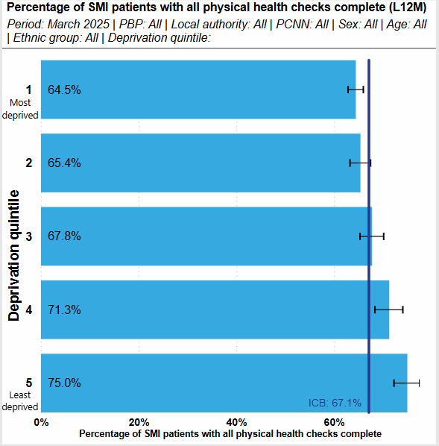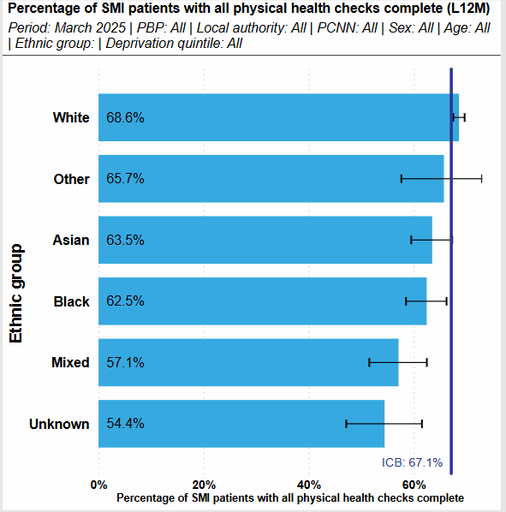

Rates of total Mental Health Act detentions
The chart below shows the crude rate of detentions under the mental health act by deprivation quintile, taken from the national data set Mental Health Act Statistics, Annual Figures 2023-2024. The rate uses the GP-registered population for the denominator. Those living in the most deprived areas are significantly more likely to have been detained under the Mental Health Act.
Figure 19 The count of detentions under the Mental Health Act by deprivation 2023/2024.
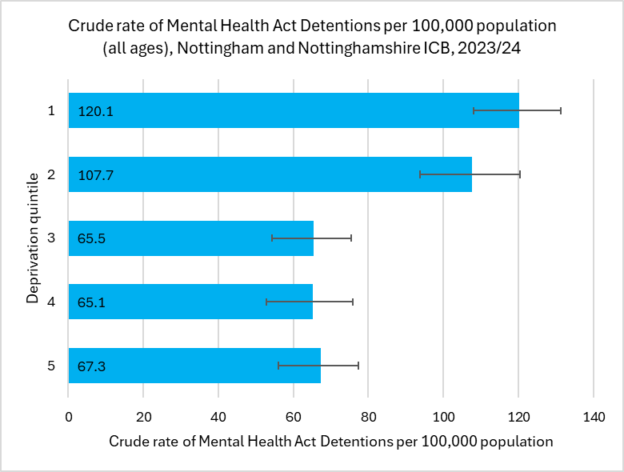
The chart below shows the crude rate of Mental Health Act detentions by ethnicity, again using the GP-registered population for the denominator. The chart shows there is a higher rate of detentions of those from Other and Black ethnic groups in comparison to those from a White or Asian ethnic group. However, this data should be interpreted with caution as crude rates can provide only a basic understanding of whether there is under or over representation between population groups. In addition there are further complexities surrounding interpretation of this data; age, severity and the point of contact with the system can be contributing factors impacting on restrictions used and are not reflected in this data set. It is the longer-term aim of the ICB to continue working with Trusts to help interpret and understand this data in a standardised way which will help to identify any disparities more clearly. This will also allow us to identify any additional factors contributing to these disparities, such as point of access to the system, which could highlight further inequalities regarding access and experience.
Figure 20 The crude rate of detentions under the Mental Health Act by ethnicity, 2023/2024
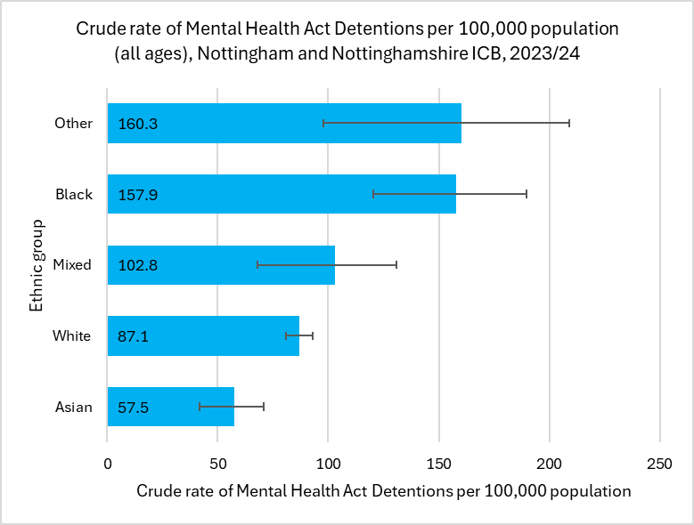

Rates of restrictive interventions
The charts below show the rate of restrictive interventions in NHS funded secondary mental health, learning disabilities and autism services per 1,000 bed days, broken down by the deprivation quintile and ethnicity of the patient. By using bed days as the denominator, this measure allows us to understand inequalities in the frequency of mental healthcare staff deciding to use a restrictive intervention for a specific group rather than just providing a proxy for the rate of mental health inpatients for the population overall. Restrictive interventions are more frequently used for those living in the most and the least deprived areas. By ethnicity, restrictive interventions are used less frequently for Asian mental health inpatients, and more frequently for mental health inpatients of mixed ethnicity.
Figure 21: The crude rate of detentions under the Mental Health Act by ethnicity, 2023/2024
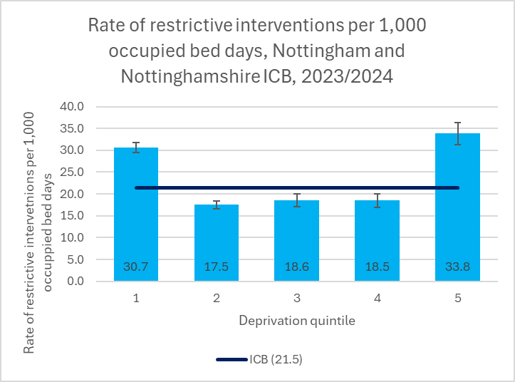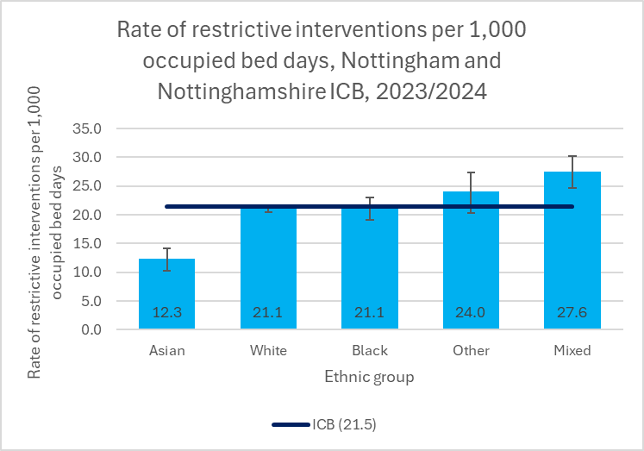

NHS Talking Therapies recovery rate
Talking therapies are psychological treatments for mental and emotional problems like stress, anxiety and depression. The Talking Therapy recovery rate for the ICS is currently 50.4%, which is similar to the 2022/2023 figures of 51.2% included in the previous statement. This is within the range of the national target figure of 50%. The charts below show there is a 14 percentage point gap in the recovery rates between the most and least deprived areas. The recovery rate amongst all ethnic minority groups except Black and Other is also lower than White ethnic groups.
Figure 21 The rate of talking therapies recovery by deprivation and ethnicity.
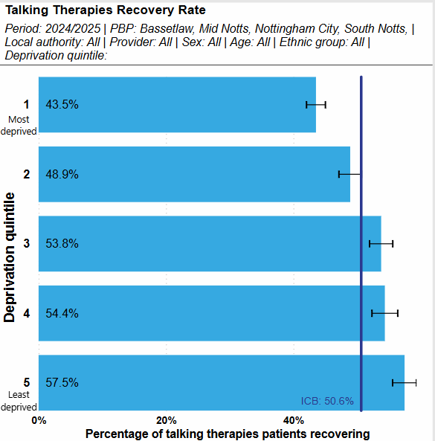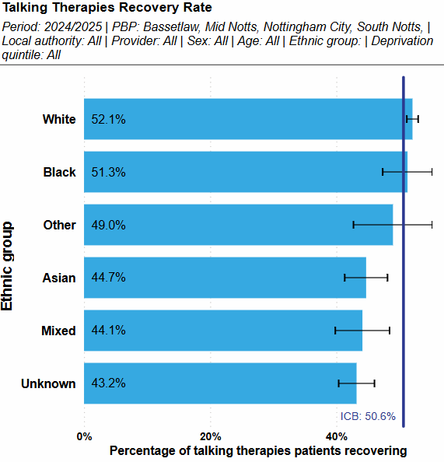

Children and Young People’s (CYP) Mental Health Access
The charts below show the rate of children and young people age 0-17 who had contact with a mental health service in 2023/2024 by deprivation and ethnicity. This shows rates are higher than the ICB overall in the most deprived IMD quintile and lower than the ICB in the least deprived quintiles. The high numbers of contacts with ‘Unknown’ or ‘Other’ ethnicity make comparisons by ethnic group difficult. However, where ethnicity is known, Black and Asian CYP appear to have a significantly lower rate of contact with mental health services.
Figure 22 Rate of CYP with a mental health first contact in the last 12 months, by deprivation and ethnicity
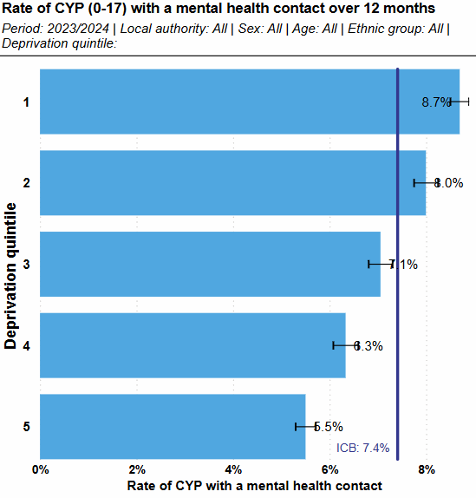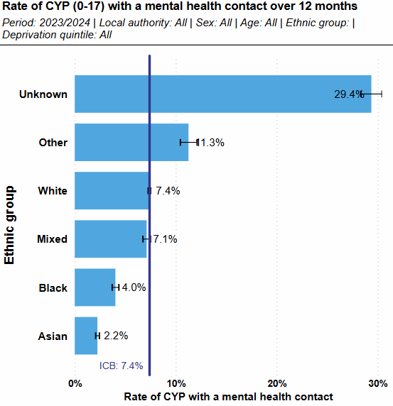

Cancer
Cancer is one of the leading causes of the inequality in life expectancy across Nottingham and Nottinghamshire, contributing between 18-21% of the life expectancy gap between the most and least deprived areas. Breast, prostate, lung and bowel cancers are the most common cancers in the UK, however around a fifth of all cancer deaths are from lung cancer. Around 38% of cancers are estimated to be preventable, with many cases attributed to lifestyle factors such as smoking, obesity, alcohol consumption, and poor diet. There may also be occupational risks which could increase the risk of cancer.
Populations with higher deprivation often have higher prevalence of cancer risk factors. These populations may also be less aware of symptoms of cancer and report more barriers to seeking help, participation in screening programmes is lower and there are higher proportions of cancer diagnosed through routes with worse survival outcomes.

Percentage of cancers diagnosed at stage 1 and 2, case mix adjusted for cancer site, age at diagnosis, sex
Data on cancer diagnosis is available through the East Midlands Cancer Alliance as well as nationally published data through the National Disease Registration Service. The previously published statement contained data on cancers diagnosed at stage 1 or 2 between 2018 and 2020. The ICB has now moved to reporting cancer staging data by year for health inequalities.
Between 2021 and 2022, the overall percentage of cancers diagnosed in the early stages increased by two percentage points from 55% to 57%. Rapid registrations statistics from the East Midlands Cancer Alliance up to March 2024 indicate this figure may have improved further with potentially 61% of cases being diagnosed at stage 1 or 2, however these figures are awaiting formal verification and publication. These figures are, however, still below the national target of 75% of cancers diagnosed in stage 1 or 2
The most recently available verified data shows there is a significant gap between those living in the most and least deprived quintiles, with 51% of cancers diagnosed early for IMD quintile 1, and 62% of cancers diagnosed early for IMD quintile 5. There are no statistically significant differences between ethnic groups where the ethnicity is known.
Figure 23 Proportion of stageable cancers diagnosed at stage 1 or 2 by deprivation quintile and ethnicity as of 2022
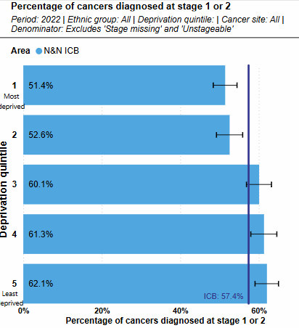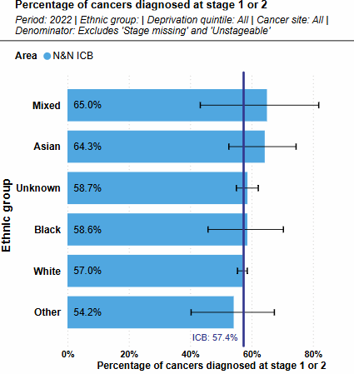

Cardiovascular Disease (CVD)
CVD is an umbrella term for conditions which affect the heart and circulatory system. CVD is one of the leading causes of the gap in life expectancy between the least and most deprived across Nottingham and Nottinghamshire.
Ashfield has overtaken Nottingham City as area with the highest premature mortality from CVD in the ICS, with a rate of 124.6 per 100,000 deaths from CVD under age 75 this is the 5th highest rate in England and an increase of 37.5 since 2021 and 2022 data. Nottingham City rates are 113 per 100,000, which has decreased since 2021 data reported in the previous statement of 131 per 100,000. This figure remains double the rate of Rushcliffe, the least deprived area of the ICS at 52 per 100,000. Ethnicity can also increase the risk of developing some cardiovascular conditions; Black African/Caribbean or South Asian ethnic groups are two ethnic groups which may have an increased risk of development.
Hypertension is the leading preventable risk factor for CVD development and mortality. The risk of hypertension development is higher in areas of deprivation. People from Black African/Caribbean ethnic groups are also more likely to develop hypertension and are also disproportionally more likely to live in areas of high deprivation in the ICS.

Stroke - rate of non-elective admissions (per 100,000 age, sex standardised)
Stroke is a form of CVD. The charts below show the age standardised admissions for Stroke across the ICB by deprivation and ethnicity. Rates of admission are higher in the most deprived populations and are lowest in the least deprived populations.
Data for 2024 shows there was a slight reduction in the age standardised rates of stroke admissions for those in the most deprived areas, however larger reductions were seen in the least deprived areas, meaning the gap has widened. Where ethnicity is known, emergency admission rates for Stroke are similar across ethnic groups.
Figure 24 Age standardised rates for non-elective stroke admission by deprivation and ethnicity 2024
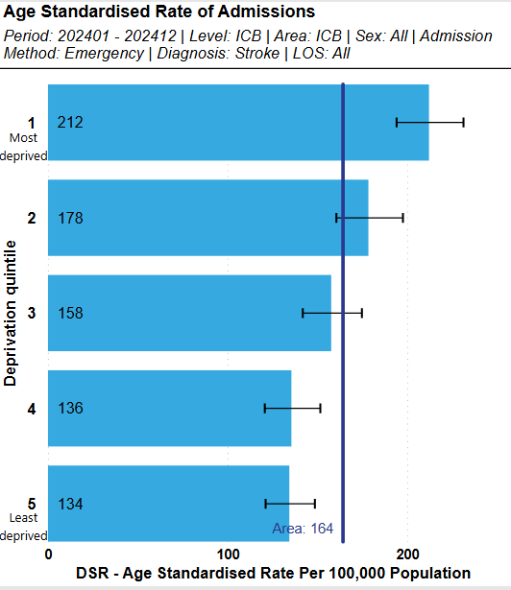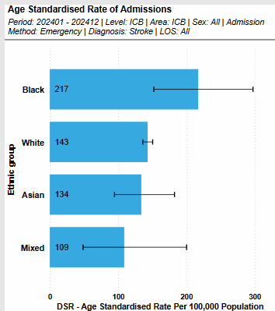

Myocardial infarction – rate of non-elective admissions (per 100,000 age-sex standardised)
Myocardial infarction is also a form of CVD. The overall rate of admissions for myocardial infarction reduced from 2023 to 2024. However, rates remain significantly higher in people for the most deprived populations and lower for those in the least deprived populations. Numbers are too small and ethnicity coding too unreliable to draw reliable conclusions about the differences in myocardial infarction for admissions by ethnicity.
Figure 25 Age standardised rates for non-elective myocardial infarction admission by deprivation and ethnicity Jan 2024 – Dec 2024
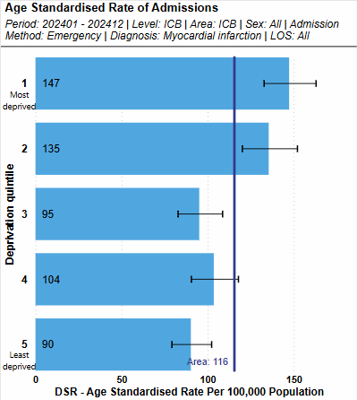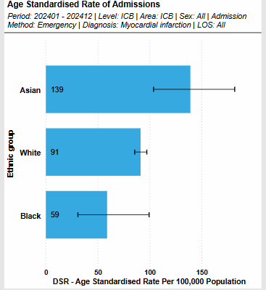

Percentage of patients aged 18 or over with GP recorded hypertension, in whom the last blood pressure reading in the preceding 12 months is below age-appropriate treatment thresholds (indicator of optimal condition management)
Hypertension (high blood pressure) is the leading modifiable risk factor for CVD development. A blood pressure reading within age-appropriate thresholds for people diagnosed with hypertension is an indicator of optimal management of the condition. In the long term, optimal management will improve patient outcomes, reducing the risk of heart attacks, strokes and other complications resulting from high blood pressure.
Across the ICS, older adults and females are more likely to be within these thresholds, indicating better management within these groups. However, those from the most deprived areas are less likely to be within these thresholds as highlighted in the chart below. This could lead to an increased risk of serious illness from the effects of having high blood pressure in these cohorts. People from White ethnic groups are more likely, and those from all other ethnic groups less likely, to meet these targets. Figures have remained similar in the last year when comparing March 2025 data to 2024 data.

Figure 26 Percentage of hypertensive patients with their latest blood pressure reading within age-appropriate thresholds by deprivation and ethnicity, March 2025
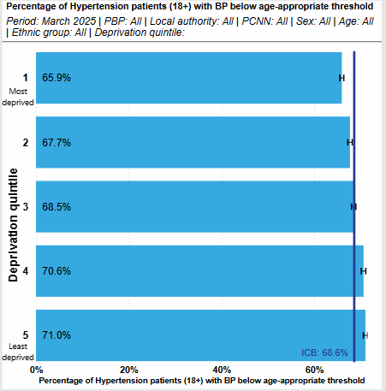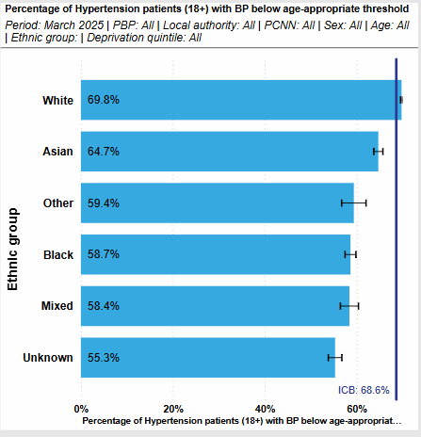

Percentage of patients aged 18 and over with no GP recorded CVD and a GP recorded QRISK score of 20% or more, on lipid lowering therapy
Over the last 12 months, the overall percentage of eligible patients on lipid lowering therapy has remained at a similar level to March 2024. Those living in the most deprived areas are more likely than those living in the least deprived areas to be treated with lipid lowering therapy, reversing the usual link between deprivation and poorer treatment uptake. This pattern is is also true for England overall. The gap between the most and least deprived has narrowed slightly in the last year as lipid uptake has increased in the least deprived areas.
Figure 27 also shows Asian patients are the most likely within this cohort to be on lipid lowering therapy. Between the other main ethnic groups there are no statistically significant differences.
Figure 27 Proportion of patients aged 18+, no CVD and a QRISK score above 20% on lipid lowering therapy by deprivation and ethnicity, March 25.
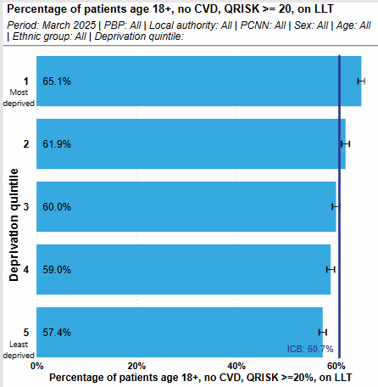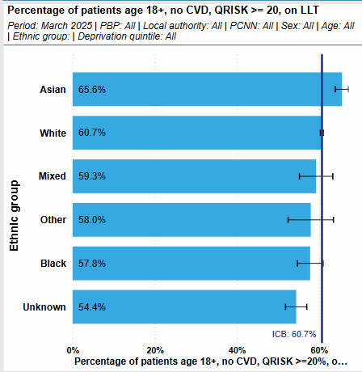

Percentage of patients aged 18 or over with GP recoded atrial fibrillation and a record of CHA2DS2-VASc Score of 2 or more who are currently treated with anti-coagulation drug therapy
There are no statistically significant differences by ethnic group or deprivation quintile for this indicator. The overall performance for this indicator has remained similar over the last 12 months.
Figure 28 Percentage of patients aged 18+ with Atrial Fibrillation and a record of CHA2DS2-VASc score 2 or more treated with anti-coagulation drug therapy by deprivation and ethnicity, March 2025
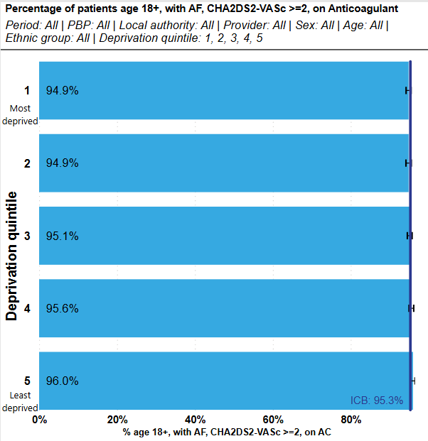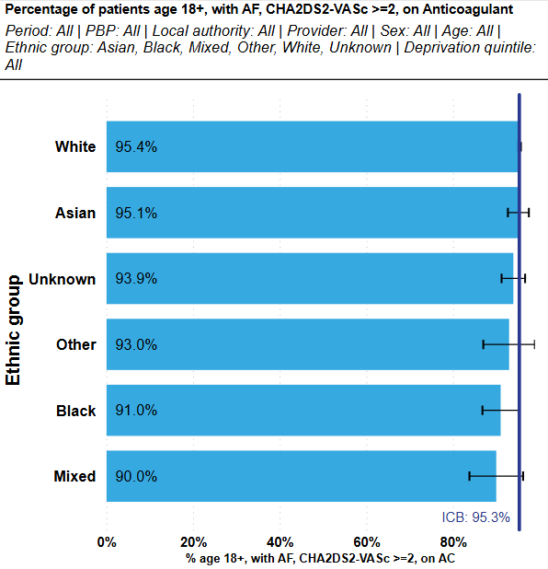

Diabetes
Type 1 Diabetes is an autoimmune condition where the body cannot produce insulin and cannot be prevented. Differently, with Type 2 Diabetes the body can still produce insulin, however it is unable to produce enough insulin or the insulin produced by the body is not working well enough for optimal health. Type 2 diabetes can be prevented through lifestyle factors, with obesity being the main driver in development of the condition. The risk of development also increases with age, family history and ethnicity (South Asian and Black African/Caribbean ethnic groups have a higher risk). Type 2 diabetes is often more prevalent in areas of higher deprivation where people may be more likely to experience lifestyle risk factors associated with its development. Across the ICS, 30.5% of the Type 2 diabetic population are from IMD quintile 1, the most deprived quintile.
Diabetes can weaken the body’s immune system which can increase the risk of poorer outcomes from ill health. The consequences of uncontrolled diabetes are also severe and can be life changing, for example developing chronic kidney disease or requiring limb amputation.

Variation between percentage of people with Type 1 and Type 2 Diabetes receiving all 8 care processes.
The 8 care processes are key health markers identified by NICE Guidance for the treatment of diabetes and are an importance factor in ensuring positive patient outcomes and preventing complications associated with the condition. The 8 care processes should be checked annually. For patients with type 1 diabetes this is usually within a hospital setting, for patients with type 2, this is often managed within primary care.
The charts below show the variation in completed 8 care processes for type 1 and type 2 diabetics by deprivation. There is a clear correlation between deprivation and achieving all 8 care processes for Type 2 diabetes with those in the least deprived quintile 1.3 times more likely to achieve all eight than those in the most deprived quintile.
By ethnicity, for type 1 diabetes, those of mixed heritage are less likely to have all care processes completed. For type 2 diabetes, white patients are more likely than all other ethnicities to have all care processes completed.
Figure 29 Percentage of people with all 8 care processes complete for Type 1 vs Type 2 Diabetes by deprivation quintile (March 2024 - March 2025)
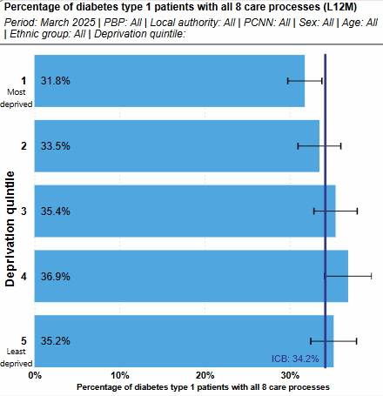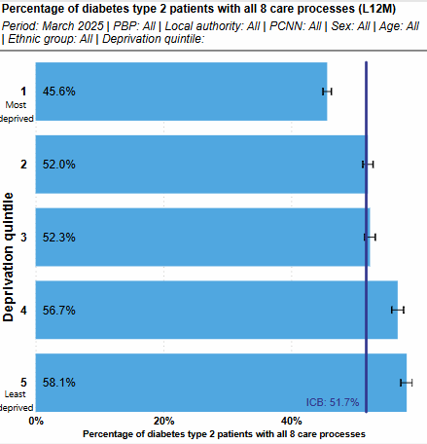

Figure 30 Percentage of people with all 8 care processes complete for Type 1 vs Type 2 Diabetes by ethnicity (last 12 months)
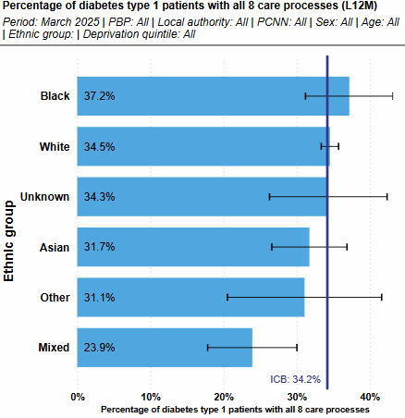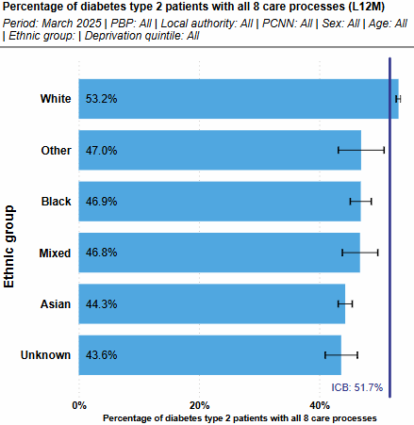

Variation between percentage of referrals to the National Diabetes Prevention Programme from the most deprived quintile and percentage of Type 2 Diabetes from the most deprived quintile
The National Diabetes Prevention Programme (NDPP) identfies people at risk of Type 2 diabetes and offers the opportunity to take part in a 9 month lifestyle programme with the aim to prevent the condition developing.
Referals to the NDPP have increased by 7% in the last 12 months. Despite this uptake is still lower in the most deprived areas and the difference in uptake between the most and least deprived areas has widened from 5 to 8 percentage points. There are not statistically significant diffferences by ethnicity where ethnic group is known
Figure 31 Percentage of people at risk of Type 2 Diabetes referred to the NDPP by deprivation and ethnicity, March 2025
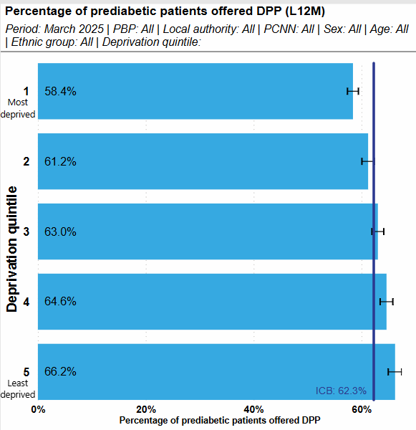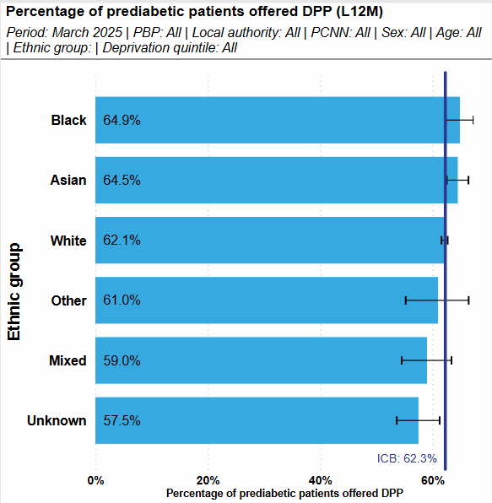

Smoking Cessation
Smoking is the leading cause of health inequalities and accounts for half of the difference in life expectancy between the most and least affluent communities in England. An estimated 12% of the Nottingham and Nottinghamshire population aged 18+ are current smokers. This is a 4% decrease on the data included in the previous statement and is now similar to the England average, previously the ICS average was worse.
Despite reductions in the overall figures, there are still disparities with higher smoking rates often within areas of high deprivation. Nottingham City has the highest smoking rates at around 18%, followed by Broxtowe at 14%. In 2021, Mansfield had the highest smoking rates at 25%, however 2023 data shows a significant decrease to 13%. Ashfield is one of the most deprived districts in the ICS but has seen reductions in smoking rates since 2011, when rates were as high as 28%. As of 2023, figures were at 7% which is now significantly better than the England average.
NHS partners are members of the Nottingham and Nottinghamshire Smoking and Tobacco Alliance, led by Public Health. The Alliance brings together partner organisations including Nottingham City Council and Nottinghamshire County Council, to work towards eliminating smoking and tobacco-related harm, creating a smoke-free generation for Nottingham and Nottinghamshire by 2040.
The Alliance has published the Nottingham and Nottinghamshire Smoking and Tobacco Long Term Vision which confirms a clear and shared ambition to see smoking amongst adults reduced to 5% or lower by 2035 as well as ensuring those born in 2022 remain smoke free by their 18th birthday to help create a smoke-free generation. There are four key delivery themes of the vision:
- Helping vulnerable people quit smoking: A particular focus on more deprived communities, those in social housing, working in manual and routine jobs, those with poor mental health and those with multiple needs such as homelessness.
- Effective regulation of tobacco products
- Reducing exposure to second hand smoke
- Prevention and engagement with children and young people
Key actions within each of the four areas and can be viewed within the vision Statement here: 43.114-Smoking-and-Tobacco-Control-Vision.pdf (mynottinghamnews.co.uk)

Proportion of adult acute inpatient settings offering smoking cessation services
100% of adult acute inpatient settings offer smoking cessation services across Nottingham and Nottinghamshire.
Smoking tobacco is linked to just over 500,000 hospital admissions each year, with smokers being 36% more likely to be admitted to hospital than non-smokers. Smoking tobacco is linked to over 100 different conditions. Stopping smoking results in an improved response to cancer treatments, faster recovery after surgery, fewer exacerbations of cardiovascular disease, slower decline in lung function, lower pharmacotherapy costs and a beneficial impact on long-term levels of depression and anxiety. Increasing access to tobacco treatment services whilst in hospital can help improve quit rates, continued support in the community following discharge is also an important part of the pathway to ensure continued positive outcomes for patients.

Proportion of maternity inpatient settings offering smoking cessation services
100% of maternity inpatient settings offer smoking cessation services across Nottingham and Nottinghamshire.
Smoking is also the single greatest modifiable risk factor for poor outcomes in pregnancy. The harms associated with smoking relate not only to the mother but also to the unborn child, where we see a doubling of the likelihood of stillbirth and tripling of the likelihood of sudden infant death. Smoking rates are higher amongst those in the most deprived areas. The service offer aims to help pregnant people who smoke set quit dates to reduce risks during pregnancy.

Oral Health
Tooth decay is the most common oral disease affecting children and young people in England, yet it is largely preventable. Almost 9 out of 10 hospital tooth extractions among children aged 0 to 5 years are due to preventable tooth decay and tooth extraction is still the most common hospital procedure in 6 to 10 year olds, according to data up to 2019. Data also shows that children in the most deprived populations have more than twice the level of tooth decay than those in the least deprived areas.

Tooth extractions due to decay for children admitted to hospital aged 10 and under (number of admissions)
The overall number of children admitted as inpatients to hospital tooth extractions in Nottingham and Nottinghamshire is relatively small, with between 100 and 150 extractions each year. In 2023/24 there were 93 extractions in under 10s.
In 2023/24, Bassetlaw remains the highest locality for tooth extractions in under 10s. As numbers are so low, there is no statistically significant variation by deprivation or ethnicity.

Figure 32 Rate and count of tooth extraction admissions in under 10s by deprivation quintile, 2023/24
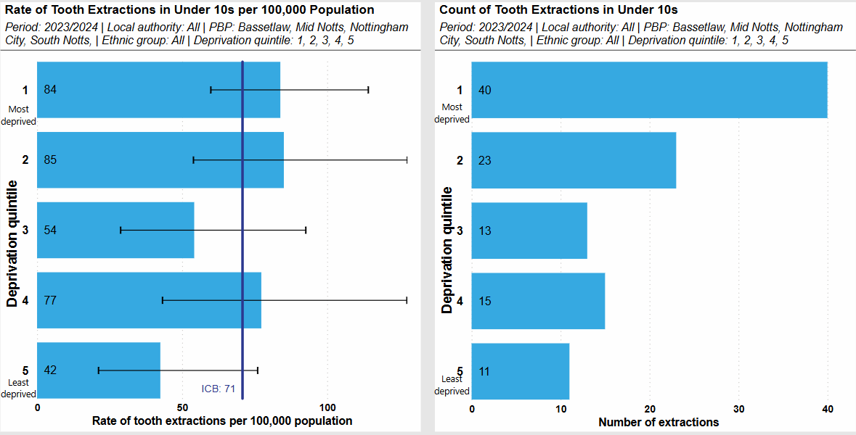

Figure 33 Rate and count of tooth extraction admissions in under 10s by ethnicity, 2023/24
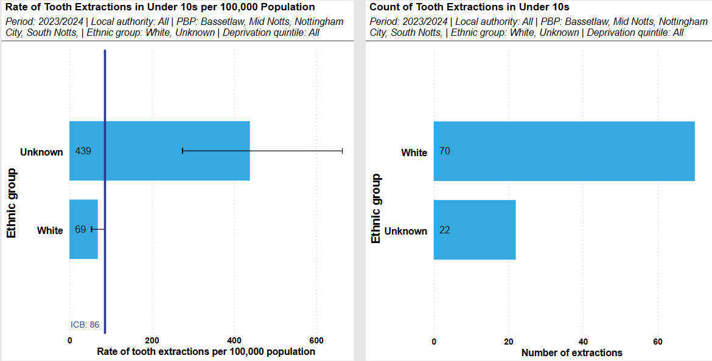

People with Learning Disabilities and Autistic People
Health Inequalities are evident in people with Learning Disabilities, with the average life expectancy around 20 years less in this population group. Further data indicates that 49% of deaths in this group were from avoidable causes. Annual health checks enable contact with a health professional to spot early signs of illness and prevent conditions worsening.

Learning disability annual health checks
As of March 2025, 83% of people with a learning disability (age 14+) had an annual health check completed in the previous year. The rate of checks is lower in IMD quintiles 1 and 3. While the percentage of checks completed is also below the ICS average for several ethnicity categories, these differences are not statistically significant. Those in younger age categories (below age 33) also have a lower rate of checks than older age categories. Figures have remained similar to those from March 2024.
Figure 34 Rate of completed learning disability health checks by deprivation and ethnicity, March 2025.
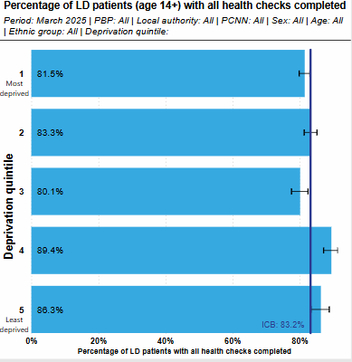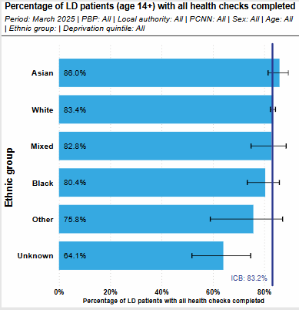

Adult mental health inpatient rates for people with a learning disability and autistic people
Based on the Learning Disability: Assuring Transformation Dataset, there were 40 mental health inpatients who were registered with a Nottingham and Nottinghamshire GP and had a learning disability or autism at the end of February 2025. This equates to 42 per million adult population, which is similar to England overall. Around 41% of this group had learning disabilities only, 44% had autism only, and the remainder had both learning disabilities and autism. This is a broadly similar composition to England considering the small number of patients involved.
Data broken down by deprivation and ethnicity is not available for this indicator.
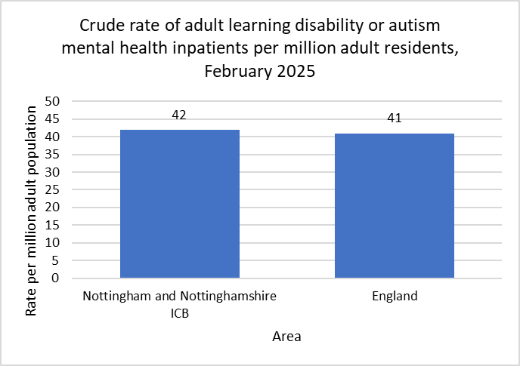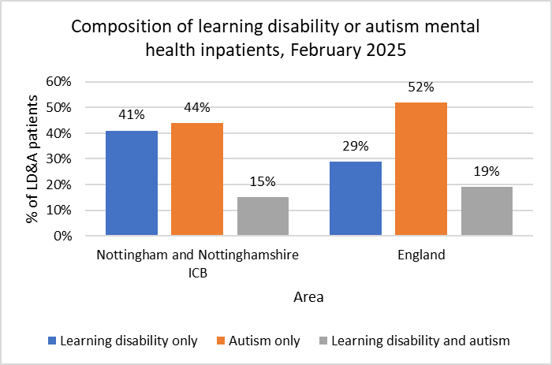

Maternity and Neonatal

Pre-term births under 37 weeks
Complications from premature birth remains one of the three main causes for infant mortality in the UK. The Marmot Review 2010 stated that one quarter of all deaths under the age of one would potentially be avoided if all births had the same level of risk as those to women with the lowest level of deprivation.
As shown by the charts below, those in the most deprived IMD Quintile have the highest count of pre-term births, and are 1.3 times as likely to have a preterm birth than those in the least deprived quintile. Pre-term births by ethnic group are also presented, however numbers of pre-term births where the ethnicity of the mother is known are too small to show statistically significant differences.
Figure 35 Rate and count of preterm births by deprivation, 2023/24
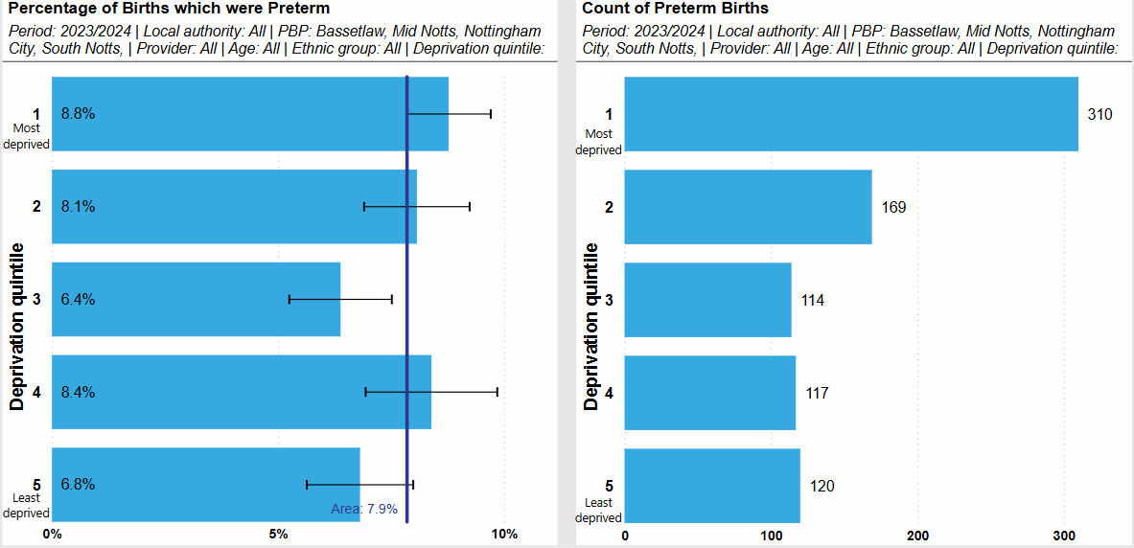

Figure 36 Rate and count of preterm births by ethnicity, 2023/24
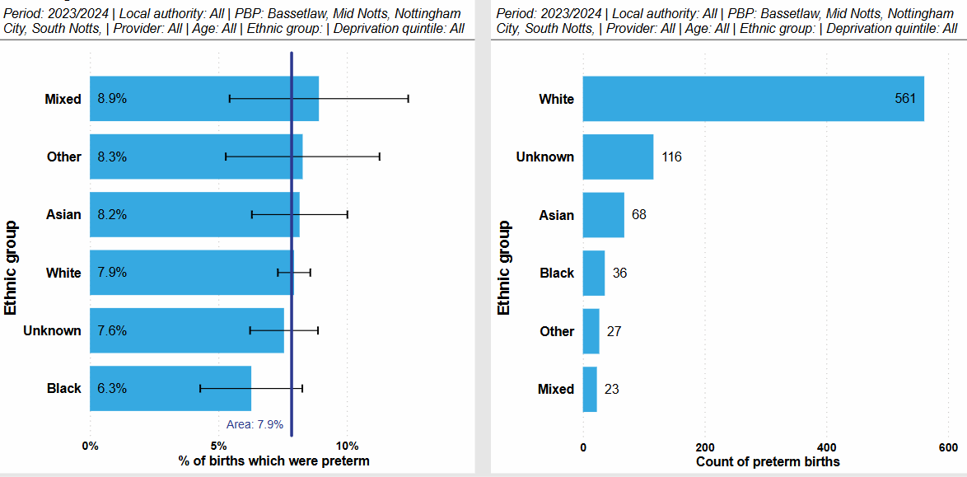

Data Quality
The data used in this statement has been take from the suggested NHS England data sources as well as local primary and secondary care data where available.
Efforts have been taken to ensure data sources are complete and valid. Data Quality is part of Contract and/or Information review meetings led by Contracting Teams. Data quality issues are raised and discussed as part of these meetings, usually when problems are identified.
However, it should be noted that within ethnicity coding, “Not Stated” is considered a valid code, in addition the category “other” may also be used incorrectly for example in instance’s when ethnicity is not stated or unconfirmed. This may result in a distorted view of differences by ethnicity for some indicators.
  - Impact of ethnicity coding quality on the calculation of rates from secondary care data
The population denominators used for indicators presented here are based on the Nottingham and Nottinghamshire ICB GP-registered population. Ethnicity coding in the GP-registered population is generally near-complete, with only 5% of patients having an unknown ethnicity, either because they have declined to share their ethnicity or it hasn't been recorded.
Secondary care data sources, such as SUS and the Waiting List Minimum Dataset, tend to have a significantly higher proportion of 'Unknowns', often between 10 and 25%. Additionally, the number of patients in secondary care data sources with an 'Other' ethnicity is substantially higher than would be expected for the GP-registered population.
When crude or age-standardised rates are calculated with a secondary care data source as the numerator and the GP-registered population as the denominator this produces a distorting effect when viewed by ethnicity due to the mismatch between the numerator and denominator: Rates for the 'Unknown' and 'Other' populations appear to be excessively high, and rates in smaller ethnic groups (Asian, Black, Mixed), for which missing a small number in the numerator has a greater effect, are likely depressed.
Crude and age-standardised rates based on secondary care data should be interpreted with caution when broken down by ethnic group. For age-standardised rates, 'Unknown' and 'Other' ethnic groups have been omitted.
For further information, please see the below tables which detail the Nottingham and Nottinghamshire GP Population breakdown by ethnicity and the validity of ethnicity coded within secondary provider trusts.
Nottingham and Nottinghamshire ICB GP-registered population by ethnicity, March 2025
Ethnic Group | % of population | Count of population
White | 75.8% | 969,328
Asian | 9.5% | 121,494
Unknown | 4.7% | 60,336
Black | 4.6% | 53,563
Mixed | 3.5% | 45,211
Other | 1.8% | 23,459

Ethnicity coding validity for Nottingham and Nottinghamshire Secondary Care providers
The table below details the percentage of patients with a valid ethnicity code for Secondary Care Providers in comparison with the national average based on the Data Quality Maturity Index for ethnicity fields. The DQMI accepts ethnicity codes which are not null or 99 (Not known) as valid. Z (Not Stated) is considered a valid code. Nottingham and Nottinghamshire Secondary Care providers generally perform better than the national average for ethnicity coding validity.
In September 2024, Nottingham University Hospitals, the ICS’ largest secondary care provider performed slightly worse than the national average for the Admitted Patient Care Dataset, and Nottingham Citycare Partnership performed worse than the national average for the Emergency Care Dataset.

Table xx Valid ethnicity coding, Data Quality Maturity Index, September 2024
Data Provider Name | Dataset | Org Type | % Valid Ethnicity Coding | National Data Item Average
NOTTINGHAMSHIRE HEALTHCARE NHS FOUNDATION TRUST | APC | NHS TRUST | 93.9 | 87.7
SHERWOOD FOREST HOSPITALS NHS FOUNDATION TRUST | APC | NHS TRUST | 97.6 | 87.7
DONCASTER AND BASSETLAW TEACHING HOSPITALS NHS FOUNDATION TRUST | APC | NHS TRUST | 95.7 | 87.7
NOTTINGHAM UNIVERSITY HOSPITALS NHS TRUST | APC | NHS TRUST | 84.8 | 87.7
NOTTINGHAM CITYCARE PARTNERSHIP | CSDS | INDEPENDENT | 89.6 | 71.7
NOTTINGHAMSHIRE HEALTHCARE NHS FOUNDATION TRUST | CSDS | NHS TRUST | 83.8 | 71.7
NOTTINGHAM CITYCARE PARTNERSHIP | ECDS | INDEPENDENT | 72.3 | 85.9
SHERWOOD FOREST HOSPITALS NHS FOUNDATION TRUST | ECDS | NHS TRUST | 95.1 | 85.9
DONCASTER AND BASSETLAW TEACHING HOSPITALS NHS FOUNDATION TRUST | ECDS | NHS TRUST | 95.9 | 85.9
NOTTINGHAM UNIVERSITY HOSPITALS NHS TRUST | ECDS | NHS TRUST | 87.3 | 85.9
NOTTINGHAMSHIRE HEALTHCARE NHS FOUNDATION TRUST | MHSDS | NHS TRUST | 95 | 67.8
SHERWOOD FOREST HOSPITALS NHS FOUNDATION TRUST | MHSDS | NHS TRUST | 97 | 67.8
NOTTINGHAM UNIVERSITY HOSPITALS NHS TRUST | MHSDS | NHS TRUST | 94.1 | 67.8
NOTTINGHAMSHIRE HEALTHCARE NHS FOUNDATION TRUST | OP | NHS TRUST | 97.5 | 80
SHERWOOD FOREST HOSPITALS NHS FOUNDATION TRUST | OP | NHS TRUST | 96.6 | 80
DONCASTER AND BASSETLAW TEACHING HOSPITALS NHS FOUNDATION TRUST | OP | NHS TRUST | 95.7 | 80
NOTTINGHAM UNIVERSITY HOSPITALS NHS TRUST | OP | NHS TRUST | 84.7 | 80

Because the DQMI treats ‘Not Stated’ as a valid entry, it does not provide a complete view of how many records have a usable ethnicity, and therefore how useful a dataset is for analysis by this dimension.
The Midlands Ethnicity Reporting Dashboard includes records with null, 99 (Not known), and Z (Not Stated) in the percentage of with no ethnicity recorded. Among local NHS providers, Nottingham University Hospitals has a higher percentage of records without an ethnicity recorded compared to other trusts and England. Other providers and local GPs perform better than England on this metric.
Table xx Known ethnicity coding, Future NHS Midland Region Ethnicity Reporting, October 2024
Provider name | Dataset | % Records with no ethnicity recorded October 2024 | National
NOTTINGHAMSHIRE HEALTHCARE NHS FOUNDATION TRUST | APC | 6.9 | 12.1
NOTTINGHAM UNIVERSITY HOSPITALS NHS TRUST | APC | 22.2 | 12.1
SHERWOOD FOREST HOSPITALS NHS FOUNDATION TRUST | APC | 4.4 | 12.1
NOTTINGHAM UNIVERSITY HOSPITALS NHS TRUST | ECDS | 19.9 | 13.9
SHERWOOD FOREST HOSPITALS NHS FOUNDATION TRUST | ECDS | 5.5 | 13.9
NOTTINGHAMSHIRE HEALTHCARE NHS FOUNDATION TRUST | OPA | 10 | 17.6
NOTTINGHAM UNIVERSITY HOSPITALS NHS TRUST | OPA | 22.1 | 17.6
SHERWOOD FOREST HOSPITALS NHS FOUNDATION TRUST | OPA | 5 | 17.6
NOTTINGHAMSHIRE HEALTHCARE NHS FOUNDATION TRUST | MHSDS | 5 | 12
N&N ICB 52R (Nottinghamshire Sub-ICB) | GPES | 6.6 | 9
N&N ICB 02Q (Bassetlaw Sub-ICB) | GPES | 5.6 | 9

What are health inequalities? 2022 What Are Health Inequalities? | The King's Fund (kingsfund.org.uk)
Inequalities in Accident and Emergency department attendance, England: March 2021 to March 2022 Inequalities in Accident and Emergency department attendance, England - Office for National Statistics (ons.gov.uk)
Inclusion Health: Applying all our health 2021 Inclusion Health: applying All Our Health - GOV.UK (www.gov.uk)
Health matters: reducing health inequalities in mental illness (2018) Health matters: reducing health inequalities in mental illness - GOV.UK (www.gov.uk)
Severe mental illness (SMI) and physical health inequalities: briefing (2018) Severe mental illness (SMI) and physical health inequalities: briefing - GOV.UK (www.gov.uk)
Mental Health Act Statistics Annual figures 2023-24 Mental Health Act Statistics, Annual Figures, 2023-24 - NHS England Digital
NHS England, Mental Health Bulletin, 2023-24 Annual report, Chapters 4 and 7 data tables
Cancer statistics UK Cancer Statistics for the UK (master-7rqtwti-hreqyzlibi4ac.uk-1.platformsh.site)
Cancer in the UK 2020: Socio-economic deprivation Cancer in the UK 2020: socio-economic deprivation (cancerresearchuk.org)
OHID, Fingertips, Under 75 mortality rate from cardiovascular disease (Persons, 1 year range)
Public Health England 2017, Health matters: combating high blood pressure https://www.gov.uk/government/publications/health-matters-combating-high-blood-pressure/health-matters-combating-high-blood-pressure
Differences between type 1 and type 2 diabetes Differences between type 1 and type 2 diabetes | Diabetes UK
Smoking and Health Inequalities 2019 ASH-Briefing_Health-Inequalities.pdf
OHID, Fingertips, Smoking prevalence in adults (aged 18 and over) – current smokers (APS) 2023
Tobacco Dependency Programme 2019 NHS England » Tobacco dependency programme
Child oral health: applying All Our Health 2022 Child oral health: applying All Our Health - GOV.UK (www.gov.uk)
Learning disability - applying All Our Health (2023) Learning disability - applying All Our Health - GOV.UK (www.gov.uk)
NHS England, Learning Disability Services Monthly Statistics, AT: February 2025

