Winter messaging
Suggested copy | Image | Alt text
NHS 111
Need medical help?  Use 111 online to get assessed and directed to the right place for you, like a consultation with a pharmacist.  ➡️More info: http://nhs.uk/111 | 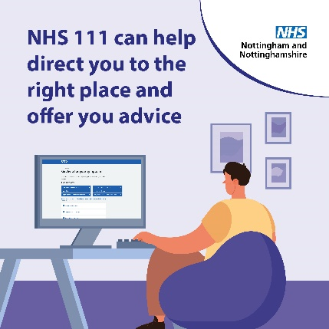
If you need medical help, visit NHS111 or call 111 to find the right service for your needs.  Please only attend A & E in a life-threatening emergency.  👇  https://111.nhs.uk | 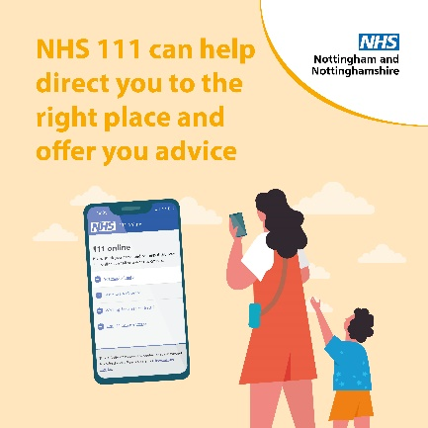
Children
It’s never nice to see your child unwell.  Our website has information on a range of common illnesses such as rashes, coughs, colds, tummy aches, head injuries, difficulty breathing and much more.  Take a look: https://notts.icb.nhs.uk/your-services/childrens-health-and-wellbeing/ | 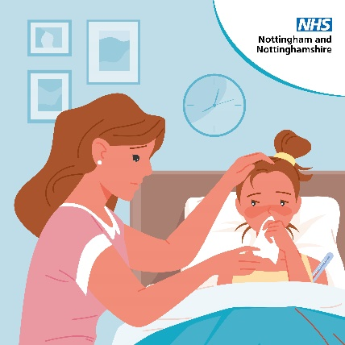
Children can catch and spread illnesses easily.  When it's urgent but not an emergency, visit NHS 111 online:  🏘️ Get the advice you need at home  👩‍⚕️ Get a face-to-face timeslot if you need one  🚨 In an emergency, always call 999 | 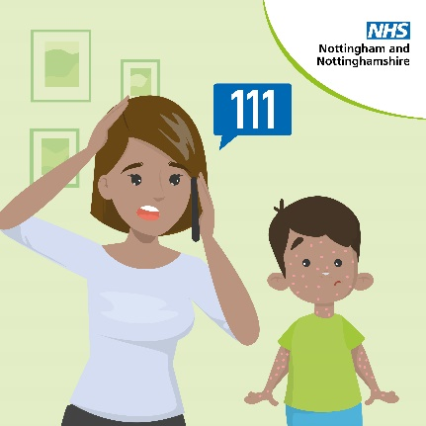
If your child needs medical help, please remember the NHS is still here for you.  You can contact your pharmacy, GP, 111 online or call 111 for help.  We also have a range of information on our website. Take a look: https://notts.icb.nhs.uk/your-services/childrens-health-and-wellbeing/ | 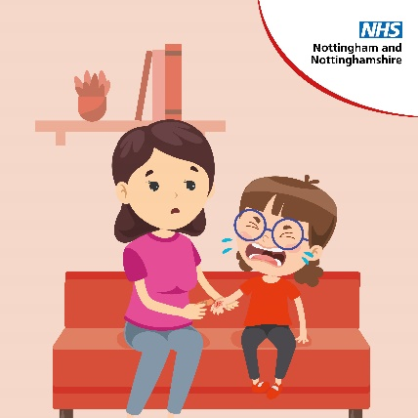
Community pharmacists are highly qualified healthcare professionals, who offer clinical advice and treatment for common illnesses, at a time convenient for you.  Find your nearest pharmacy ➡ https://ow.ly/kqFg50Q1uhr | 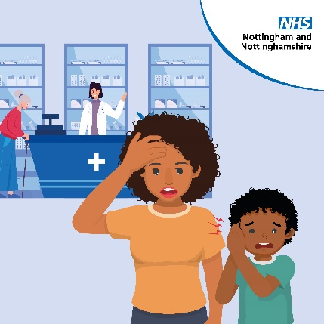
Did you know there is lots of information on our website about children's illnesses and how to treat them?  It includes information on rashes, coughs, colds, tummy aches, head injuries, difficulty breathing and much more.  Take a look: https://notts.icb.nhs.uk/your-services/childrens-health-and-wellbeing/ | 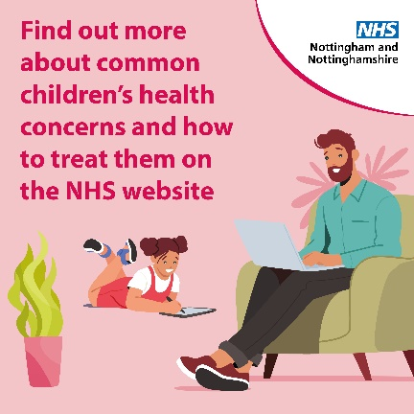
Pharmacy
Got a minor illness? Your local pharmacy team is highly trained to give expert advice and provide a wide range of healthcare services.  Find a pharmacy near you. ➡️ http://nhs.uk/find-a-pharmacy | 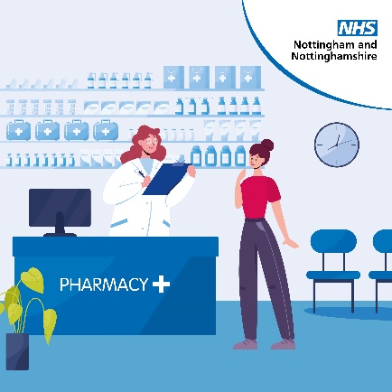
Community pharmacists are clinically trained professionals who can advise and treat a range of minor illnesses and injuries, such as aches and pains, skin rashes, cystitis and earache.  Find your local community pharmacy ▶️ http://nhs.uk/service-search/pharmacy/find-a-pharmacy | 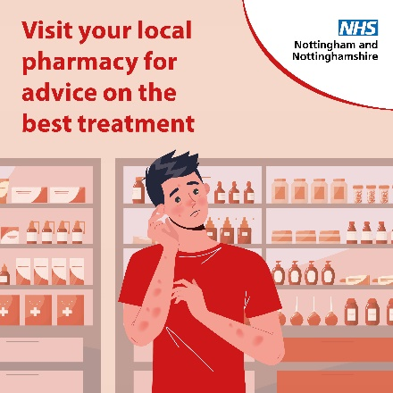
Think you have a Urinary Tract Infection (UTI)? Pain or a burning sensation when peeing?  More and more of our community pharmacies are signing up to offer you immediate advice and treatment.  Check if your local pharmacy is taking part: https://ow.ly/24FU50Q23Lp | 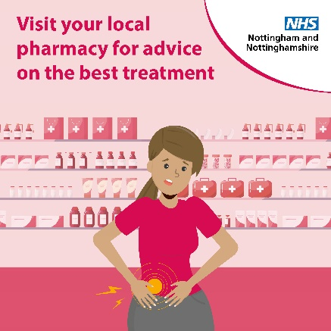
Got a minor illness? Your local pharmacy team is highly trained to give expert advice and provide a wide range of healthcare services.  Find a pharmacy near you. ➡️ http://nhs.uk/find-a-pharmacy | 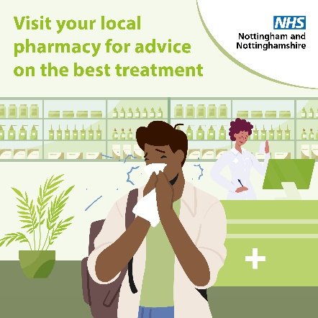
Self Help
Many common illnesses such as blocked sinuses and sore throats can often be treated at home with over the counter medication.  Your local pharmacy team is highly trained to give expert advice and provide a wide range of healthcare services.  Find a pharmacy near you. ➡️ http://nhs.uk/find-a-pharmacy | 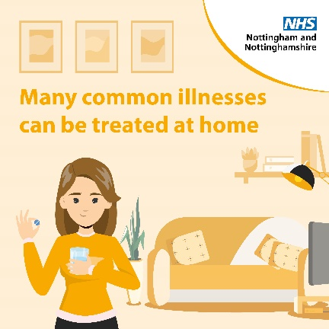
The NHS A-Z web pages have lots of information about symptoms and what to look out for.  It's useful to refer to if you or a loved one have a minor illness or injury and are unsure on the next steps to take.  If you think you need medical help right now, 111 online can tell you what to do.  https://www.nhs.uk/conditions/ | 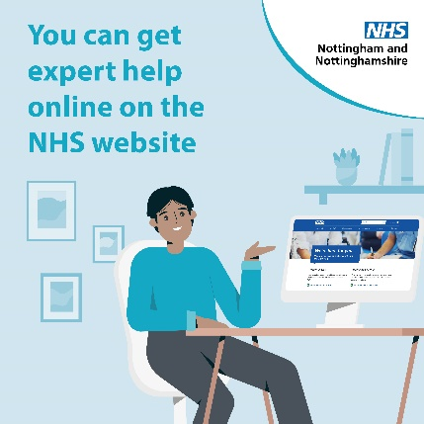
Urgent Treatment Centres
If you need medical help this weekend but it is not a life-threatening emergency, please use NHS 111 online, pharmacies or urgent treatment centres where possible.  Please keep A&E for life-threatening emergencies. | 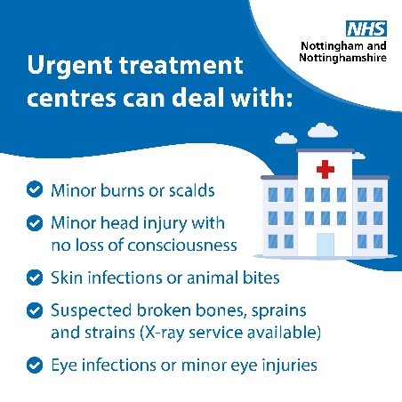
👩‍⚕️ Urgent treatment centres can help with a range of medical issues, especially at the weekend.  Only go to A & E in a life threatening emergency.  Find an urgent treatment centre near you ➡ https://ow.ly/z48V50Q430i | 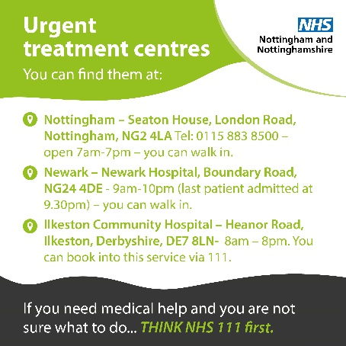
Dentist
If you have toothache, try taking some pain relief tablets to see if it helps.  If the pain persists, then go to http://nhs.uk/conditions/toothache for advice on what to do next. | 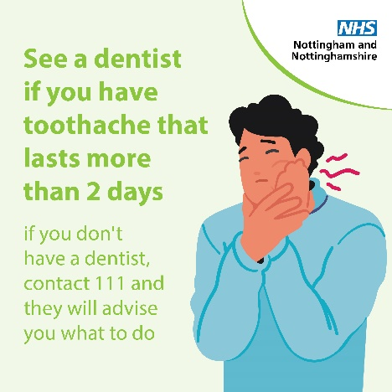
Did you know? If you're unclear if your dental condition requires immediate care or don't know where your nearest emergency dentist is, call NHS 111 for more info. | 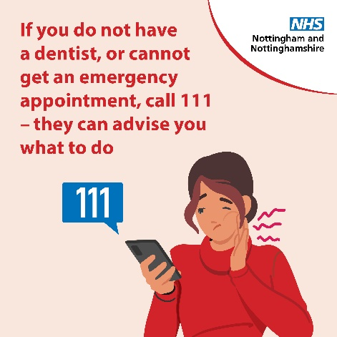
See a dentist if you have toothache that lasts more than 2 days.  There are things you can do to ease it while you wait for an appointment.  https://www.nhs.uk/conditions/toothache/ | 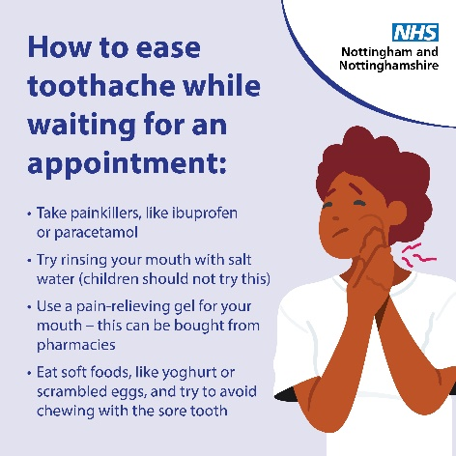
Vaccination
The COVID-19 vaccine has been properly tested and is safe and effective ✅  All vaccines in the UK are trialled and tested and have gone through a rigorous safety approval and clinical trials. | 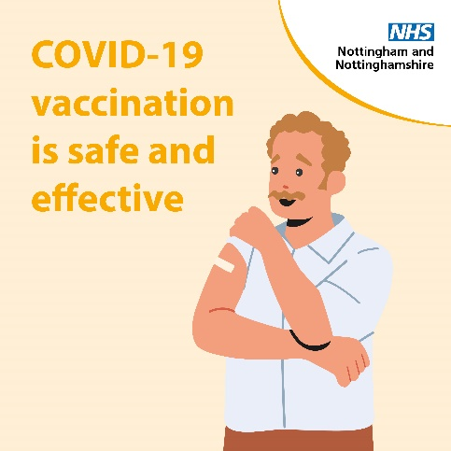
Get vaccinated, get winter strong! 💪  For some, COVID-19 can be very dangerous & even life-threatening - vaccines reduce the risk of serious illness in colder months.  Find out if you’re eligible and book now at http://nhs.uk/seasonalvaccinations | 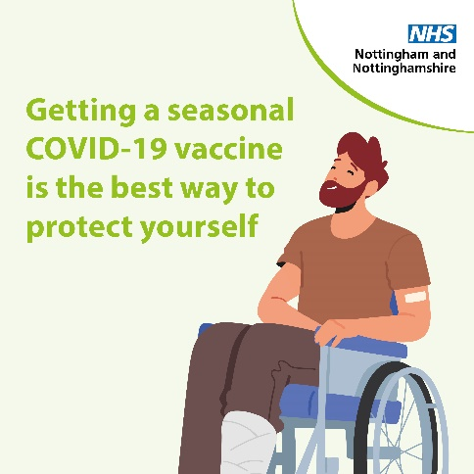
For some, flu or COVID-19 can be very dangerous and even life-threatening. Flu and COVID-19 vaccines reduce the risk of serious illness in colder months.  Find out if you’re eligible and book now.  ➡️ https://ow.ly/Nloa50PXuoX | 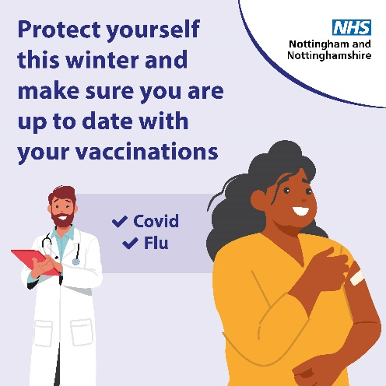
Flu will often get better on its own, but it can make some people seriously ill. It’s important to get the flu vaccine if you’re advised to.  It's is a safe and effective vaccine which is offered every year on the NHS to help protect people at risk of flu and its complications.  Book a vaccine via your GP or pharmacist. | 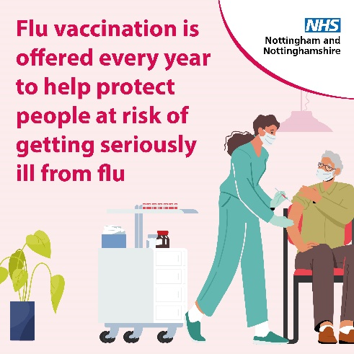
Flu will often get better on its own, but it can make some people seriously ill. It’s important to get the flu vaccine if you’re advised to.  It's is a safe and effective vaccine which is offered every year on the NHS to help protect people at risk of flu and its complications.  Book a vaccine via your GP or pharmacist. | 