This documentation should be used in conjunction with the Post Falls Guidance for Care Homes document to support the decision-making process following a fall in a Nottingham City or Nottinghamshire County care home.

**Supporting a person to get up off the floor with minimal support.**

If the resident is deemed not to be seriously injured, then the following steps can be followed to support a resident up off the floor following a fall.

1. If a minor injury is present commence first aid
2. Encourage person to bring their knees up to their chest and use their arms to raise their chest off the floor to get back to side sitting.
3. Advise person to then lean their weight forward onto their arms and then to lift their bottom up and over their knees so they are in four-point kneeling.
4. Place a sturdy chair in front of person and encourage them to slowly place hands one at a time onto the chair.
5. Encourage the resident to bring up their stronger leg first and then puh up with their stronger leg.
6. Resident should then lean weight over their arms and ush up onto the stronger leg
7. You may need to adjust how far away the chair is placed to get a good step forward.

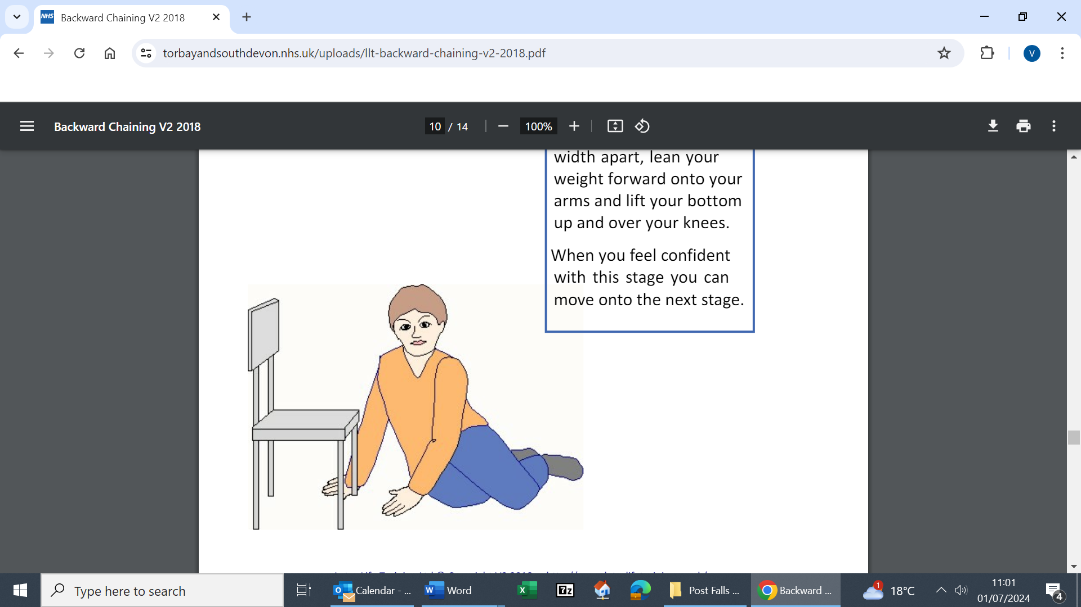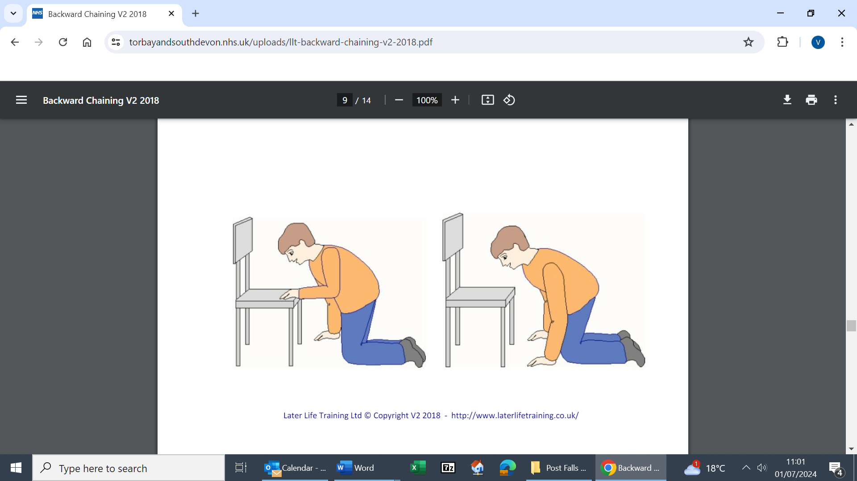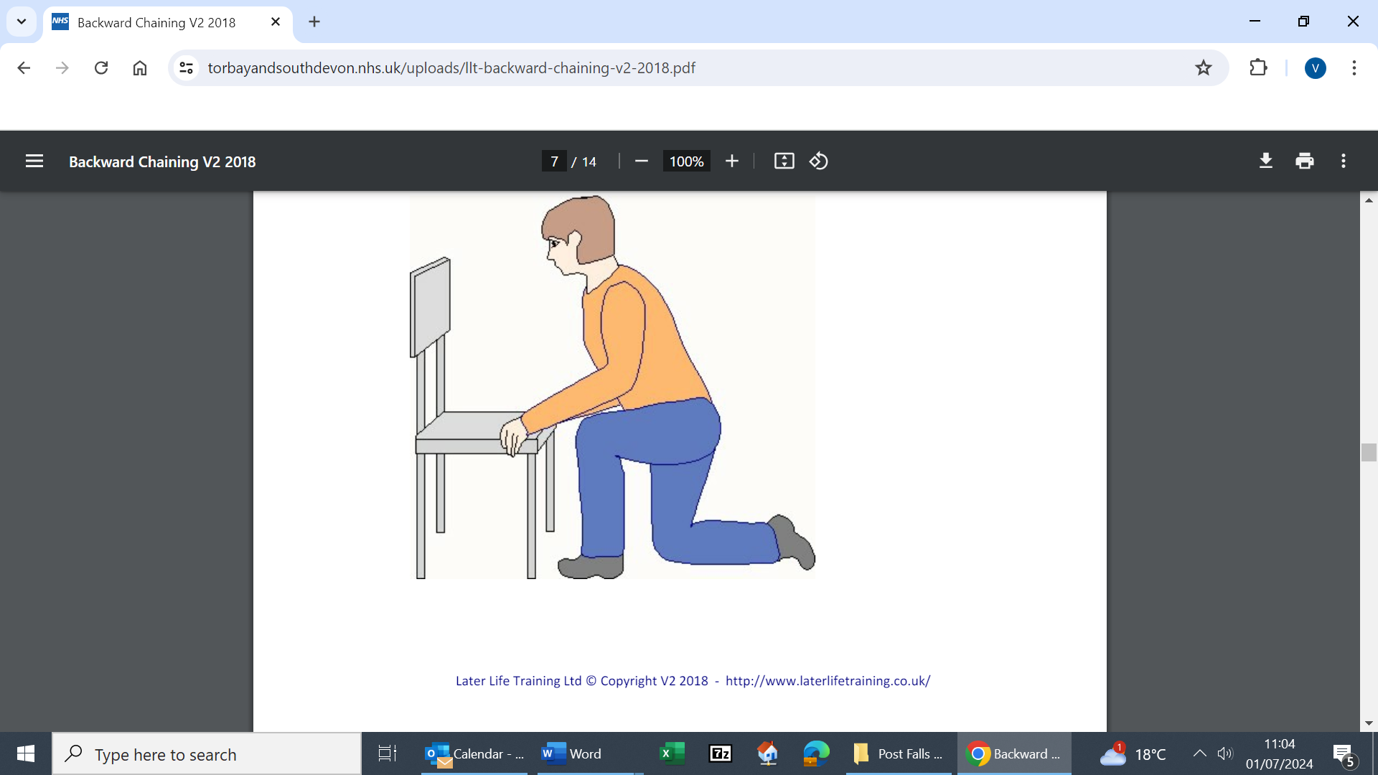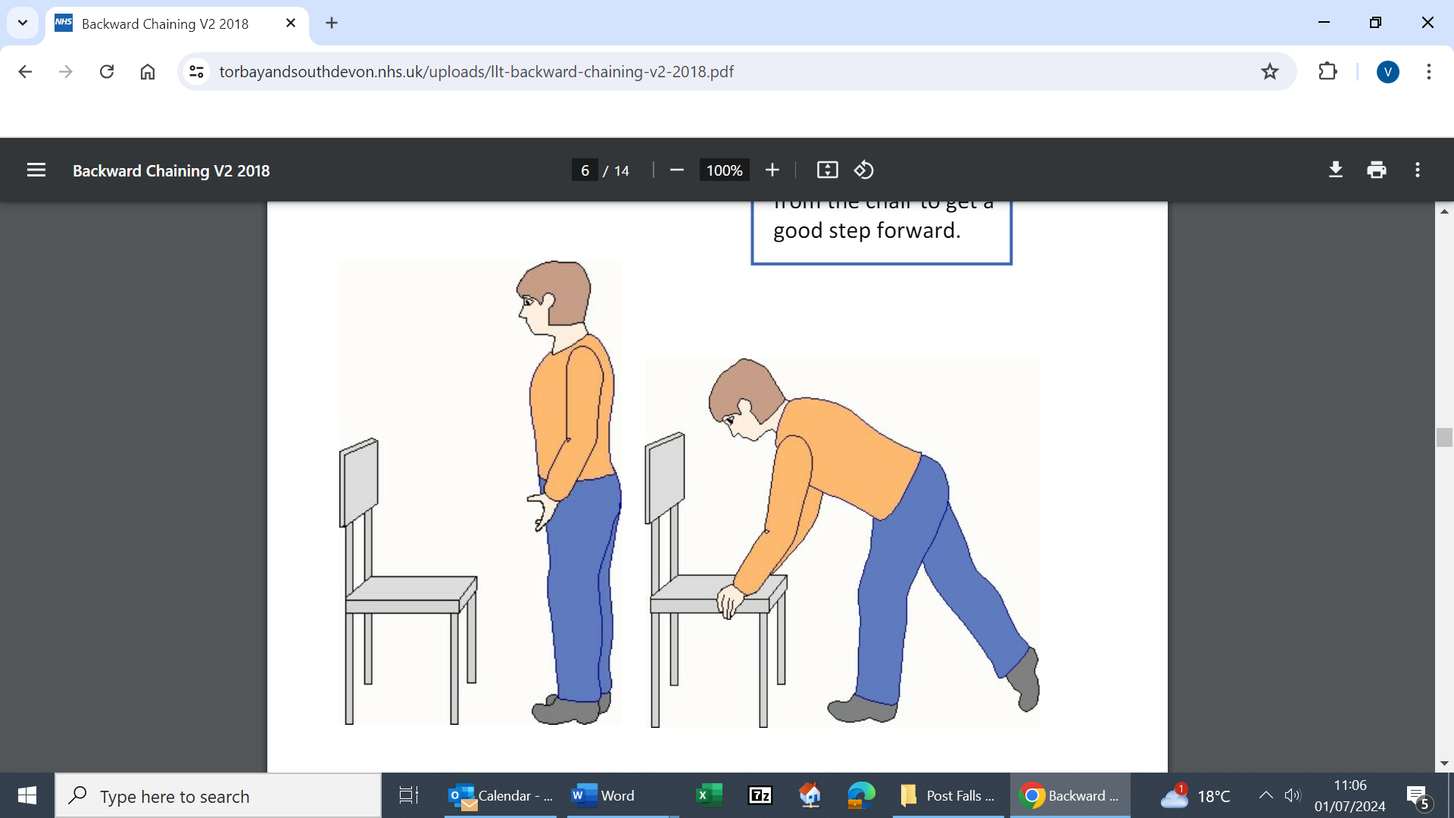

1. Some residents may not have the physical strength to follow the above steps. On these occasions staff may reason that a hoist is a safe method of supporting a resident off the floor. This is a decision individual to the situation and resident. Please consider how well the resident may tolerate a hoist. Do they use this regularly? Are they agitated or confused? If so, could the hoist make this worse and compromise safety? Is there room to bring in the hoist safely?
2. Remember the UCR team (for homes in the county) and 111 numbers are there to support you. If none of the above is suitable advice for the resident, please call for advice. See Post Falls Guidance for Care Homes Document for contact details or your local Urgent Community Response Team.
3. Closely monitor resident for any signs of deterioration. It is best practice for any trained staff members to commence half hourly observations for two hours, then 1 hourly for 4 hours and then 2 hours for next 24 hours.

**Post Falls Guidance for Care Homes: Supporting Document**

jip

For end-of-life residents please refer to the wishes as stipulated in their RESPECT form

**Prior to supporting the resident check for any of the following symptoms. If any of these symptoms are present, please call 999**

Extreme pain or pressure in the neck, head, back or specific joint

Weakness, incoordination, or loss of control in any part of

the body.

Numbness, tingling or loss of feeling in the hands, fingers,

feet or toes.

Loss of bladder or bowel control.

Shortening or sideways rotation of a leg

Nausea and/ or vomiting.

Intense pain, swelling, bruising, or bleeding.

Broken skin with bone protruding.

Headache, blurred vision or sensitivity to noise and light

Increased or unusual Irritability or confusion

Severe Fatigue or lethargy

A visibly out-of-place or misshapen limb or joint.

References:

National Institute of Clinical Excellence: Falls in Older People 2013; Head injury: assessment and early management 2023.

Later Life Training: laterlifetraining.co.uk