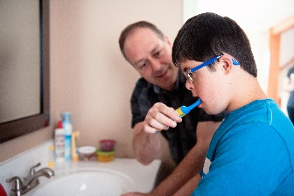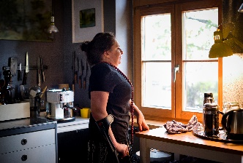****

**NHS Nottingham and Nottinghamshire**

**Integrated Care Board**

**LeDeR Programme Annual Report 31st March 2024**

**Learning from the Lives & Deaths of people with Learning Disabilities and Autistic people**

|  |  |
| --- | --- |
| **Table of Contents:** |  |
| Introduction & Forward | 3 |
| A Perspective from an Expert by Experience | 4 |
| Progress against objectives | 5 |
| Key achievements | 7 |
| The LeDeR Team | 9 |
| LeDeR governance arrangements | 11 |
| Focused reviews | 12 |
| Statistics and data | 13 |
| Average age of death | 19 |
| Ethnicity | 22 |
| Annual Health Checks | 24 |
| STOMP & STAMP | 26 |
| Areas for improvement | 28 |
| Objectives for 24/25 | 28 |
| A final word | 30 |
| Credits | 31 |
| Appendix 1 | 32 |

|  |  |
| --- | --- |
|  |  |
|  |  |
|  |  |
|  |  |
|  |  |

# **Introduction & Forward**

Welcome to Nottingham & Nottinghamshire ICB 2023 – 2024 LeDeR Annual report.

The LEDER programme was first established in 2015 and was introduced into Nottingham & Nottinghamshire in 2017. The programme was set up to support local areas to review the deaths of people with learning disabilities and in January 2022, this was extended to include people with a diagnosis of Autism. The aim is to identify learning from these deaths and change and improve care and services as a result of this This will contribute to improving the lives of people with learning disabilities, ensuring that they receive equitable health and social care to that of the general population and reduce the life expectancy gap.

This is our sixth LeDeR Annual Report since Nottingham & Nottinghamshire first introduced the Programme in 2017. Since then, LeDeR has become an integral part of the ICS Learning Disability & Autism Programme, shaping, and influencing the design and development of services for our population. This programme contributes to the Integrated Care Strategies key aim around tackling health inequalities in outcomes, experience, and access. As well as enhancing the safety and quality oversight across the system evidencing strong links into safeguarding, quality assurance and service design.

I am pleased to report that this year sees the beginning of our own dedicated LeDeR team within the ICB. We have invested in developing a specialised team within the ICB to oversee and coordinate the learning from the LeDeR reviews. This investment has led to us being able to determine our own local priorities that reflect the needs of our population, based upon data and local intelligence to focus services for our LDA population.

We have included contributions from system colleagues and “Experts by Experience” within the report. Looking forward to the year ahead one of the keys aims of the programme is to create a more inclusive programme by listening to people with a learning disability, their families, and carers. This will be supported by the LeDeR and wider LDA & Co Production ICB teams. Having our own permanent reviewers will facilitate this as they begin to develop those trusting relationships and work across the partnership and communities.

I want to take this opportunity to thank everyone across the system who has contributed towards the LeDeR programme and specially to those families and loved ones that have taken the time to share their stories with our reviewers.

Rosa Waddingham       
Learning Disability & Autism Senior Responsible Officer 



Rosa Waddingham

Learning Disability & Autism Senior Responsible Officer

**Adrian is an “Expert by Experience” who sits on several groups that work for the benefit of people with Learning Disabilities and Autistic People in Nottingham and Nottinghamshire. He has kindly given us his valuable insight in the following piece:**

Hello everybody my name is Adrian and I have been asked to provide my view of the LeDeR Programme from the perspective of an expert by experience because of a lifetime of care.

Having a second son who did not develop as we would have expected, our family started a life-long involvement with Health and Social Care as he was diagnosed with cerebral palsy. He needs complete support with his personal care due to tetraplegia and epilepsy. Involvement has always been key for us in understanding the current issues and being able to provide the best support, through Personal Centred Care, Valuing People and the Learning Disability and Autism Partnership Board. When it works well, social care changes lives, taking on personal assistants, supported us to enable our son to live the life he chooses.

In looking at the current challenges faced by families dealing with learning disabilities and autism, we have seen the long-term effects growing because of austerity and budget cuts to local authorities, with staff became increasingly stretched, wind down the support for families with learning disabilities and autism in the community.

Traffic Light Assessments, Communication Plans, and Health Action Plans can all offer vital information, if nursing staff are given the time to read them.

New technologies and advancing communication offer greater access to healthcare, but that has to be fully accessible and inclusive of the elderly and the disabled. ‘SystmOne™’ and the NHS App can give you a simple and secure way to access a range of NHS services, yet not all GP practices offer a full range of services. We were forced to move our son when the GP surgery was rebuilt two floors above a shop, to a physically accessible practice on the ground floor, for safety reasons. We now find that the new practice disables electronic service, preventing all patients from viewing service like test results, which appears an unnecessary restriction.

As an expert by experience, I’m involved in groups that highlight reasonable adjustments in healthcare settings, including longer appointment times, individualised easy-read information, and the proper recording of ‘Do Not Attempt Cardiopulmonary Resuscitation’ instructions.

One of the groups has promoted use of the ‘VIP Red Bag’ to take with you to any medical appointments or hospital admissions, holding all the person’s important information, so that healthcare staff know how best to treat and support the person. The group explores reports such as LeDeR reviews and shares learning and health information in webinars whilst encouraging healthier lifestyles.

Overall, I am in no doubt that although there is always a lot more to do as we live in increasingly difficult times, to achieve the improvements we all want to see, there are clear and encouraging benefits that are reflected into the community through involvement and hopefully can help with ground discussions viewed from a person-centred perspective.

**Progress against objectives outlined in 2021/2022 LeDeR Report**

**The following Objectives were set for 2022 – 2023.**

|  |  |  |  |
| --- | --- | --- | --- |
| Objective | Actions Undertaken | Outcome | Next Steps |
| The LeDeR Governance Panel to review 100% of recommendations and share the learning through the LDA Aging Well Work Stream | LeDeR Governance Panel consisting of Subject Matter experts from LDA, Safeguarding, Medicine Management and Quality Team have quality assured all completed reviews or the system | Learning, themes and SMART actions have been identified and shared with the LDA Aging Well Workstream, care providers and system colleagues such as mortality and safeguarding leads. | Gain assurance and feedback on how the learning and actions arising from LeDeR reviews is being utilised to improve processes and policies that are then embedded in care environments. |
| Identify and analyse the average age of death by locality to enable us to understand the variance between LDA deaths against the general population. | The data is now collated using the postcode and combined with government and NHSE data. | We hope to be able to understand better the potential effect of differing services on those in our care between City and County. | Continue to analyse data and use this to support LeDeR Learning. |
| To Increase communication and education of LeDeR into the community and wider workforce with a focus on raising General Practitioner (GP) awareness. | ICB LeDeR reviewers have been recruited and will deliver promotion of LeDeR amongst stakeholders including General Practitioner’s (GP’s) and community representatives, with particular focus on ethnic minorities and representatives of those with protected characteristics. | As a result, there has been an increase in awareness of the LeDeR programme. This is evidenced by the fact that multiple notifications are being seen in an increasing number of individual cases. | LeDeR team to continue to strengthen raising awareness for increased numbers of notifications of ‘autism only’ cases.    LeDeR team to continue to work with strategic partners to develop an understanding and support action in ethnic minorities accessing NHS services and social care. |
| Work with NHS England regional team to ensure that we are supporting delivery of the Oliver McGowan training in conjunction with the Nottinghamshire Training Alliance Hub. | The ICB are developing a pilot to test the infrastructure of the ICS to deliver the OMMT programme | The pilot is being led by the Professional Standards within the ICB in conjunction with a Project Manager and System wide Steering Group | All members of the LeDeR Team will undertake the Oliver McGowan Mandatory Training as soon as available. |
| Greater use of reasonable adjustments in health and care services for people with a learning disability and autistic people. | LeDeR reviews are capturing where reasonable adjustments have and have not been made in primary and secondary services. | Reviews are feeding back to services in SMART actions and highlighting areas of positive practice to reinforce the legal requirement to all people with learning disabilities and autistic people, in line with The Equality Act 2010. | To continue a progressive dialogue with services to recognise where reasonable adjustments can be made in their relevant healthcare setting. |
| To complete LEDER reviews within NHS England timescales using ICB employed reviewers to optimise timely learning from LeDeR Reviews | Measures have been put in place to deliver LeDeR reviews of robust quality within the NHS England timeframe of 6 months.  This includes regular meetings between members of the LeDeR Team to discuss and prioritise reviews that are close to deadline and fortnightly progress reports, so that colleagues can support the timely completion of good quality reviews.  The LeDeR Governance Panel is made up with professionals from different backgrounds, including nurses specialising in learning disabilities, mental health, physical health, safeguarding and pharmacists. We are working with system colleagues to ensure the prompt receipt of care records for our reviewers and now have access to GP patient administration systems. | The overall quality and useability of reviews is improving month by month.  Our performance against NHS England Key Performance Indicators (KPI’s) is now on an upward trajectory. | We will continue to improve the quality and useability of our reviews and SMART actions, whilst maintaining our performance against NHS England KPI’s. |

**Key Achievements**

The LeDeR programme is an integral tool for improving patient care and safety. The programme has made considerable progress in Nottingham and Nottinghamshire and has helped to foster a culture of transparency & shared learning. However, there are still areas where significant further improvement is required. The Nottinghamshire Integrated Care Board (NNICB) is committed to continuing to support the LeDeR programme and to making patient safety and improving outcomes by driving down health inequalities one of our foremost priorities.

This report provides an overview of the progress and impact of the LeDeR programme in Nottingham and Nottinghamshire has made from 1st April 2023 to 31 March 2024. Below are the key achievements of the programme throughout this period.

The programme has:

* Improved the quality and optimised the impact of LeDeR reviews that are fed back to care providers (in a redacted format), by strengthening the learning and SMART (Specific, Measurable, Achievable, Relevant, and Time-bound) actions arising from the learning.
* Challenged & prompted internal and external reviews where they have not been carried out or considered.
* Shared learning from serious incidents and deaths across the healthcare system via completed reviews and, by sharing of themes at system stakeholder meetings.
* LeDeR reviews have identified where further investigation processes should have taken place such as Serious Adult Reviews. This has prompted a more detailed analysis of causes for concern.
* Enable the implementation of changes to practice, based on learning from serious incidents and deaths.
* Employed two NNICB LeDeR reviewers who commenced their roles in September 2023 and October 2023 respectively. This is enabling, as planned, a more organic approach to reviews and real-time.
* As we transitioned from using a consultancy to complete our LeDeR reviews we experienced some fluctuations in performance against the NHS England 6-month time frame, but as our new reviewers began to submit reviews against a managed performance plan, we are now seeing an upward trajectory for NHS England Key Performance Indicators (KPI’s).
* Systems access to General Practitioner (GP) notes has been achieved for reviewers (Rio™ and SystmOne™), thus expediting the LeDeR process so that we can feed back learning that enables positive change.
* Enable platform access to hospital notes from our largest system acute trust. This has ensured the secure transfer of confidential patient information.
* Create a culture where it is incumbent on all stakeholders to report serious incidents and deaths, with commitment to learning from these events.
* Highlighted learning in local areas of focus:
* **Respiratory**
* Pneumococcal vaccine should be considered in adults with a higher risk of developing pneumonia. This has been highlighted in SMART actions fed back to care providers.
* Ensuring timely assessment and processes for dysphagia and aspiration risk management from Speech and Language Therapy (SaLT). Once referrals are received by SaLT, positively, they are responded to and actioned quickly. As a result of LeDeR Learning, we have advised that care homes should **promptly** refer their residents for SaLT assessment when coughing and/or swallowing difficulties arise as their needs change. Often treated with antibiotics and monitoring.
* The term 'aspiration' relates to when food or drink 'goes down the wrong way', i.e. into the airway (toward the lungs) instead of into the food pipe/oesophagus (toward the stomach). Aspiration can be associated with the use of antipsychotics as stated by our panel of expert pharmacists in learning from our LeDeR reviews. Certain anti psychotics should be used in cautiously in patients at risk for aspiration pneumonia.
* Learning from LeDeR has played a role in discussions with colleagues across the Nottingham/Nottinghamshire system as to how we might improve the outcome of people with an intellectual/learning disability and who have complex respiratory issues that lead to aspiration pneumonia. Collaborative work is ongoing.
* We think that the following website is an excellent resource for people with a learning disability and autistic people and recommend that you take a look: <https://keepingmychesthealthy.bdct.nhs.uk/> © Copyright, Bradford District Care 2024
* **Cardiac**
* Expert pharmacist feedback has highlighted where combinations of prescribed medication may have resulted in a cardiac event. SMART actions to prescribers have recommended that consideration is made to risks associated when combining medicine therapy, and that careful monitoring is undertaken.
* Lifestyle is emerging as a potential contributing factor in cardiac deaths. This is fed back to care providers, but it is clear that education and opportunities for a healthy diet, exercise, alcohol reduction and smoking cessation need to be embedded wherever people with learning disabilities and autistic people live.



**The LeDeR Team**

During 2022/23, an external consultancy was undertaking 87% of Nottingham and Nottinghamshire LeDeR reviews at a cost to the ICB.

Las year we committed to aligning our programme with NHS England guidelines that required us to use NHS Nottingham & Nottinghamshire Integrated Care System employed reviewers and as previously reported we have now delivered on this.

The ICB reviewers work within the LeDeR and Learning Disabilities Team to undertake the timely completion of LeDeR reviews and to support the wider Learning Disabilities Team in Care and Treatment Reviews (CTR’s) and Local Area Emergency Protocol meetings (LAEPs).

They have supported the effective development and implementation of processes to ensure that robust reviews of good quality are undertaken to meet with NHS England Key Performance Indicators (KPI’s). Working with the LeDeR Local Area Contact (LAC), Senior Reviewer and wider nursing/quality leads, they are identifying areas of improvement for local practice by using the learning and intelligence from the reviews.

This allows us to support care providers in affecting change and influence the reduction of premature and avoidable deaths whilst improving the lives of people with a Learning Disability and people with Autism.

Jonathan Sansome, (Quality and LeDeR Programme manager), along with Kirstie Charlesworth (LeDeR Programme administrator) runs the LeDeR Programme in Nottingham and Nottinghamshire.

The LeDeR Reviewers experience by Jo Johnson & Sarah Edwards

Photo of LeDeR Reviewer Jo JohnsonPhoto of LeDeR reviewer, Sarah Edwards 

Working for LeDeR is a rewarding role and having another LeDeR reviewer to work closely with and to share skills, experiences and specialist knowledge has enabled us to work collaboratively on some challenging area’s by supporting one another. We have membership of the LeDeR Working Group, Physical Health Steering Group and the Annual Health Check Working Group to inform our practice and share learning and highlight areas of good practice and areas for improvement.

Upon completion of the reviews, we identify any themes or trends that we are experiencing in the review process to enable us to identify reoccurring areas of concern. We participate in the LeDeR working group, involving professionals from different disciplines including primary and secondary services to discuss how LeDeR recommendations are being implemented and actioned. It enables us to share LeDeR updates and findings from the reviews, discuss and take forward ideas and plans for improvement and monitor the feedback. We are working to develop on how we can accumulate both qualitative and quantitate data to measure how improvements are made.

As part of our development within the role we have expanded our network by liaising with colleagues and services to continue to raise the profile of LeDeR, our findings and planning for any areas of concern we have actioned. One such area has been linking in with the ICB’s engagement team about the LeDeR programme and how we can collaborate with their voluntary, community and social enterprises to improve health outcomes in area’s we have identified through reviewing.

Going forward, we aim to continue expanding our findings and research with the hope to create opportunity for change and improvement in the future.

**LeDeR Governance Arrangements**

The Physical Health Steering Group (PHSG) is part of the LDA Aging Well workstream. This group provides oversight and support to the local delivery of the programme.

The PHSG meets bi-monthly and has representation from the ICB, NHS (primary care, community and acute) organisations, local authorities, General Practitioners, and experts by experience.

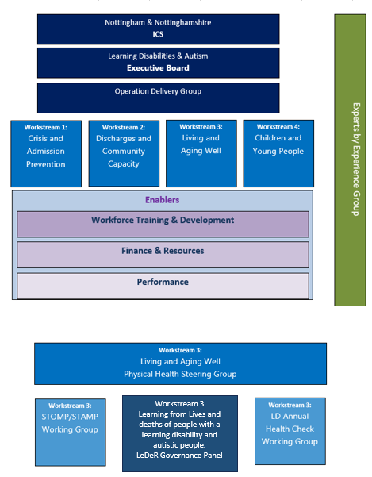

The PHSG is facilitated and chaired by the ICB and has a wider remit than LeDeR, but it receives updates to the learning and themes arising from completed LeDeR reviews across the system and is fundamental to cascading LeDeR findings to appropriate providers.

LeDeR has also informed changes to organisational policies and practice when incidents have been reviewed and learning has been cascaded with a focus on quality improvement. Examples of this include increasing the of use communication tools between primary and secondary care systems such as health passports, or challenging thinking among acute care systems regarding capacity and consent to treatment. Further work is on-going to ensure changes in practice are embedded well across the system and workforce.

The LeDeR Governance Panel identifies themes, concerns, good practice and learning with actions then taken to the Physical Health Steering Group for wider dissemination. The group also ensures that outputs from the steering group are aligned to wider system partners and processes including safeguarding adult reviews, inquests and police/prison/probation reporting. Updates, Situation reports and high-level reporting are also submitted to ICB Quality & Performance Committee to ensure system wide learning is embedded and risks are managed.

**‘Focused’ Reviews**

The focused* review asks for more information about known medical conditions and the social care the person received . For each condition listed in the person’s medical records, a sub form drops down containing more questions about the condition and relevant medication. There is also an opportunity to describe challenges or good practice around social care, drug and alcohol services and any issues relating to intersectionality that impacted on care. The reviewer completes an executive summary at the end pulling together all their findings to help the local governance panel decide what actions to take to improve local services.

**Local Priority Areas for Focussed Review:**

Respiratory, Epilepsy, Cardiac, Diabetes & Sepsis

**National criteria for a focused review:**

Autism only, Ethnic Minority, Relatives request, and when a LeDeR reviewer decides that significant learning can be extracted from the review.

NHSE KPI’s also require that over 35% of reviews are completed in a more in-depth format that gives greater focus to areas of concern and enables the collection of essential quantitative data.

In 2023/24 out of the 88 notifications 31 reviews (35%) have so far been found to require a focussed review. This figure is likely to increase as a large percentage of these reviews are ongoing and as can be seen in the KPI section, percentages of focused reviews fluctuate from month to month.

In 2023/24 61% of all focused reviews are being completed or have been completed because they fall into the “Local Priority Area for a focused review”.

Five reviews (16%) were converted to focused on the request of the reviewer. This was due to concern about potential gaps in services or learning that could be gained from a focused review.

One review was an ‘autism only’ case. Autism only cases are automatically completed as focused.

Four reviews (13%) were focused due to the individual coming from an ethnic minority, and

Two reviews (7%) were notified as ‘Focused LD’, which are completed if the notifier indicated the individual was subject to mental health restrictions at the time of death or in the previous five years.



**2023/24 Statistics & Data**

NHS England requires that the LeDeR Programme works to achieve Key Performance Indicators (KPI’s). These ensure that LeDeR reviews are completed in a timescale that makes them relevant to care providers and offers some degree of closure to bereaved family members.

Our performance against NHS England Key Performance Indicators (KPI’s) is incrementally improving and we expect this trend to continue in 2024/25

The average age of death of adults with learning disabilities and autistic people in 2023/24 was 60, showing an incremental improvement on the previous 2 years as illustrated in the table on page 20.

The breakdown of data below shows the number of notifications to date and 2023/24 performance.

90 notifications were made in 2023/24 and 88 of these were found to be ‘in scope’ and went onto be reviewed. Two were found to be ‘out of scope’.

* 90 Notifications to the LeDeR platform have been received in 2023/24.
* 2 reviews were found to be out of scope due to no diagnosis of Learning Disability (LD) or Autism Spectrum Disorder (ASD)
* 88 reviews were found to be in scope and allocated to LeDeR reviewers for completion.
* Between April 2023 and March 2024 38 reviews have been completed. 50 reviews are ongoing. 21 of these reviews are on hold due to statutory processes including coroner inquest or safeguarding investigations.
* The 2020/21 statistics in the above chart were an outlier due to COVID deaths.

As our own reviewers are allocated LeDeR reviews, we are moving towards the NHS England KPI of 100% and our performance is now sitting at 98%, as of 31st March 2024.

NNICB Key Performance Indicators (KPI’s) compare favourably with national averages.

The 6-month timeline is necessary as time is of the essence when feeding back LeDeR learning to care providers so that they can implement improvements in a timely fashion. It is also easier for reviewers to obtain information as close as possible to the notification date. The 6-month time frame also allows our reviewers to support bereaved families in a timely fashion. They invariably express sincere gratitude and find being able to talk to a reviewer very therapeutic.

[0---p0

NHS England requires each system to produce a minimum of 35% of its reviews as focused. Nottingham and Nottinghamshire ICB insists that cases that meet the national and local criteria for a focused review are reviewed as such, thus easily exceeding the KPI each month. This figure naturally fluctuates, reflecting the individual nature of each LeDeR review.

**\*[Please note that NHS England uses the USA spelling, ‘focused’ (rather than the UK spelling - ‘focussed’), so we have followed this convention when describing ‘focused reviews’ for consistency].**

**Cause of Death**

**The data below is taken from all reviews signed off between March 2023 to April 2024. This necessarily includes completed reviews from 2022-23.**

* 79 reviews were completed between April 1st 2023 and March 31st 2024. This chart shows the primary cause of death found in these reviews. The data shows the primary cause of death, but it should be noted that many of these people had multiple comorbidities which often contributed to the cause of death.
* Respiratory issues remain the highest cause of death in the cohort of people with a learning disability. We had one ‘autism-only’ death notified this year,and this is still on hold awaiting a verdict from the coroner.

**Gender and Age**

Out of the 88 LeDeR notifications received and taken to review, 62 percent w

ere male, and 38 percent were female.

There was a significantly higher percentage of male deaths compared to female deaths, with 55 Male and 33 Female. It has been confirmed that these figures reflect the ratio of males to females in the current Nottinghamshire population. The data also reflects the national picture.

This chart shows the age of the individuals with Learning disabilities at the time of death, the majority of deaths taking place between ages of 56 to 65.

**The average age of death of adults with learning disabilities and autistic people in 2023/24 was 60, showing an incremental improvement on the previous 2 years as illustrated in the table below.** Child deaths (CDOP) reviews are no longer included in LeDeR data, so we have removed it from the 2 preceding years in the chart below to give an accurate comparison.

|  |  |
| --- | --- |
| **Reporting Period** | **Average age of adults (over 18) at death** |
| 2023/24 | 60 |
| 2022/23 | 59 |
| 2021/22 | 57 |

We have included child deaths (CDOP) in the table below to demonstrate the wider context.

|  |  |
| --- | --- |
| **CDOP - Child Death Overview Panel Statistics 2023-24** | |
| Ages | Total number of deaths in age range. |
| 0-27 days | 0 |
| 28 – 364 days | 1 |
| 1-4 years | 1 |
| 5-9 years | 1 |
| 10 -14 years | 1 |
| 15 -17 years | 1 |

**Place of Death**

The data below was compiled from the 88 notifications taken to review and does not include out of scope reviews.

There were 43 deaths across Nottingham and Nottinghamshire while in hospitals, 45 deaths took place in the community or usual place of residence, this would include deaths in supported living and care homes as well as those living independently in their own homes.

Because ReSPECT forms (Recommended Summary Plan for Emergency Care and Treatment) are only recorded in focused reviews and vary in detail, an accurate picture of desired place of death would be impossible. This is the position that neighbouring systems adopt too.

This chart shows a break down in deaths by hospital and community. Most deaths occurred in Nottingham University hospitals Trust (Queens Medical Centre and Nottingham City Hospital) this reflects the significantly larger population that Nottingham University Hospitals Trust covers, in addition to having a far larger capacity.

Of the community deaths, 15 took place in the individual’s own home, and 30 were found to have taken place in residential homes / supported living placements.

Obviously, more hospital deaths are recorded, as people are only admitted when they are physically ill and in a vulnerable state. We don’t have data on these preferences, and available patient records don’t always show if a ReSPECT form was completed, as per the data below.

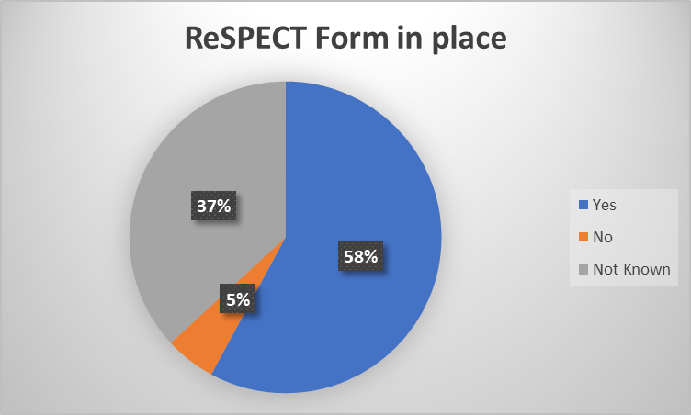

This data was taken from 19 patients who were on an end of life pathway at the time of death.

11 reviews confirmed that a ReSPECT form was in place and that 9 of these had these wishes and preferences recorded and 2 did not.

Out of the remaining 8 reviews, 1 was confirmed to have no ReSPECT form and in 7 reviews, it wasn’t known if a ReSPECT form had been completed.

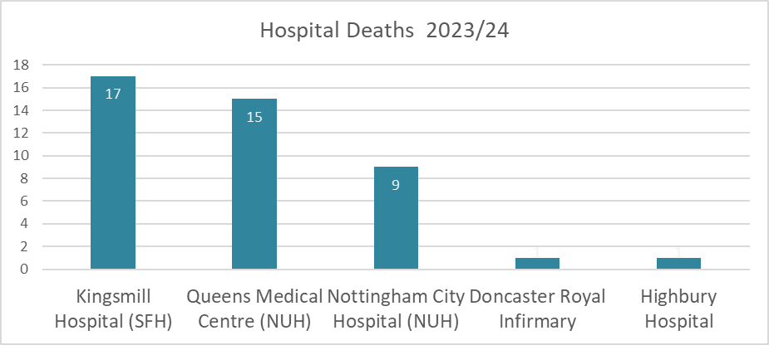



# 

**Ethnicity & Intersectionality**

We live in a changing world, and the LeDeR programme when addressing health inequalities, has to ensure that the review process takes account of, and mitigates for the fact that all people with a learning disability or autism, regardless of race, culture, gender and sexuality receive health and social care that puts them on a parity with the whole population. This may mean that reasonable adjustments and mitigations are put in place to ‘level up’ the experience of individuals who may find that their characteristic puts them at a disadvantage in obtaining appropriate care.

To give assurance that appropriate reasonable adjustments and mitigations are being put in place, LeDeR reviewers are now required to undertake NHS England intersectionality training to ensure that the life and death of a person from a minority group is reviewed through the lens of being a member of that minority. The reviewer is then better placed to examine how this intersected with their Learning Disability/Autism and influenced access to social care and healthcare.

LeDeR will continue communication with the head of Equality, Diversity and Inclusion (EDI) to explore and identify opportunities to work with people from Black & Minority Ethnic (BME) communities and form a better understanding of how LeDeR needs to interface with these groups and individuals.

Both of our reviewers have now undertaken the comprehensive, NHS England hosted Intersectionality Training session for LeDeR reviewers.

There is a clear a disparity between Nottingham and Nottinghamshire LeDeR statistics and statistics of the U.K. general population as collected in the 2021 Census which showed that the ‘White British’ portion of the population is only 74.4% whilst the overall white population is 82%. The overall percentage of non-white ethnic minorities is 18% and is broken down in more detail in the Office of National Statistics (O.N.S) chart above.

We are not at this moment certain as to the reason for this apparent under-reporting in the LeDeR cohort of people, but we are undertaking measures over the next year to investigate and mitigate for this.

In 2023/24, we:

* Rolled out intersectionality training to all reviewers in conjunction with the NHS England supplied training.
* Our newly appointed LeDeR reviewers were tasked to begin outreach into local ethnic communities in 24/25 and to explore the possibility of engaging with Ethnic minority radio stations and key community leaders and groups to disseminate information about LeDeR to encourage LeDeR notifications in this cohort of people. This work will raise the profile of the LeDeR Programme within ethnic minorities in Nottingham and Nottinghamshire and would be suitable for a collaboration with experts by experience.
* Collected postcode data on all LeDeR cases from April 2023, to give us more granular data. This has been shared with system colleagues alongside other data to inform future service specifications.

# 

# 







**Annual Health Checks**

The Nottingham and Nottinghamshire Integrated Care System (ICS) has performed favourably against the 23/24 Annual Health Check target of 5186 AHCs (76%), with 5470 health checks completed as at 28th March across the ICS, putting performance against this year’s denominator set by NHSE at the start of the year (based on the previous all age QOF GP LD register) at 80% and 77% against the GP LD register on E-Healthscope (14 years and over). This is a fantastic achievement!

95% of AHCs are recorded to have a Health Action Plan (HAP) in place, with 71 people recorded to have declined a HAP which equates to a decline rate of 1.0% against the total LD register on E-Healthscope. NHSE also asked systems to prioritise and complete health checks for everyone who didn’t receive one in the previous year, known as the priority cohort in the table above. As of 28th March 2024, 845 health checks (57%) have been completed for the priority cohort across the ICS.

NHS England have recently confirmed that the Impact and Investment Fund (IIF) in 24/25 will continue to incentivise GP practices to ensure a Health Action Plan is completed as part of the Annual Health Check, as a priority focus for Primary Care (one of only two indicators remaining from 23/24).

**LD Annual Health Check Performance 2023/24**

LD Annual Health Check Performance 2023/24

LD Annual Health Check Performance 2023/24





**STOMP/STAMP**

# **STOMP** - **S**topping **O**ver **M**edication of **P**eople with a learning disability, autism or both

# **STAMP** - **S**upporting **T**reatment and **A**ppropriate **M**edication in **P**aediatrics

# STOMP & STAMP are national programmes in the NHS to reduce the over-medication of children and young people with a learning disability, autism or both. The programmes are working to make sure that children, young people and adults with a learning disability, autism or both are only prescribed the right medication, at the right time and for the right reason. This will help to improve their health and well-being and give them a better quality of life.

The Nottingham and Nottinghamshire Integrated Care System STOMP & STAMP working group supports the aims of the national project at a local level.

The STOMP/STAMP programme aims to:

* Encourage people with a Learning Disabilities and/or Autism (LDA) to have regular check-ups about their medicines.
* Make sure doctors and other health professionals involve people, families and support staff in decisions about medicines.
* Review the use of psychotropic medicines in people with a learning disability, autism or both.
* Improve the quality of care for children and young people with a learning disability, autism or both who are prescribed medication.
* Ensure that children and young people are only prescribed the right medication, at the right time and for the right reason.

In Nottinghamshire, the STOMP working group is raising awareness of STOMP/STAMP in Children's services and considering it when developing and reviewing Education Health Care Plans (14 to 18 year-olds). They are also working to improve the quality of care for children and young people with a learning disability, autism or both who are prescribed medication.

A senior pharmacist post has been recruited to that will enable complete baseline searches on the General Practice (GP) patient records to identify children and young people with a Learning Disability, Autism or both, prescribed psychotropic medicines.

The Nottingham and Nottinghamshire ICB LeDeR programme is now fully aligned with STOMP and STAMP. The Quality and LeDeR Programme Manager is representing the ICB at system-wide and regional meetings and collaborating with system, regional and national NHS England STOMP/STAMP colleagues.

Significant findings are shared with system-wide and regional stakeholders, so that collaborative learning can be taken forward throughout the ICB to improve the lives of local people.

After a period of consultation and discussion, we are delighted to announce that expert pharmacists from the ICB Medicines Optimisation Team now form an essential part of our LeDeR review quality assurance and governance process. Evaluation of redacted LeDeR reviews is undertaken by a team of available pharmacists before final approval of the review. This process became business as usual in October 2023. We are the first ICB to have taken this step and are very proud that other ICB’s now wish to adopt a similar strategy.

**Senior Medicines Optimisation Pharmacist Deepa Baxi** **gives us a perspective from the ICB team:**

The Medicines Safety Officers began to provide input on LeDeR Reviews from November 2023 to support Nottingham and Nottinghamshire ICB LeDeR team complete learning disability and autism lives and deaths (LeDeR) reviews. The aim for our team of pharmacists and technicians is to support the medications element of the reviews, identifying areas of improvements and good practice. The team has close links with social care providers and can provide support from a governance perspective within this remit.

As experts in medicines, we provide advice in the following areas

• Information on medication licensing, ensuring treatment is in line with recommended indications.

• Reviewing whether medication prescribed is in line with National and Local guidelines and formularies.

• Information regarding correct administration.

• Identifying any potential interaction.

• Highlighting different routes of administration for a medication should the patient be unable to take the existing medication they are prescribed.

During November 2023 – end of March 2024 the team has supported 15 LeDeR reviews.

Common themes our team have identified during the reviews have been

• Learning and Disability annual reviews are often not completed.

• Directions for medication are not always complete e.g., PRN (when required) medication

• Adherence to guidelines could be improved/ strengthened messages for patient/ carer.

• Medications causing QT-prolongation of which more than one prescribed.

• Inappropriateness of medication e.g., hay fever medication prescribed during winter months.

The LeDeR team have found our feedback input invaluable and enriching, with other areas looking to onboard pharmacy input to their LeDeR reviews.

**Areas for Improvement**

The following recommendations are made to further improve the LeDeR programme in Nottingham and Nottinghamshire. Whilst the LeDeR programme has made significant progress, there are still areas where further improvement is needed. These areas include:

* Ensuring all reviews are completed within the NHS England stipulated 6-month timeframe.
* Supporting provider colleagues to complete Structured Judgement Care Reviews (SJR’s/SJCR’s) in a timely fashion that allows completion and Nottingham and Nottinghamshire Integrated Care Board (NNICB) Quality Assurance Panel approval prior to the NHS England deadline.
* Improving the quality of data collection and analysis at local and national level.
* Strengthening the learning from serious incidents and deaths to improve care practice.
* Further developing our follow up of SMART (Specific, Measurable, Achievable, Relevant, and Time-bound) actions to measure for impact and assurance that all actions have been completed by the care provider.



**Objectives for 2024/25 and Beyond**

* We will continue to feedback and consult with system colleagues on a regular basis and will communicate reviewer and LeDeR Quality Assurance panel concerns, questions, recommendations, and actions. In the spirit of PDSA (Plan, Do, Study, Act) cycles, we aim to continually review and refine our feedback processes. Regular meetings are now timetabled with the Safeguarding Team to take a detailed look at aspects of care highlighted in a LeDeR review where we feel that safeguarding issues are indicated. Our reviews have highlighted issues that have then become a safeguarding referral.
* Approximately 22% of people with learning disabilities are affected by epilepsy. They are at greater risk of premature death and higher risk of sudden unexpected death in epilepsy (SUDEP). We will work with colleagues through LeDeR reviews to identify people who die and who suffered with epilepsy during their life.
* Cardiac issues are now the second highest cause of death for people with learning disabilities and autism in 2023/24. Other causes of death such as cancer have not emerged as being statistically unusual, so we gained approval from the Nottingham and Nottinghamshire Integrated Care System Physical Health Steering Group to swap our local areas of focus for the undertaking of focussed reviews. Cardiac issues have now replaced cancer as a local area of focus. We are now in early discussions with system colleagues on how to best address this issue.
* A representative from the LeDeR team is now included in the ICB Quality/Safeguarding panel discussions for all serious incident investigations involving Learning Disability & Autism cases. This will also give advance warning if a death has occurred as the result of a serious incident. It also allows our input to be given in cases where a living person is involved. This is now ‘business as usual’.
* We are now routinely looking for any hint of safeguarding issues/referrals in the LeDeR notifications and where these are found, we’re discussing it with the ICB Safeguarding Team and Quality Team to ensure that they are alerted and that if investigations are being undertaken, the LeDeR review can be put on hold until they are complete, and all information is made available.
* The NHS England LeDeR platform has been completely overhauled and will be key to delivering improved the quality of reviews. There has been a significant improvement to the ease of use for reviewers and sections are more logically distributed, with expectations set
* out in the margins of each free-text box. This improvement has been followed up with a handbook and training session for all reviewers.
* NNICB reviewers now form part of our quality assurance panel. This not only brings their expertise to the panel but fosters a peer-learning environment for all members.
* Improve and maintain performance against our 6-month target by developing timely access to medical notes, Structured Judgment Reviews (SJR’s) and General Practice (GP) records and improving quality of reviews so that less time is spent adding to and making corrections or amendments to reviews.
* Give robust feedback to care providers in the form of SMART (Specific, Measurable, Achievable, Relevant, and Time-bound) actions that will improve the safety and care of all of those entrusted to our Nottingham and Nottinghamshire Integrated Care System.
* Respiratory, cardiac, sepsis and cancer deaths to be a focus in 2023/24 to align with system CORE20Plus5 target areas.
* Embed ICB Reviewers into the Nottingham and Nottinghamshire System

**A final word from Sue, an Expert by Experience (EBE)**

As a parent of a 26-year-old young man with severe learning disability and autism who is also non-verbal, I was happy to accept the invitation to join the LeDeR working group as an EBE recently. On the whole we have been generally fortunate with my son’s physical health, the main issue being asthma which is well controlled. However, diagnosing and treating this as a child initially was very difficult i.e. how do you explain to the GP the breathing sounds ‘off’, how do you explain that the mask you are putting over his face will make his chest feel better. Even as an adult he cannot use an inhaler himself and we use an AeroChamber™ with face mask to administer the inhaler puffs which he is used to and accepts.

Whilst a learning-disabled child or adult remains healthy there are no difficulties, the problems arise when they become ill. It is too easy even as an experienced parent/carer or professional to be caught out and put down changes to behaviour issues instead of an ailment/condition especially if symptoms are not very visible. Even minor or common conditions can be difficult to diagnose or treat when the patient has limited or no understanding as to why they are being examined and the fact that they may need more intrusive tests e.g. bloods. On the rare occasions my son has had to go to hospital I am very aware of the issues and challenges faced by their families and carers in this situation. In some areas I have seen very good practices that have developed to address some of the issues and challenges faced and I would like to see good practices shared across departments and Trusts.

Even while knowing all the above, I was still surprised and concerned by the figures that showed the number of preventable deaths of people with learning disabilities and autism and the difference in the average age of death for that group of the population. I understand the LeDeR program in addition to looking at how the deaths could have been prevented, is also looking at how the care and day to day lives of people with learning disabilities and autism can be improved and I feel certain this will be critical to increasing the average age of death for that group of the population.

One of the other reasons I was keen to be involved in workstream 3 it that I am a strong advocate for physical exercise (in my son’s case walking and swimming) which I believe are key to good physical health and emotional and mental wellbeing.

My wish for my son is no different to that for his siblings in that he has a happy and fulfilling life (for him). For my son to ‘live his best life’ it is essential that he can access the right support, care and medical care that meets his needs.

Sue sits on the on LeDeR Review Workstream (3)



**Appendix 1**

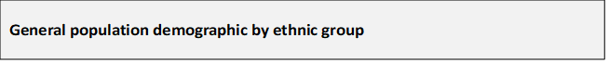

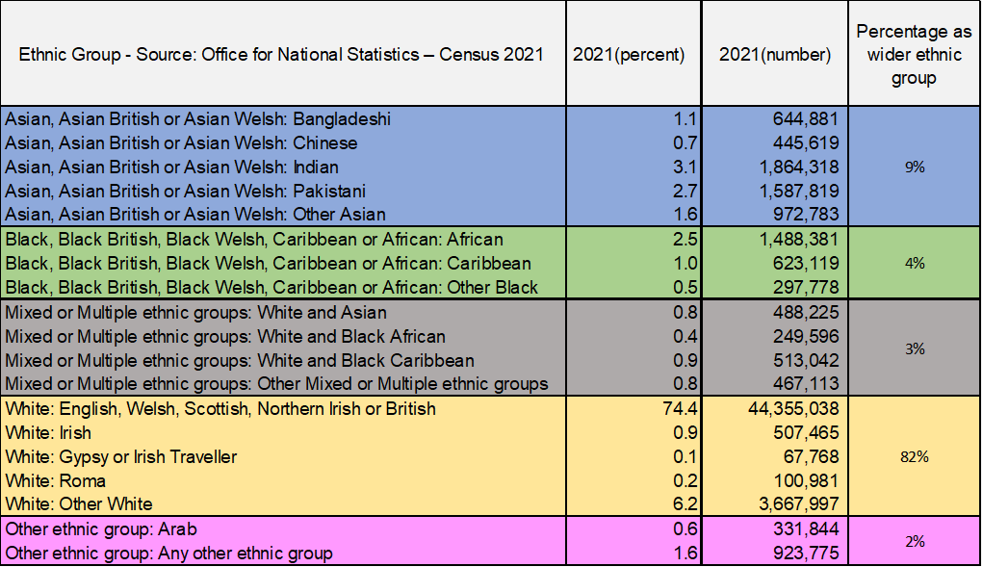

**NHS Nottingham & Nottinghamshire Integrated Care Board**

**LeDeR Programme Annual Report April 2023 – March 2024**

**Authored by:**

Jonathan Sansome RN - Quality and LeDeR Programme Manager, Nottingham & Nottinghamshire ICB

Kirstie Charlesworth - LeDeR Programme Admin, Nottingham & Nottinghamshire ICB

**Contributors:**

Sarah Edwards – RMN – LeDeR Reviewer Nottingham & Nottinghamshire ICB

Jo Johnson – RN - LeDeR Reviewer Nottingham & Nottinghamshire ICB

Adrian Hartley - Expert by Experience (EBE)

Deepa Baxi – Senior Medicines Optimisation Pharmacist

Adele Smith - Senior Transformation and Commissioning Manager, Nottingham & Nottinghamshire ICB

Susan Law – Expert by Experience (EBE) - LeDeR Review Workstream (3)

* An ‘easy-read version of this report is available on the same web page as this report.