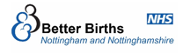

Nottingham & Nottinghamshire Local Maternity & Neonatal System
Who are we?
Background & Context
In 2016, the National maternity review’s report, Better Births, set out a vision for maternity services to become safer and more personalised.
What is a Local Maternity & Neonatal System (LMNS)?
Better Births recognised that the vision for NHS Maternity Services in England could only be realised through Local Maternity & Neonatal Systems:
A partnership of organisations, women and families working together to deliver improvements.

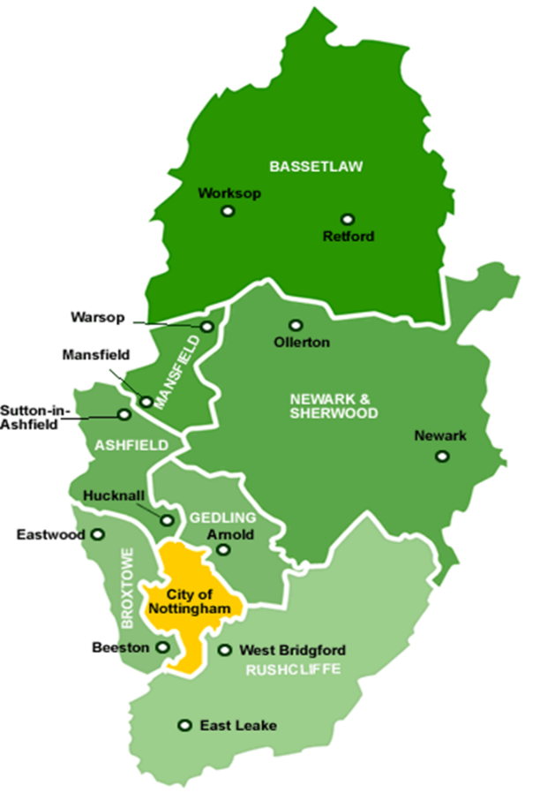

LMNS’s are responsible for Maternity Transformation:
- Ensuring all women and birthing people can make informed choices about their care during pregnancy, birth and postnatally
- Ensuring more women and birthing people have the option to give birth in non-hospital settings (at home & in midwifery units)
- Improving outcomes for all families using maternity services.
- Ensuring the co-design of services with service users and local communities
- Providing the infrastructure needed to support services to work together effectively, including interfacing with other services that have a role to play in supporting woman and families before, during and after birth
- Investigate and learn from incidents and share this learning through the Local Maternity & Neonatal System so improvements can be made.

Safety has always been at the heart of the national transformation agenda and the Ockenden Report (2020) has only further emphasised this.

Key deliverables for Maternity Transformation Programme
(For more detail, please see our webpage Maternity - NHS Nottingham and Nottinghamshire ICB)
Safe Midwifery & Obstetric staffing levels  Training programme for Maternity Support Workers  Core Competency Framework for all maternity staff | Building blocks in place to begin rolling out Continuity of Carer model
NHS smokefree pregnancy pathways for 46% of maternal smokers | Culture & Leadership development in Hospital Trusts
Equity & Equality actions | Expansion of Maternal Mental Health Services
Embed the Ockenden ‘Immediate and Essential Actions’ | Complete a Capacity & Capability Framework
Offer all women Personalised Care & Support Plans | Implement all elements of Saving babies Lives Care Bundle
Embed Maternal Medicines Networks | Implement Neonatal Improvement Plans
Offer Continuous Glucose Monitoring | Signed off Digital Strategy

To deliver our programme, the LMNS wants to work in collaboration with families and professionals.
If you are interested in getting involved or finding out more, please email us at nnicb-nn.nottslmns@nhs.net

