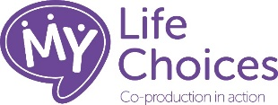

Preparing the public for Shared Decision Making – It’s Ok to Ask

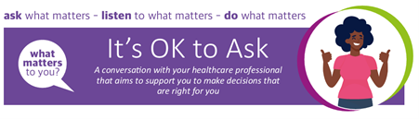

People’s participation in shared decision making is an essential part of its success. However, for various reasons, we know that people can be reluctant to ask questions because they:

- Don’t want to take up a busy health professional’s time.
- Don’t want to appear “difficult”.
- Are embarrassed to tell us they don’t understand for fear of appearing “stupid”.
- Want their healthcare professional to tell them what to do.

How to achieve a change in the conversation?
By supporting, encouraging and giving people confidence to play as active a role as they wish in decisions about their care.
All services need to ensure that people are prepared to share decisions by preparing them for their healthcare appointment.

Use this insert in all appointment letters
This insert has been fully co-produced with My Life Choices, a group of people who use Health and Care services who support personalised care, the Patient Information Forum and the Patients Association.

It is useful to think about the questions you want to ask at your appointment. This lets our doctors, nurses and other healthcare professionals (HCPs) give you the information you need.

Knowing more about you can help them give you the best advice and care. Completing the ‘About Me’ information will help you have a better conversation.

You can do this by filling in the ‘About Me’ form in this letter.

By the end of the appointment, we want to be able to answer these questions together:

1. What is my main problem?

2. What do I need to do?

3. Why is it important to do this?

When you are deciding on treatments it is OK to Ask about the

- Benefits of the treatment
- The Risk of the treatment
- Any Alternatives
- And what would happen if you did Nothing and decide against treatment.

Remember it is OK to Ask if

- Anything is unclear
- You have questions about symptoms, medicines or other health issues.
Bringing a family member or friend to your appointment can be helpful. They can ask questions too and help you remember what is said so you make the best decision for you.

Write down your questions before the appointment to make sure you ask everything you want to. Use the space below to do this and bring the letter with you to the appointment.

My questions

1

2

3

About Me
Remember to complete the About Me information before your appointment.
Find more information https://notts.icb.nhs.uk/your-health/personalised-care-2/about-me/

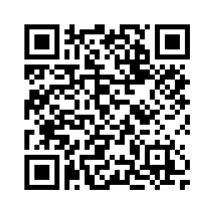

It’s Ok to Ask
Remember It’s Ok to Ask. Find more information
https://notts.icb.nhs.uk/your-health/personalised-care-2/its-ok-to-ask/

