

Display Screen Equipment (DSE) Use Policy

July 2023 - July 2026

CONTROL RECORD

Reference Number | Version |  | Status | Author
H&S-003 | 2.0 |  | Final | Head of Corporate Assurance
 |  |  |  | Sponsor
 |  |  |  | Associate Director of Governance
 |  |  |  | Team
 |  |  |  | Corporate Assurance
Title | Display Screen Equipment Use Policy
 | Updated format for Equality Impact Assessment (EIA) at section 15.
Amendments | DSE links updated to include Office 365 forms.
 | Working from Home mentioned at paragraph 8 regarding DSE.
Purpose | To ensure that the organisation is compliant with the Health and Safety
Purpose | (Display Screen Equipment) Regulations 1992 (as amended in 2002)
Superseded | Display Screen Equipment Use Policy v1.1
Documents
 | All employees of NHS Nottingham and Nottinghamshire Integrated Care Board
Audience | and agency workers who have been working at the ICB for a qualifying period
 | of twelve weeks
Consulted with | N/A
Equality Impact | Complete - see Section 15
Assessment
Approving Body | Audit and Risk Committee |  |  |  | Date approved | June 2023
Date of Issue | July 2023
Review Date | July 2026

This is a controlled document and whilst this policy may be printed, the electronic version available on the ICB’s document management system is the only true copy. As a controlled document, this document should not be saved onto local or network drives.

NHS Nottingham and Nottinghamshire Integrated Care Board (ICB)’s policies can be made available on request in a range of languages, large print, Braille, audio, electronic and other accessible formats from the Engagement and Communications Team at nnicb-nn.comms@nhs.net.

2

Contents

 |  | Page
1 | Introduction | 4
2 | Purpose | 4
3 | Scope | 4
4 | Definition of a User | 5
5 | Roles and Responsibilities | 5
6 | Workstation Assessments | 7
7 | Eyesight Tests and Glasses | 8
8 | Portable DSE and Working from Home | 8
9 | Reporting Incidents/Injuries | 9
10 | Equality and Diversity Statement | 9
11 | Communication, Monitoring and Review | 10
12 | Staff Training | 10
13 | Interaction with other Policies | 11
14 | References | 11
15 | Equality Impact Assessment | 12
 | Appendix A: Display Screen Equipment User Eye Test Voucher | 18
 | Claim Form | 18
 | Appendix B: Display Screen Equipment User Corrective | 19
 | Appliances Claim Form | 19
 | Appendix C: Corporate Eye Care Scheme (Process) | 20

3

- Introduction

1.1 This policy applies to the NHS Nottingham and Nottinghamshire Integrated Care Board, hereafter referred to as ‘the ICB’.

1.2 The purpose of this document is to inform all Nottingham and Nottinghamshire ICB employees of the relevant guidance pertaining to the Health and Safety (Display Screen Equipment) Regulations 1992 (as amended in 2002).

1.3 The regulations set out the requirements for employers to analyse workstations and assess and reduce risks. In general, employers need to look at:

- The whole workstation including equipment, furniture, and the work environment and ensure that they comply with the minimum requirements;

- The job being done; and

- Any specific needs of individual staff.

1.4 The main risks that may arise in work with display screen equipment (DSE) are musculoskeletal disorders, such as back pain or upper limb disorders (sometimes known as repetitive strain injury or RSI), visual fatigue and mental stress. Whilst the risks to individual users are often low, they can still be significant if good practice is not followed.

- Purpose

2.1 This policy seeks to protect the health and safety of staff by reducing the risks from working with DSE and explain the organisation’s responsibilities for:

  - Ensuring that DSE users undertake a workstation assessment every two years at the desks that they sit at (both at home and in the office, if applicable to the role).

  - Ensuring that newly identified DSE users (i.e., new starters) undertake a DSE risk assessment including a visual Portable Appliance Test (PAT).

  - Providing arrangements for meeting the costs of eye and eyesight tests and any required visual aids for DSE work (see Appendix C).

- Scope

3.1 This policy applies to all employees within the Nottingham and Nottinghamshire ICB. In accordance with the Agency Worker Regulations 2010, this policy also applies to agency workers who have completed a qualifying period of twelve weeks in a particular job within the ICB. These are collectively referred to as ‘individuals’ hereafter.

4
- Definition of a User

 | Term |  |  | Definition
 | ‘User’ |  |  | A ‘user’ is an employee who habitually uses display screen
 |  |  |  | equipment (DSE) as a significant part of their working day for
 |  |  |  | continuous or near continuous spells of an hour or more at a
 |  |  |  | time; and uses it in this way more or less daily.
 |  |  |  | A ‘user’ also refers to an employee who is highly dependent on
 |  |  |  | display screen equipment or an employee who has little or no
 |  |  |  | discretion over the use of the equipment.

- Roles and Responsibilities

 | Roles |  |  | Responsibilities
 | Audit and |  |  | To oversee the delivery of all statutory and mandatory
 | Risk |  |  | requirements relating to health, safety, security and fire.
 | Committee
 | Health and |  |  | The Health and Safety Steering Group exists to develop and
 | Safety |  |  | oversee the implementation of comprehensive and effective
 | Steering |  |  | health and safety (including fire and security management)
 | Group |  |  | arrangements within the ICB, in line with the Health and Safety
 |  |  |  | at Work Act 1974 and other legislative requirements (including
 |  |  |  | the Health and Safety (Display Screen Equipment)
 |  |  |  | Regulations 1992 (as amended in 2002)).
 | Head of |  |  | The Head of Corporate Assurance will:
 | Corporate |  |  | • Ensure this policy is compliant with any changes to Health
 | Assurance |  |  | and Safety legislation.
 |  |  |  | • Facilitate the provision of awareness training and
 |  |  |  | information for display screen equipment users.
 |  |  |  | • Facilitate the provision of display screen equipment
 |  |  |  | assessment training for those identified to verify and support
 |  |  |  | workstation self-assessments.
 |  |  |  | • Ensure all users complete a DSE and PAT self-assessment
 |  |  |  | in accordance with this policy and that these are reviewed
 |  |  |  | regularly, in the event of any change or two-yearly.
 | Line |  |  | In order to secure the health and safety of members of staff
 | Managers |  |  | who are regular users of display screen equipment, in so far as
 |  |  |  | is reasonably practicable, line managers must:
 |  |  |  | • Identify users.
 |  |  | 5

Roles |  | Responsibilities

- Ensure that DSE and PAT assessments are carried out for their teams and reviewed if there is a reason to suspect they are no longer valid, i.e., in the event of any change.

- Ensure full compliance with the Health and Safety (Display Screen Equipment) Regulations 1992 and associated legislation, including the provision of suitable equipment identified by assessment.

- Reduce the risks identified in an assessment to the lowest extent reasonably practicable.

- Ensure users are provided with adequate information and guidance about all aspects of health and safety relating to their work and workstation.

- Ensure that the activities of users are planned so that daily work on display screen equipment is periodically interrupted by breaks or changes of activity.

- Approve voucher issue for eye tests using the Corporate Eye Care Process where appropriate (eye test voucher claim form at Appendix A; process at Appendix C).

- Approve reimbursement for eyesight test and corrective appliances (i.e., glasses) if prescribed by an optician for display screen equipment work, if completed outside of corporate scheme (Appendix B).

All Staff | All staff will:

- Follow health and safety guidance and report any perceived problems to their line manager (or the Head of Corporate Assurance).

- Attend training and awareness sessions and familiarise themselves with information when provided.

- Undertake any self-assessments and co-operate with any support required.

- Arrange an appropriate eye test using the corporate eye care schemes and completing the appropriate form in advance of any test being undertaken (Appendix A).

- Use the correct form in the event of a claim for corrective appliances if agreed by the line manager (i.e., glasses) prescribed by an optician for display screen equipment work (Appendix B).

- Use corrective appliances (i.e., glasses) if prescribed by an optician for display screen equipment work.

6

Trained DSE Workstation Assessors – Occupational Health

The ICB’s Occupational Health staff are the trained DSE Workstation Assessors and will:

- Review self-assessments and support with queries and complex assessments.

- Log completed assessments.

- Attend training for undertaking workstation assessments when provided.

- Carry out workstation assessments when required and undertaking any required actions that arise from the assessment.

- Workstation Assessments

6.1. A workstation assessment for new or newly categorised DSE users should be undertaken as soon as the user comes into post/becomes a user and arranged as part of their induction process.

6.2. Workstation self-assessments are carried out by the individual using the ICB Display Screen Equipment Self-Assessment and Staff IT Equipment Questionnaire

6.3. Workstation self-assessments can then be reviewed by the Assurance Team and advice can be sought if required.

6.4. Employees who share a workstation with one or more people should each complete their own assessment. This is of particular importance given the agile/ ‘hot desk’ working across the ICB’s sites.

6.5. Where risks are identified, all reasonable and practicable measures to rectify them will be taken and employees must co-operate with these measures.

6.6. Where a specialist assessment is required – for example, due to existing health issues e.g., musculoskeletal disorders or eyesight problems, or work-related issues for example, routinely using multiple screens, or regularly working remotely from a laptop, the workstation assessment will be carried out in conjunction with the trained DSE workstation assessor and any risks of actions agreed collectively.

6.7. A specialist DSE referral will be made by line managers to the ICB’s Occupation Health Service via the Medigold Referral Portal. The password is: Nottinghamshire.ICB.MR

6.8. The workstation assessment will need to be reviewed in light of the following:

- Major changes made to the equipment, furniture, work environment or software; e.g., office move or change around.

7

  - Users change workstations; e.g., new equipment.

  - The nature of work tasks change considerably; e.g., new tasks introduce longer periods of DSE work.

  - It is thought that the controls in place may be causing other problems e.g., health problems noticed.

  - Reviewed two-yearly – if no changes detailed above have been made.

- Eyesight Tests and Glasses

7.1. Individuals can arrange for eye tests and obtain the required visual aids through the organisation’s Corporate Eye Care Scheme (information on this is available at Appendix C).

7.2. The DSE user will need to have an in-date DSE assessment and the voucher claim form (Appendix A) must be completed and submitted to the Head of Corporate Assurance by their line manager confirming the individual is a DSE user and agreeing to the issue of the corporate eye care scheme voucher.

7.3. All sight tests are required to be carried out by a registered optometrist or ophthalmologist in accordance with the corporate eye care scheme. The ICB’s current provider of the Corporate Eye Care Scheme is Vision Express.

7.4. Employers only have to pay for glasses for DSE work if the test shows an employee needs special glasses prescribed for the distance the screen is viewed at. If an ordinary prescription is suitable, employers do not have to pay for glasses. The ICB will contribute up to £45 towards any glasses that are required for DSE work.

7.5. Where a member of staff obtains a test independently and without the prior knowledge and agreement of his/her manager, then the organisation will not be responsible for the costs incurred. Where a member of staff has sought approval from their line manage for an eye test with a different provider the ICB will contribute up to £20.

7.6. Users are entitled to further eye tests at regular intervals if they are having difficulties which may reasonably be attributed to their VDU work. In these cases, further vouchers will be agreed by line management.

- Portable DSE and Working from Home

8.1. Portable DSE, such as laptop and notebook computers, are subject to the DSE regulations if it is in prolonged use. The DSE regulations also apply to employees working from home.

8.2. Individual self-assessments must be carried out for portable DSE.

8

8.3. Where employees highlight that they work from home (in line with the organisation’s agile working arrangements), the employee will conduct their own self-assessment and be responsible for ensuring that this is completed.

- Reporting Incidents/Injuries

9.1. All users should inform their manager if after prolonged periods of use of the equipment they become aware of any of the following:

- Backache, shoulder or neck pain.

- Tired eyes/headaches.

- Aches or pains in hands or arms.

- Impairment of grip or movement of fingers or other joints.

- Other health issues that may be affected by DSE work.

9.2. Any issues, however minor, must be reported using the ICB’s Incident Report Form (Non Information Governance). Please refer to the ICB’s Incident Reporting and Management Policy.

9.3. It is the responsibility of the employee to complete the incident form as soon as possible after the issue has occurred or they have become aware of the issue.

9.4. A referral to Occupational Health should be considered at this point for a physio assessment. Referrals will be made by line managers to the ICB’s Occupation Health Service via the Medigold Referral Portal. The password is: Nottinghamshire.ICB.MR

- Equality and Diversity Statement

10.1 Nottingham and Nottinghamshire ICB pay due regard to the requirements of the Public Sector Equality Duty (PSED) of the Equality Act 2010 in policy development and implementation as a commissioner and provider of services as well as an employer.

10.2 The ICB is committed to ensuring that the way we provide services to the public and the experiences of our staff does not discriminate against any individuals or groups on the basis of their age, disability, gender identity (trans, non-binary), marriage or civil partnership status, pregnancy or maternity, race, religion or belief, gender or sexual orientation.

10.3 We are committed to ensuring that our activities also consider the disadvantages that some people in our diverse population experience when accessing health services. Such disadvantaged groups include people

9

experiencing economic and social deprivation, carers, refugees and asylum seekers, people who are homeless, workers in stigmatised occupations, people who are geographically isolated, gypsies, Roma and travellers.

10.4 As an employer, we are committed to promoting equality of opportunity in recruitment, training and career progression and to valuing and increasing diversity within our workforce.

10.5 To help ensure that these commitments are embedded in our day-to-day working practices, an Equality Impact Assessment has been completed for, and is attached to, this policy.

- Communication, Monitoring and Review

11.1 The Head of Corporate Assurance will be responsible for monitoring the implementation and use of this policy on an ongoing basis and will also be responsible for updating the document in accordance with any changes required due to the following:

- Legislative changes.

- Good practice guidance, and/or

- Incidents reported in relation to DSE use.

11.2 The Head of Corporate Assurance will also be responsible for communicating this policy through the appropriate ICB’s communication methods.

11.3 This policy will be reviewed by the Audit and Risk Committee every three years or in light of any legislative changes.

11.4 Any individual who has queries regarding the content of this policy, or has difficulty understanding how this policy relates to their role, should contact the ICB’s Corporate Assurance Team - notts.corporateassurance@nhs.net.

- Staff Training

12.1 In addition to the training given in the organisation’s mandatory health and safety training, all DSE users are encouraged to familiarise themselves with information on display screen equipment (DSE) by reading the Health and Safety Executive guidance ‘Working safely with display screen equipment’ - https://www.hse.gov.uk/msd/dse/

12.2 Any individual who has queries regarding the content of the policy, or has difficulty understanding how this relates to their role, should contact the ICB’s Corporate Assurance Team by email: notts.corporateassurance@nhs.net.

10
- Interaction with other Policies

13.1 This policy should be read in conjunction the following ICB policies:

  - Health, Safety and Security Policy.

  - Incident Reporting and Management Policy.

- References

  - https://www.hse.gov.uk/msd/dse/index.htm

  - Health and Safety Executive (2013), Working with Display Screen Equipment https://www.hse.gov.uk/pubns/indg36.pdf

11
- Equality Impact Assessment

 | Overall Impact on: |  | Positive ☐ Neutral ☒
 | Equality, Inclusion and Human Rights |  | Positive ☐ Neutral ☒
 | Equality, Inclusion and Human Rights |  | Negative ☐ Undetermined ☐
 | [Select one option] |  | Negative ☐ Undetermined ☐

 | Name of Policy, Process, Strategy or | Display Screen Equipment (DSE) Use Policy |  | Date of Completion | July 2023
 | Service Change | Display Screen Equipment (DSE) Use Policy |  | Date of Completion | July 2023
 | EIA Responsible Person | Siân Gascoigne, Head of Corporate Assurance
 | Include name, job role and contact details. | Email: siân.gascoigne@nhs.net
 | EIA Group | Siân Gascoigne, Head of Corporate Assurance
 | Include the name and position of all members | Siân Gascoigne, Head of Corporate Assurance
 | Include the name and position of all members | Emma Pearson, Corporate Compliance Manager
 | of the EIA Group. | Emma Pearson, Corporate Compliance Manager
 | Wider Consultation Undertaken
 | State who, outside of the project team, has | Staff Engagement Group
 | been consulted around the EIA.
 | Summary of Evidence
 | Provide an overview of any evidence (both
 | internal and external) that you utilised to | Equality Act 2010
 | formulate the EIA. E.g., other policies, Acts,
 | patient feedback, etc.
 |  |  | 12

 |  |  |  |  |  |  | What actions have been |  | What, if any, additional
 |  |  |  |  |  |  | What actions have been |  | actions should be considered |  | Score
 |  |  | What are the actual, |  | What are the actual, |  | taken to address the |  | actions should be considered |  | Score
 |  |  | What are the actual, |  | What are the actual, |  | taken to address the |  | to ensure the policy, process, |  | Score
 |  |  | expected or potential |  | expected or potential |  | actual or potential |  | to ensure the policy, process, |  | Score
 |  |  | expected or potential |  | expected or potential |  | actual or potential |  | strategy or service change is |  | Score
 |  |  | positive impacts of the |  | negative impacts of the |  | positive and negative
 |  |  | positive impacts of the |  | negative impacts of the |  | positive and negative |  | as inclusive as possible? |  | Impact
 |  |  | policy, process, strategy |  | policy, process, strategy |  | impacts of the policy, |  | as inclusive as possible? |  | Impact
 |  |  | policy, process, strategy |  | policy, process, strategy |  | impacts of the policy, |  | Include the name and contact |  | Impact
 |  |  | or service change? |  | or service change? |  | process, strategy or |  | Include the name and contact |  | Impact
 |  |  | or service change? |  | or service change? |  | process, strategy or |  | details of the person |  | Impact
 |  |  |  |  |  |  | service change? |  | details of the person |  | Impact
 |  |  |  |  |  |  | service change? |  | responsible for the actions.
 | Age |  | There are no actual or |  | There are no actual or |  | None. |  | None. | 3
 |  |  | expected positive impacts |  | expected negative
 |  |  | on the characteristic of |  | impacts on the
 |  |  | Age. |  | characteristic of Age.
 | Disability¹ |  | There are no actual or |  | There are no actual or |  | Standing workstations |  | None. | 3
 | (Including: mental, |  | expected positive impacts |  | expected negative |  | are provided at most
 | physical, learning, |  | on the characteristic of |  | impacts on the |  | office bases.
 | intellectual and |  | Disability. |  | characteristic of Disability. |  | office bases.
 | intellectual and |  | Disability. |  | characteristic of Disability. |  | There are accessible lifts
 | neurodivergent) |  |  |  |  |  | There are accessible lifts
 | neurodivergent) |  |  |  |  |  | at all office basis for
 |  |  |  |  |  |  | wheelchair users.
 | Gender² |  | There are no actual or |  | There are no actual or |  | None. |  | None. | 3
 | (Including: trans, |  | expected positive impacts |  | expected negative
 | non-binary and |  | on the characteristic of |  | impacts on the
 | gender |  | Gender. |  | characteristic of Gender.
 | reassignment)

13
Marriage and Civil | There are no actual or | There are no actual or | None. | None. | 3
Partnership | expected positive impacts | expected negative
 | on the characteristic of | impacts on the
 | Marriage and Civil | characteristic of Marriage
 | Partnership. | and Civil Partnership.
Pregnancy and | There are no actual or | There are no actual or | None. | None. | 3
Maternity Status | expected positive impacts | expected negative
 | on the characteristic of | impacts on the
 | Pregnancy and Maternity | characteristic of
 | Status. | Pregnancy and Maternity
 |  | Status.
Race³ | There are no actual or | There are no actual or | None. | None. | 3
 | expected positive impacts | expected negative
 | on the characteristic of | impacts on the
 | Race. | characteristic of Race.
Religion and Belief⁴ | There are no actual or | There are no actual or | None. | None. | 3
 | expected positive impacts | expected negative
 | on the characteristic of | impacts on the
 | Religion or Belief. | characteristic of Religion
 |  | or Belief.
Sex⁵ | There are no actual or | There are no actual or | None. | None. | 3
 | expected positive impacts | expected negative
 | on the characteristic of | impacts on the
 | Sex. | characteristic of Sex.

14
Sexual Orientation⁶ | There are no actual or | There are no actual or | None. | None. | 3
 | expected positive impacts | expected negative
 | on the characteristic of | impacts on the
 | Sexual Orientation. | characteristic of Sexual
 |  | Orientation.
Human Rights⁷ | There are no actual or | There are no actual or | None. | None. | 3
 | expected positive impacts | expected negative
 | on the characteristic of | impacts on the
 | Human Rights. | characteristic of Human
 |  | Rights.
Community | There are no actual or | There are no actual or | None. | None. | 3
Cohesion and | expected positive impacts | expected negative
Social Inclusion⁸ | on the characteristic of | impacts on the
 | Community Cohesion and | characteristic of
 | Social Inclusion. | Community Cohesion and
 |  | Social Inclusion.
Safeguarding⁹ | There are no actual or | There are no actual or | None. | None. | 3
(Including: adults, | expected positive impacts | expected negative
children, Looked | on the characteristic of | impacts on the
After Children and | Safeguarding. | characteristic of
adults at risk or who |  | Safeguarding.
lack capacity)
Other Groups at | There are no actual or | There are no actual or | None. | None. | 3
Risk¹⁰ of | expected positive impacts | expected negative
Stigmatisation, | on the characteristic of | impacts on the
Discrimination or | Other Groups at Risk. | characteristic of Other
Disadvantage |  | Groups at Risk.

15

Additional Narrative |  |  |  |  |  |  |  |  |  |  |  |  | Here you should add additional detail or
 |  |  |  |  |  |  |  |  |  |  |  |  | explanation around the positive, negative,
Provide additional evidence and narrative about the positive, negative, and |  |  |  |  |  |  |  |  |  |  |  |  | and neutral impact of the proposals on the
neutral impacts of the proposal on the equality, inclusion and human rights |  |  |  |  |  |  |  |  |  |  |  |  | above protected characteristic and health
elements detailed above. |  |  |  |  |  |  |  |  |  |  |  |  | inclusion groups. To address this, you
 |  |  |  |  |  |  |  |  |  |  |  |  | should consider the barriers to accessing or
You should consider: |  |  |  |  |  |  |  |  |  |  |  |  | using the service, including the mitigations
• Three elements of Quality (safety, experience and effectiveness) |  |  |  |  |  |  |  |  |  |  |  |  | to respond to these.
• | Intersectionality
• Impact of COVID-19
• | Access to Services
 | o | Physical
 | o | Written communication
 | o | Verbal communication
• | Digital Poverty
• | Safeguarding
• | Dignity and Respect
• Person-centred Care
Positive Impact |  |  |  | Neutral Impact |  |  | Negative |  | Undetermined
 |  |  |  | Neutral Impact |  |  | Impact |  | Impact
 |  |  |  |  |  |  | Impact |  | Impact |  |  |  | Equality Impact Score Total |  |  |  |  | 39
 | 56 to 50 |  |  | 49 to 36 |  |  | 35 to 22 |  | 21 to 14
 |  | Positive |  |  |  |  |  | Neutral |  |  |  |  | Negative |  | Undetermined
 |  |  | 4 |  |  |  |  | 3 |  |  |  | 2 |  |  | 1
 |  |  |  |  |  |  |  |  |  |  |  |  |  |  | 16

- Disability refers to anyone who has: “…a physical or mental impairment that has a ‘substantial’ and ‘long-term’ negative effect on your ability to do normal daily activities…” (Equality

Act 2010 definition). This includes, but is not limited to: mental health conditions, learning disabilities, intellectual disabilities, neurodivergent conditions (such as dyslexia, dyspraxia and dyscalculia), autism, many physical conditions (including HIV, AIDS and cancer), and communication difficulties (including d/Deaf and blind people).

- Gender, in terms of a Protected Characteristic within the Equality Act 2010, refers to: “A person has the protected characteristic of gender reassignment if the person is

proposing to undergo, is undergoing or has undergone a process (or part of a process) for the purpose of reassigning the person's sex by changing physiological or other attributes of sex.”

- Race, in terms of a Protected Characteristic within the Equality Act 2010, refers to: A person’s colour, nationality, or ethnic or national origins. This also includes people whose first spoken language is not English, and/or those who have a limited understanding of written and spoken English due to English not being their first language.

- Religion and Belief, in terms of a Protected Characteristic within the Equality Act 2010, refers to: Religion means any religion and a reference to religion includes a reference to a lack of religion. Belief means any religious or philosophical belief and a reference to belief includes a reference to a lack of belief.

- Sex, in terms of a Protected Characteristic within the Equality Act 2010, refers to: A reference to a person who has a particular protected characteristic and is a reference to a man or to a woman.

- Sexual Orientation, in terms of a Protected Characteristic within the Equality Act 2010, refers to: Sexual orientation means a person's sexual orientation towards persons of the same sex, persons of the other sex or persons of either sex.

- The Human Rights Act 1998 sets out the fundamental areas that everyone and every organisation must adhere to. In relation to health and care, the most commonly applicable of the Articles within the Human Rights Act 1998 include: Article 2 Right to Life, Article 5 Right to Liberty and Security, Article 8 Right to Respect of Private and Family Life, and Article 9 Freedom of Thought, Conscience and Religion.

- Community Cohesion is having a shared sense of belonging for all groups in society. It relies on criteria such as: the presence of a shared vision, inclusion of those with diverse backgrounds, equal opportunity, and supportive relationships between individuals. Social Inclusion is defined as the process of improving the terms of participation in society, particularly for people who are disadvantaged, through enhancing opportunities, access to resources, voice and respect for rights (United Nations definition). For the EQIA process, we should note any positive or negative impacts on certain groups being excluded or not included within a community or societal area. For example, people who are homeless, those from different socioeconomic groups, people of colour or those from certain age groups.

- Safeguarding means: “…protecting a citizen’s health, wellbeing and human rights; enabling them to live free from harm, abuse and neglect. It is an integral part of providing high-quality health care. Safeguarding children, young people and adults is a collective responsibility” (NHS England definition). Those most in need of protection are children, looked after children, and adults at risk (such as those receiving care, those under a DoLS or LPS Order, and those with a mental, intellectual or physical disability). In addition to the ten types of abuse set out in the Health and Care Act 2022, this section of the EQIA should also consider PREVENT, radicalisation and counterterrorism.

- Other Groups refers to anyone else that could be positively or negatively impacted by the policy, process, strategy or service change. This could include, but is not limited to: carers, refugees and asylum seekers, people who are homeless, gypsy, Roma and traveller communities, people living with an addiction (e.g., alcohol, drugs or gambling), people experiencing social or economic deprivation, and people in stigmatised occupations (e.g., sex workers).

17
Appendix A:

Display Screen Equipment User Eye Test Voucher Claim Form


Part A: To be completed by employee

 | Employee’s Name: | Date of Birth: | Directorate:
 | (Block Capitals)
 | Assignment Number:
 | (See Pay slip)
 | Signature: | Contact Telephone No: | Date:
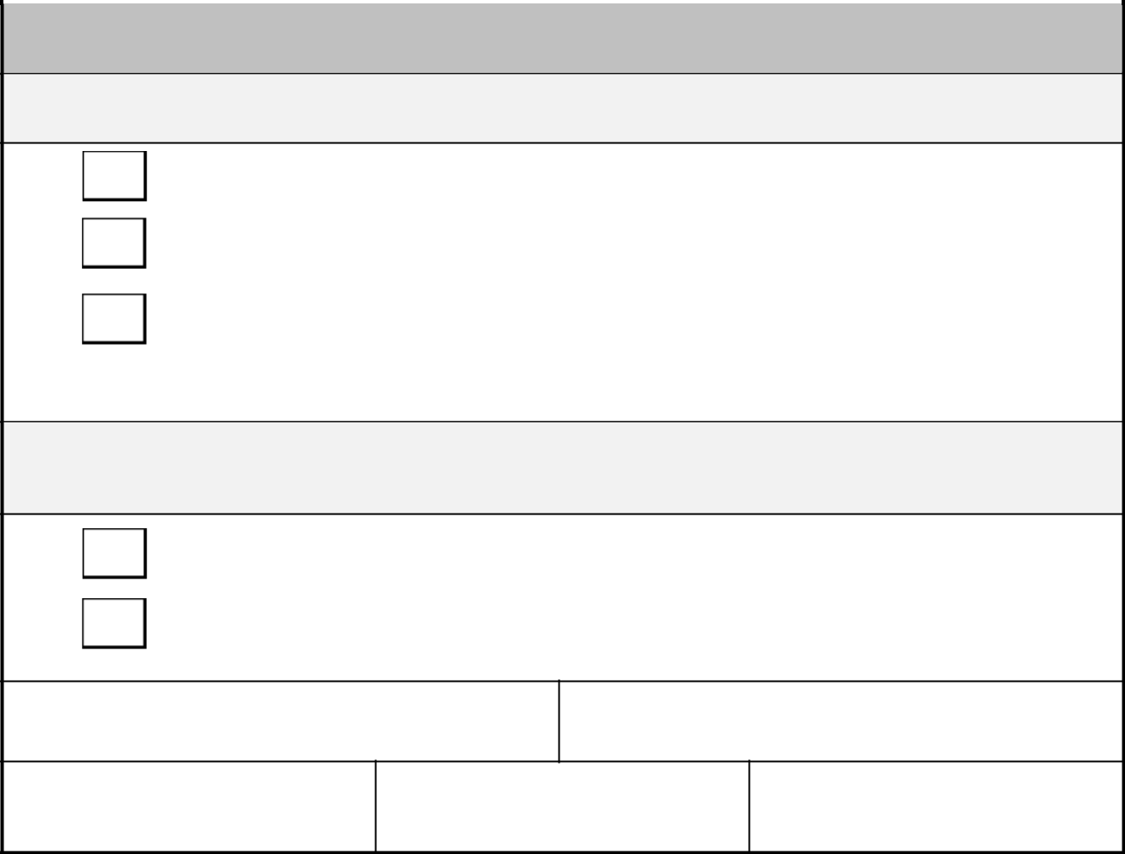
Part B: To be completed by line manager

1) To be completed fully

I confirm that the above employee is a display screen equipment user, and

A workstation assessment has been carried out.

The employee is either a new user, due a routine test, or is experiencing difficulties which may be reasonably considered to be related to display screen equipment work.

- ICB preference is to utilise the eye care scheme. It is left to the line manager’s discretion whether we reimburse outside of this scheme

The employee wishes to use the Corporate Eye Care Scheme using the ICB’s current provider - Vision Express.

A receipt for the eye test is attached for reimbursement.

Line Manager’s Name:

(Block Capitals)

Position:

Signature:

Contact Telephone No:

Date:

If the Corporate Eye Care Scheme is used, no further confirmation of the need for corrective appliances specifically for display screen equipment use is required.

If reimbursement is required, please also complete the Display Screen Equipment User Corrective Appliances Claim Form at Appendix B.

Please return form to the Corporate Assurance Team - notts.corporateassurance@nhs.net.

18

Appendix B:

Display Screen Equipment User Corrective Appliances Claim Form


Part A: To be completed by employee

Employee’s Name: | Date of Birth: | Directorate:
(Block Capitals)
Assignment Number:
(See Pay slip)
Signature: | Contact Telephone No: | Date:
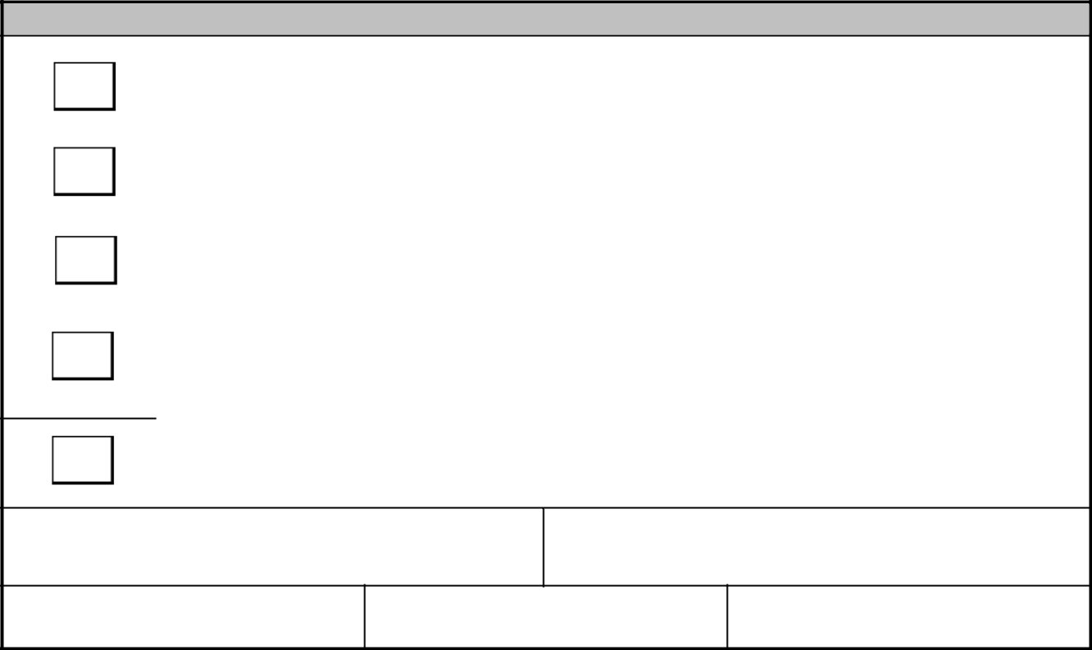

Part B: To be completed by line manager

I confirm that the above employee is a display screen equipment user.

A display screen equipment risk assessment has been carried out.

A prescription is attached showing that the optician has confirmed that corrective appliances (i.e., glasses or lenses) are required specifically for display screen equipment work.

A prescription is attached showing that the optician has confirmed that new corrective appliances (i.e., glasses or lenses) are required as a result of “deterioration” through the specific use of display screen equipment work.

The receipt for payment made by the employee is attached.

Line Manager’s Name:

(Block Capitals)

Position:

Signature:

Contact Telephone No:

Date:

Please return form to the Corporate Assurance Team - notts.corporateassurance@nhs.net.

19

Appendix C

Corporate Eye Care Scheme (Process)

The ICB’s current provider of the Corporate Eye Care Scheme is Vision Express
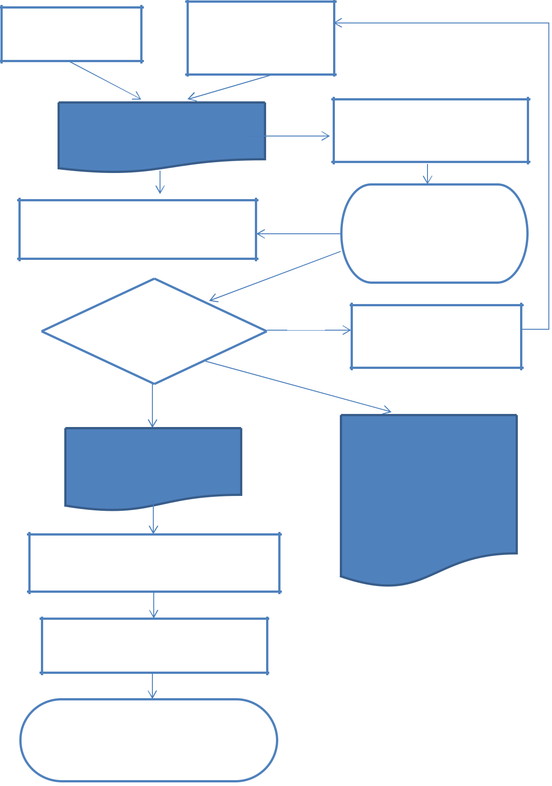

New user into post

as part of induction

Review of existing

assessment (due to

change or two-yearly

reviews)

DSE SELF ASSESSMENT and

Guidance

(see section 6.2)

If no action required, form to be reviewed, signed off and logged by Corporate Assurance Team

If recommendations required, form to be agreed/actioned by Line Manager

Manager to log team

compliance to Policy and

log with Corporate
Assurance Team

Does DSE user

require eye test

No

No further action required

until review

Yes Yes

EYE TEST VOUCHER

CLAIM FORM
Appendix A

Form to be completed by manager and passed to trained DSE workstation assessor

Trained DSE workstation assessor

issues voucher to user and logs
the voucher issue

User utilises voucher for eye

test/care/corrective appliances as

required

DISPLAY SCREEN EQUIPMENT USER CORRECTIVE APPLIANCES FORM Appendix B [Manager approval is required to depart from this process]

20

